**VERTEX3 GT**

**3DOF Motion Simulator Chassis**

**Assembly Guide**

v1.41

April 2015



Table of Contents

Introduction 3

PREP 3

Assembling Base Cradle Chassis 4

Assembling Roll Frame 11

Assembling Pitch/Yaw Frame 33

Cockpit Assembly 43

SubAssy Cockpit Bottom and Front 43

SubAssy Cockpit Rear 48

Attach SubAssy Bottom and Front to the Rear 51

SubAssy Cockpit Sides – BUILD 2 52

Connect Top frames to rest of the cockpit Assembly 55

SubAssy Pitch Actuator Mount 58

Attach Pitch Actuator Mount Assy to rest of Cockpit 62

SubAssy Seat Mount 64

Normal Configuration vs. Wide Configuration 65

Integrating the seat mount subassy into the cockpit 68

SubAssy Wheel Shelf 71

SubAssy Pedals :: Top Hinge or Bottom Hinge 72

Bottom Hinge 74

Integrating the pedal mount subassy into cockpit 76

SubAssy Shifter Mount 78

SubAssy Monitor(s) Mount 80

Integrating into the rest of the cockpit assembly 83

Final Assembly 86

Finishing the Cockpit 86

Mounting the Seat 86

Mounting the Monitors 86

Mounting the Wheel, Shifter and Pedals 86

Mounting the Cannon GT Pedals 87

Roll Frame to Base 87

Pitch/Yaw Frame to Roll Frame 93

Cockpit to Pitch/Yaw Frame 96

Balancing the Sim 98

End Caps 98

Wiring 98

Appendix A – Listing of Parts 99

Appendix B – Sim Wiring Diagram 106

Appendix C 108

Appendix D 109

# Introduction

This is an assembly manual for the VERTEX3 GT 3DOF Motion Simulator Chassis from SimCraft. It is intended to be a step by step instructional, designed to create the easiest path of assembly for the VERTEX3 GT aluminum extrusion bolt together frame system and is intended to be used in conjunction with a compatible SimCraft Motion System. Take proper safety precautions before beginning and throughout the assembly process.

The pictures contained in this manual are for informational display purposes and should not be used as part of the assembly guide as they may be outdated. Instead, please rely on the line drawings and illustrations contained within the assembly steps for your reference. If you run into trouble or have any questions about the contents of this manual, e-mail SimCraft Support: [scsupport@simcraft.com](mailto:scsupport@simcraft.com) or call 877-SimCraft and press “1” when you hear the introduction.

Before we begin, take an inventory of parts. You will find a complete listing in Appendix A of this manual. During your inventory of parts, we advise that you following the prep steps below, and keep an eye out for some specific parts (detailed in the below PREP section) to set aside as they are very similar to another part and could be mistakenly used before they are supposed to be.

Review the appendices for information on working with aluminum extrusions, T-Nuts, Anchor Fasteners and End Fasteners

# PREP

* Loosen (just loosen, do not remove) pre-assembled Socket Head Cap Screw (SHCS) and Econ T-nut on all 9232565, 9232570, 9232571, 9232572, and 9232573 (all 45 degree mitre cut aluminum extrusions). During this step, keep an eye out for four 9230323 parts and set aside. This mitre cut part will have an access hole drilled in its side, two displaced at 2” and two displaced at 5”

**Please Note**

**DO NOT use drop in style T-Nuts for actuator mounting as they may not hold securely.**

**DO use the center channel when mounting actuator mounts to the chassis.**

# Assembling Base Cradle Chassis

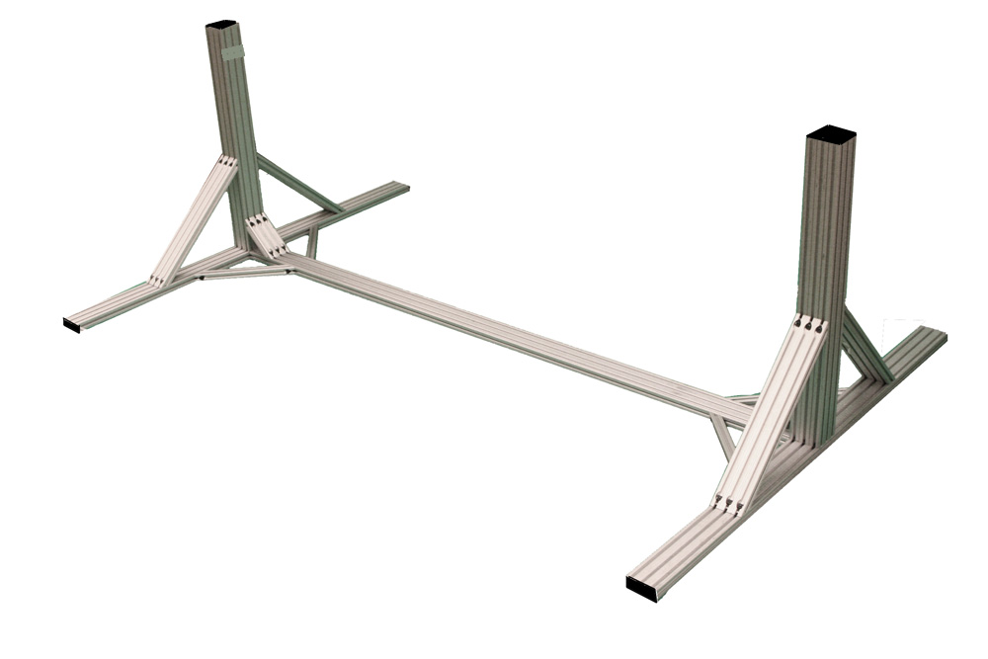

Step #1 Prep Center Frame (9230901) with 6 End Fastener Assemblies (9233381)

* End Fasteners (9233381) are composed of two parts: The Button Head Socket Cap Screw (BHSCS) and a Wing Clip.

* Place the BHSCS through the hole in the Wing Clip as shown in the photo.

* Orient the Wing Clip in the direction of the mating profile's T-slot. Begin to screw the BHSCS into the tapped hole of the mounting profile. (Do NOT fully tighten)

* Repeat for all 6 END holes on the center frame.

*Reference appendices at the end of this manual for visual assembly tips*

Step #2 With the Econ T-nuts loosened, (from PREP work above), slide four 9232570 within the side channels of the center frame (9230901) in place as shown and one 9232572 (12”) and one 9230114 (11.25”) onto top three channels of the (Center Frame) 9230901. It does matter which end gets the shorter of the two 1x3 pieces.

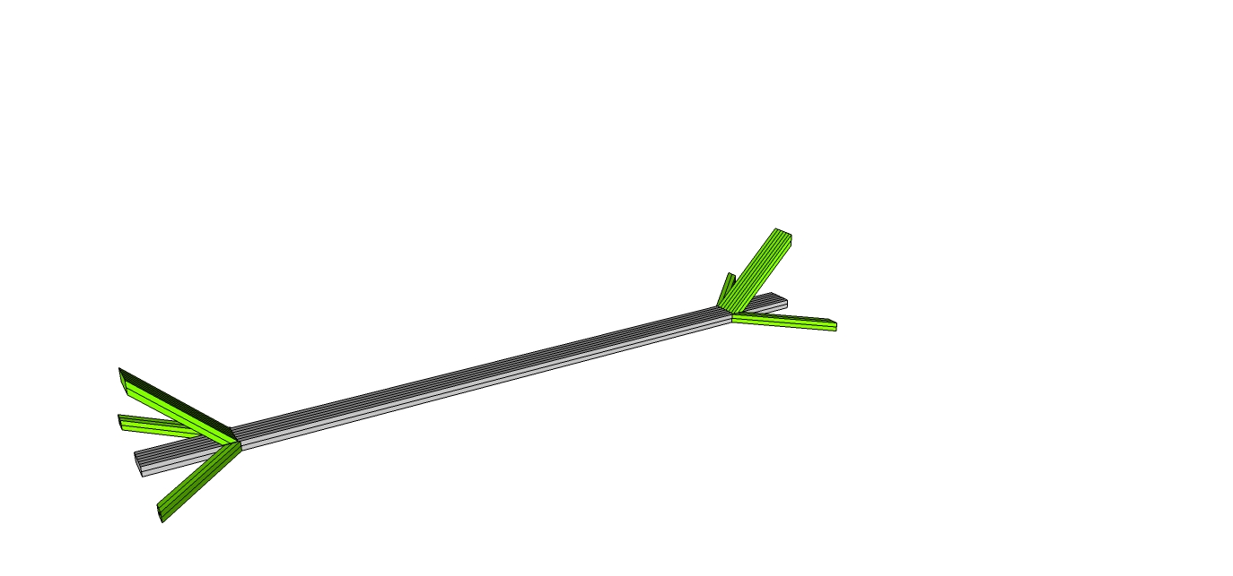

Step #3 With the End Fasteners (9233381) slightly loosened on the center frame, slide the (Main Ends) 9230902 into place. Slide the main end part through the side channel starting with the 9232570 nut, then the other 9232570. When aligned, the access holes on the mating profile (center of Main Ends/9230902) should align with the BHSCS on the end of the center frame from Step #1 above.

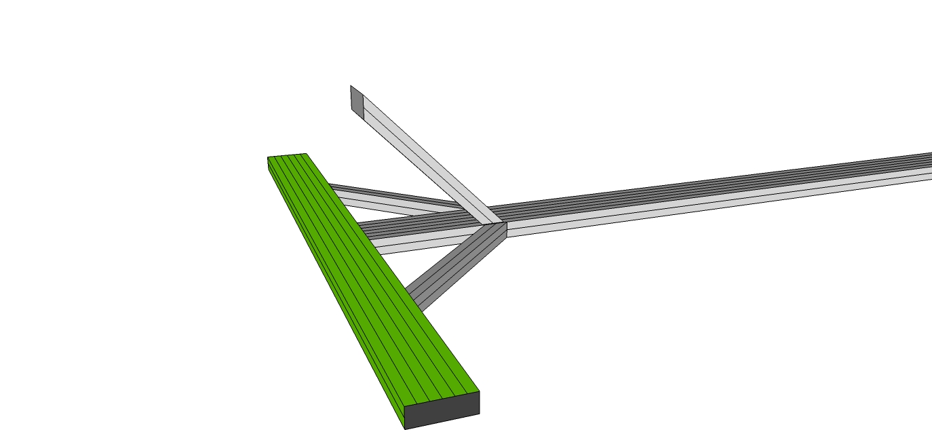

Step #4 To tighten the connection, place the T-handle hex wrench into access hole until the wrench head inserts into the BHSCS. Tighten all three clockwise until secure.

Then, to tighten the 9232570 place T-handle hex wrench into SHCS tightening clockwise until secure forming a 90 degree angle between Center Frame 9230901 and Main Ends (9230902).

Step #5 Repeat Steps 3 and 4 on other side of the center frame for the second main end.

Step #6 *Assemble the Main Vertical column onto the base frame*. Remove the Econ T-nuts from the 12” 45 degree support (923572) that is on top of the Center Frame (9230901).

Step 6.5 – Slide two T-Nuts into the 45 degree support, in the 1st and 3rd channels. Use some tape to hold in place for later in the process to connect the Actuator support offset.

Step #7 Take three (3) main vertical frames (9230903) to form a column with the tapped end oriented towards the floor. With the Econ T-nuts slightly loosened slide the two 18” 45 degree supports (9232573) in place as shown onto the column. Orient the three 9230903 frames forming the column from so that the 3 profile edges face the smaller 45 degree support, sliding the nuts from the 18” 45 degree support (9232573) into the side channels. Once the bottom of the 18” 45 degree supports (9232573) are aligned with the bottom of the column, slightly tighten one of the bolts to hold in place. (Completed assemblies are referenced as Main Vertical Column below). Later, a small 3 hole plate will be used to join the top of the column together just underneath the knuckle bearing.

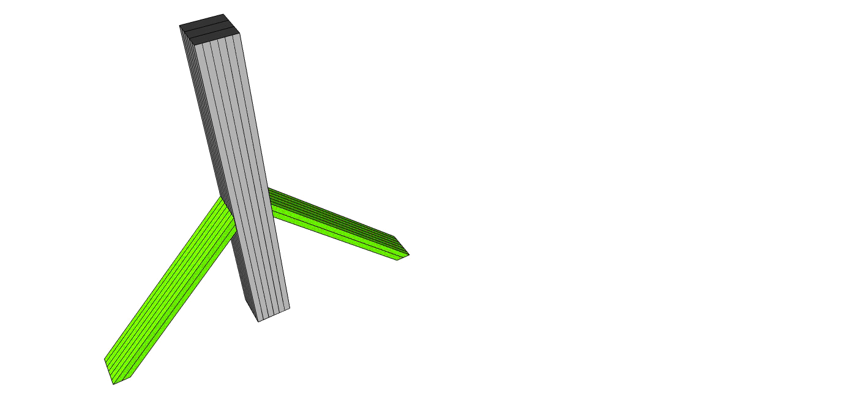

Step #8 Prep the Main Vertical Column (9230903) with 9 End Fastener Assemblies (9233381) (Reference Step #1 above for pre-assembling three End Fasteners (9233381) on each pre-tapped end.)

Step #9 With the End Fasteners (9233381) slightly loosened; slide the Main Vertical column into place on the Main Ends (9230902) as shown on each Main End

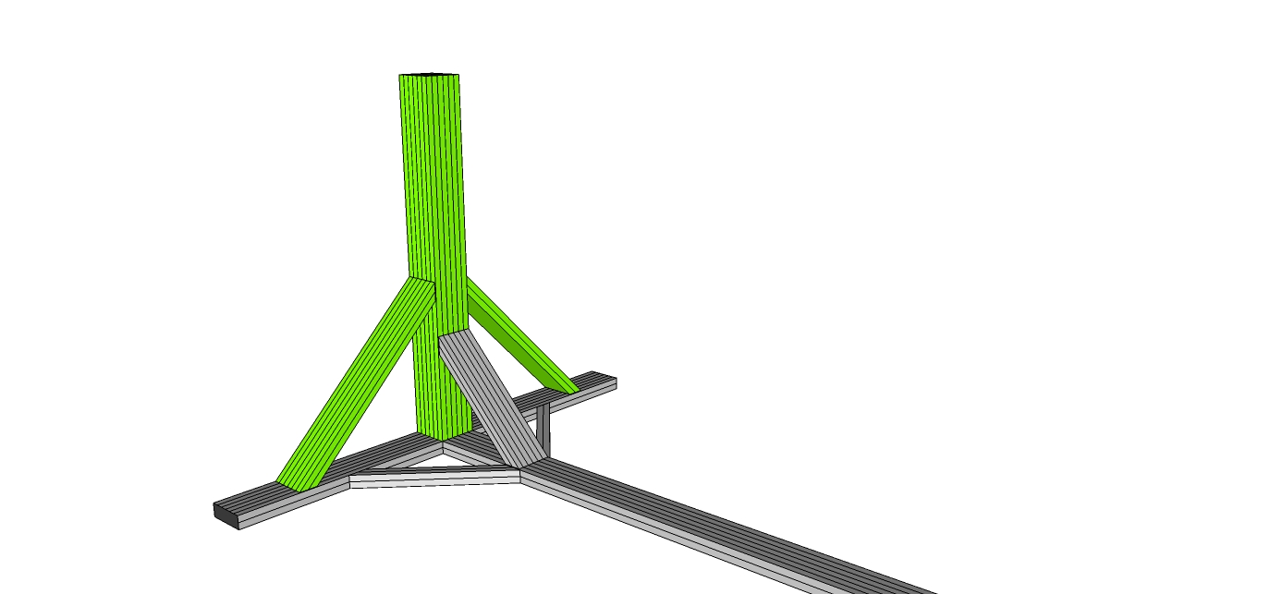

When aligned, the access holes on the bottom center of Main Ends (9230902) should align with the nine BHSCS of the End Fasteners (9233381) of the main vertical supports (9230903).

Step #10 To tighten the connections, place a T-handle hex wrench into access hole on the ***underside*** of the Main Ends (9230902) until the wrench head inserts into the BHSCS. Tighten all 18 End Fasteners (9233381) clockwise until secure.

Step #11 Tighten all 9232573 and 9232572/9230114 to firm up the main vertical assembly connections to the main ends (9230902), placing T-handle hex wrench into SHCS tightening clockwise until secure forming a 90 degree angle between Main Verticals (9230903) and Main Ends (9230902).

Step #12 Insert three “drop in” T-nut in each Main Vertical (9230903) as shown aligning with 9232572/9230114 from the Center Frame (9230901). Repeat for other side.

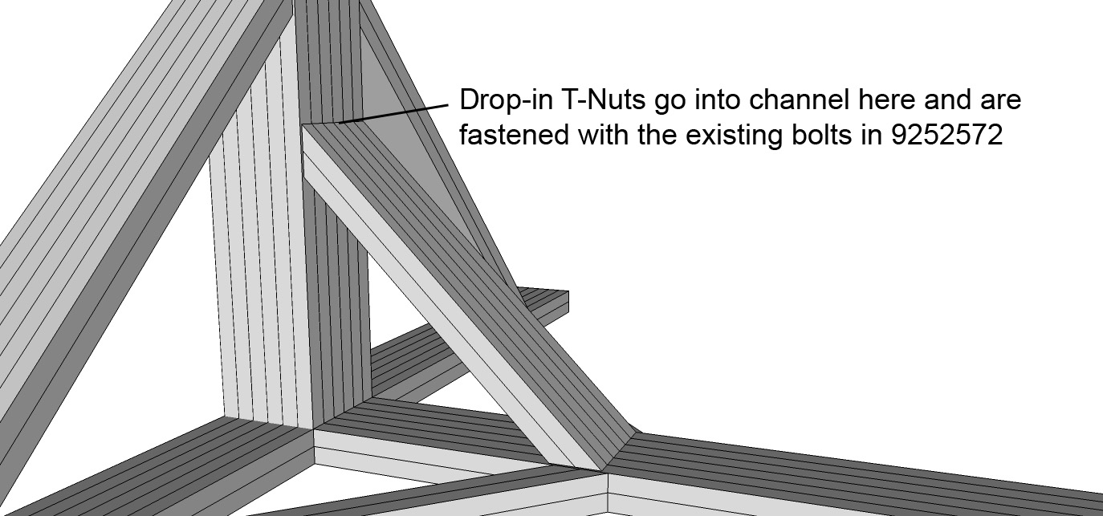

Step #13 Attach three hole joining strip (9234118) to be used as mounting plate for knuckle bearings.

Step #13a One is to be installed on the inside of both vertical members to support knuckle bearing for final assembly stage.

Step #13b Pre-assemble three 9233321 T-Nut and Bolt to each plate.

Step #13c Slide plate onto inside of Main Vertical (9230903) - locate using the knuckle bearing to measure the distance for fastening. The knuckle bearing top surface should be flush with the top of the Main Vertical (9230903). DO NOT attach the knuckle bearing at this time. Set aside til later once the three hole plate has been positioned.

Step #13d To tighten place T-handle hex wrench into 9233321 tightening clockwise

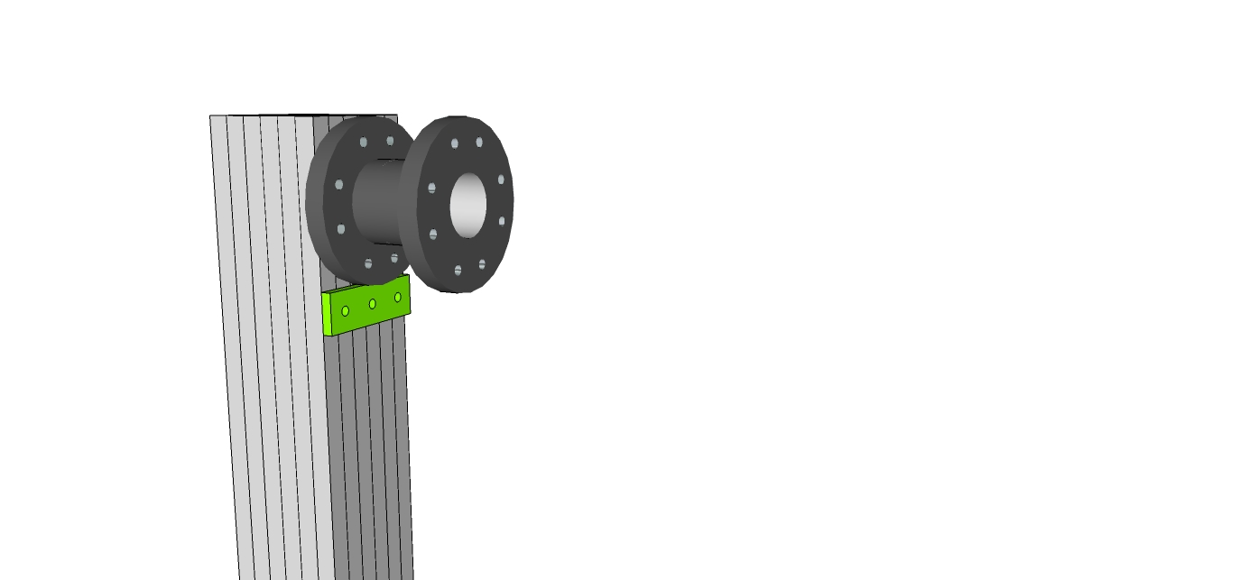

When all 13 steps are complete, your base cradle chassis should look something like the below assembly. For additional rigidity, you may consider securing the front vertical of the base frame to a wall, although this is certainly not required. If you choose to do this, make sure you locate a stud to secure the unit to.

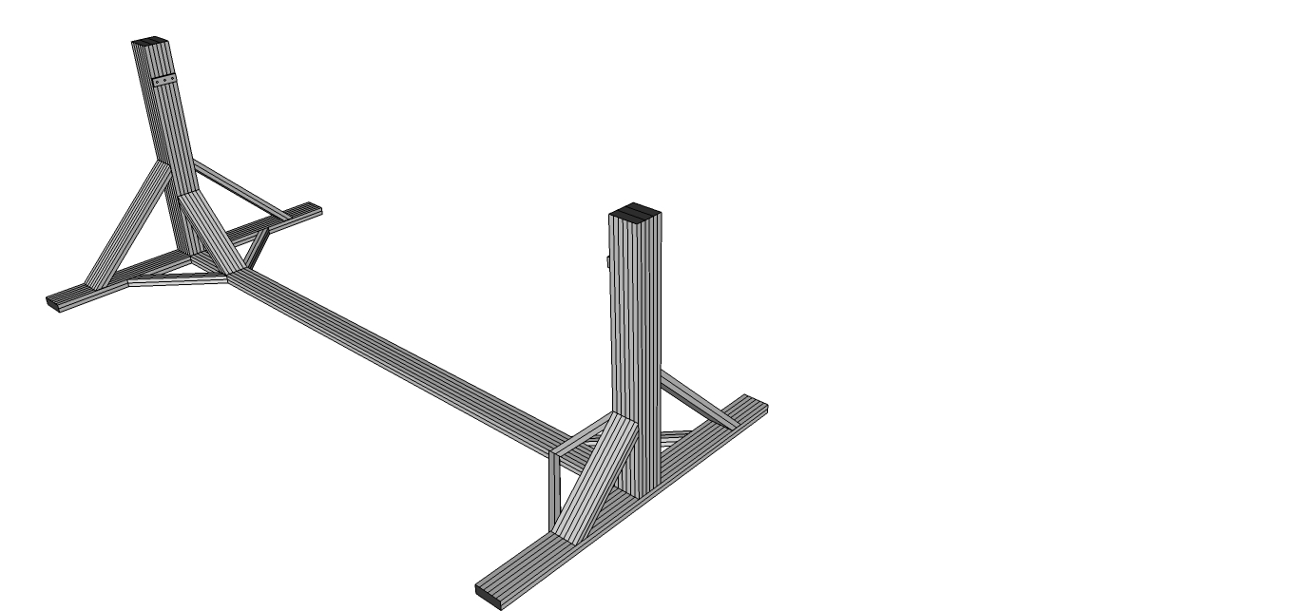

# Assembling Roll Frame

# 

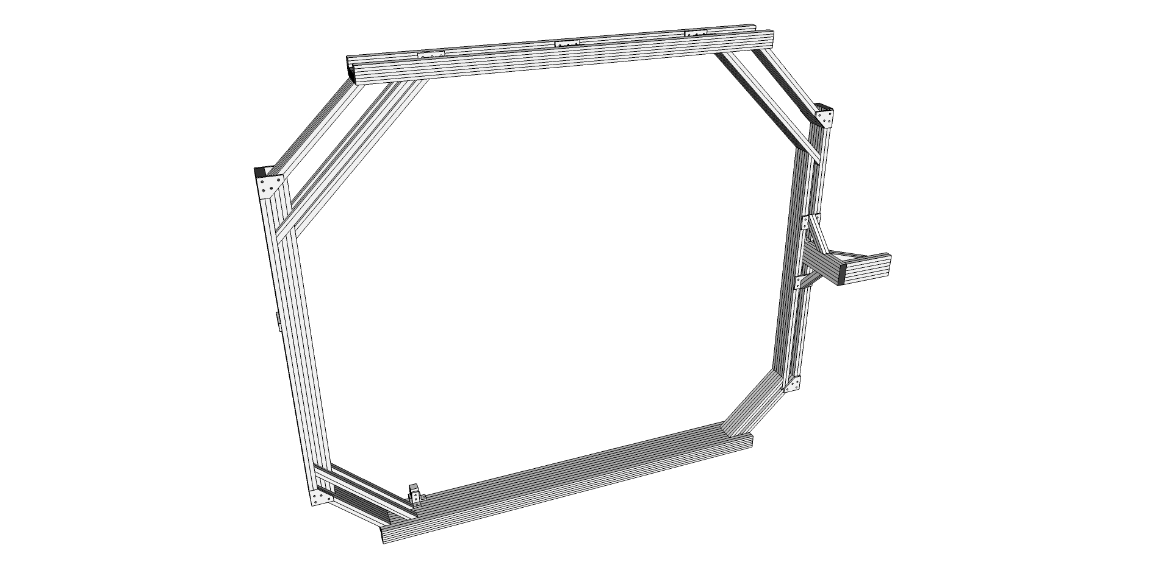

Step #1 Prep twelve of the 6-hole corner brackets (9234015) with T-Nuts and bolts (9233393) leaving the T-Nuts loose for inserting and sliding in the T-Slot.

Step #2 Take Main Length (Top) (9230106) and slide the six connectors from Step #1 into the two outer T-Slots as shown. Space three connectors on each side evenly distributed. Do not yet tighten.

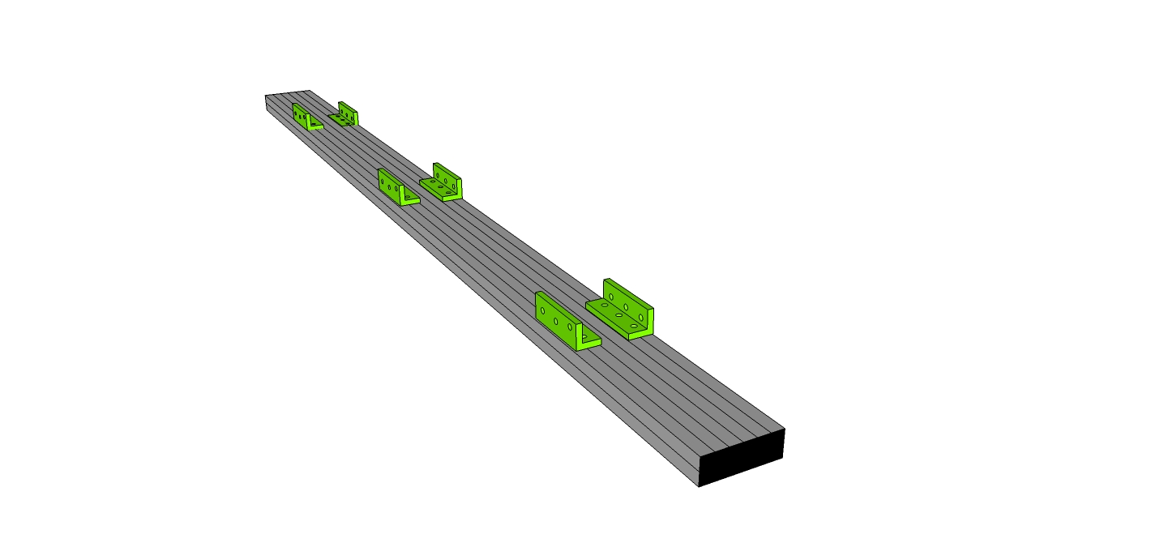

Step #3 Prep ten (10) of the 3/8" long 1-4"-20 BHSCS (Button head cap screws) + Econ T-nut (9233416). Slide 5 on each side to affix the 9230109 supports to the main length (top) 9230106. Use the access holes in the lower channel of the 9230109 supports to line up and tighten each of the bolts, tightening the T-Nut into the outer slots of the main length top 9230106. Alternatively, you may choose to use tape to preset the t-nuts into their appropriate positions before sliding the 1020 supports for top roll frame (9230109). Additionally, each of the supports for top roll frame (9230109) must slide into the six hole connectors from the previous step, three on each side on the bottom T-Slot as show. Tighten all 46 bolts.

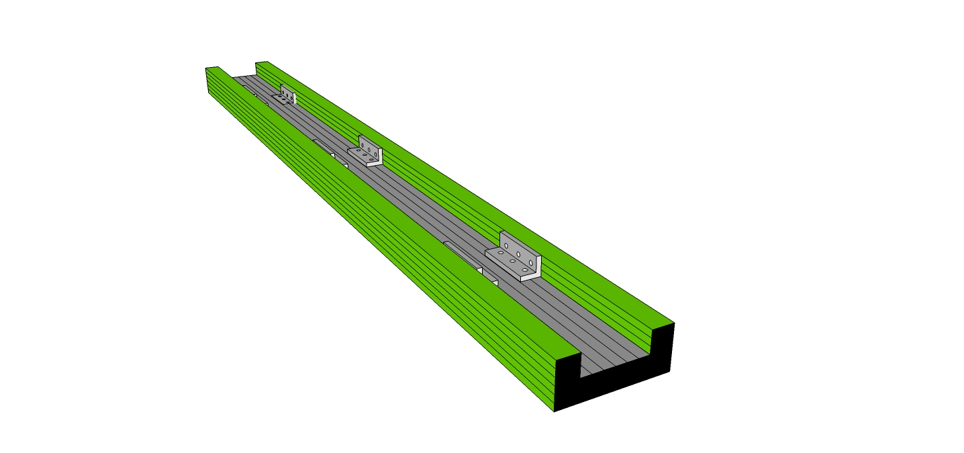

**IMPORTANT – Slide two T-Nuts in the bottom center channel of the main length (9230106), and tape in place for use later to secure the YAW knuckle bearing.**

Step #4 - Take the two rear 45 degree supports (16.25” (9230104) and 24” (9232574)), slide one of the loosened ends of each onto rear end of the Main Length Top (9230106) as shown. Align the end of 9230104 with the end of 9230106. Tighten all 6 bolts slightly into place.

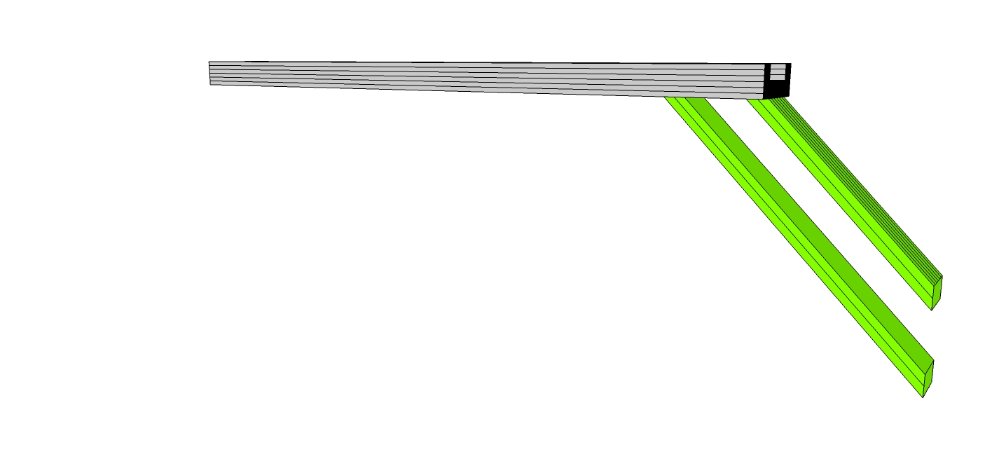

Step #5 Take the four front 45 degree supports, one 16.25” (9230104) and three of the 24” (9230111)), slide one of the loosened ends of each onto front end of the Main Length Top (9230106) as shown. One 9230111 goes into each lower channel. Align the end of 9230104 with the end of 9230106. Tighten all 6 bolts slightly into place.

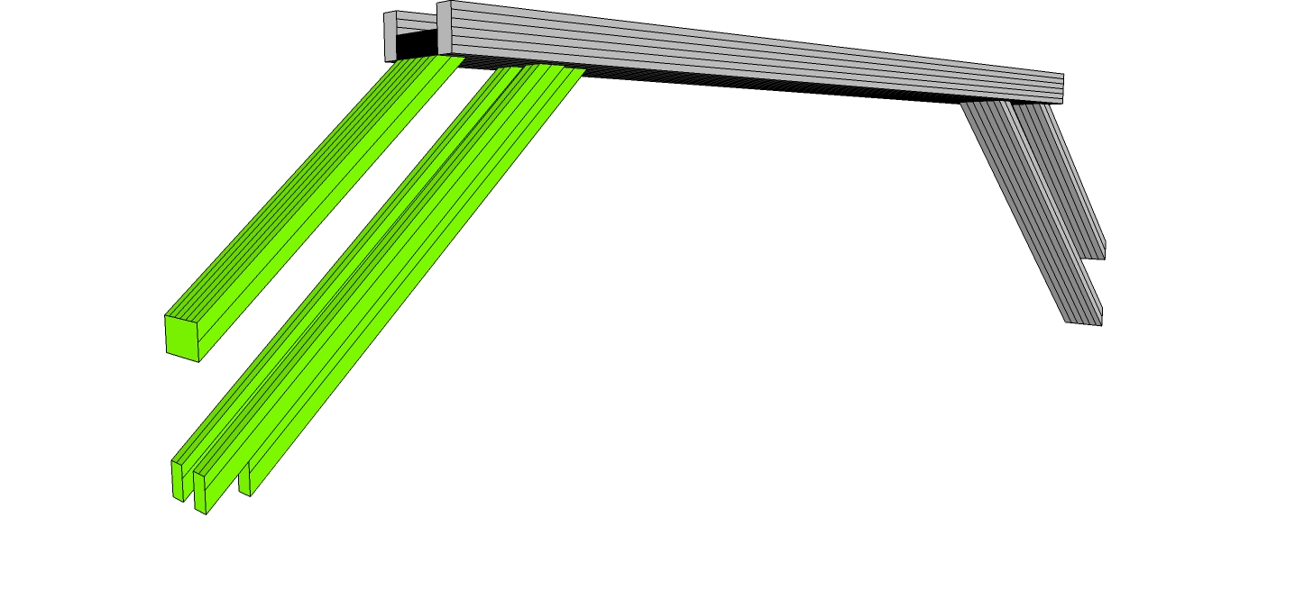

Step #6 Prep four 4 hole 45 degree joining plates (9234145) with four T-Nuts and Bolts (9233393). Then slide two of the prepped t-nuts into plate on the outer channel of the 16.25” (9230104) Support. Repeat on both sides of each of the 9230104 supports, four total. Tighten the two bolts that mate with the 9230104 on each, leaving the other two loose for the next step.

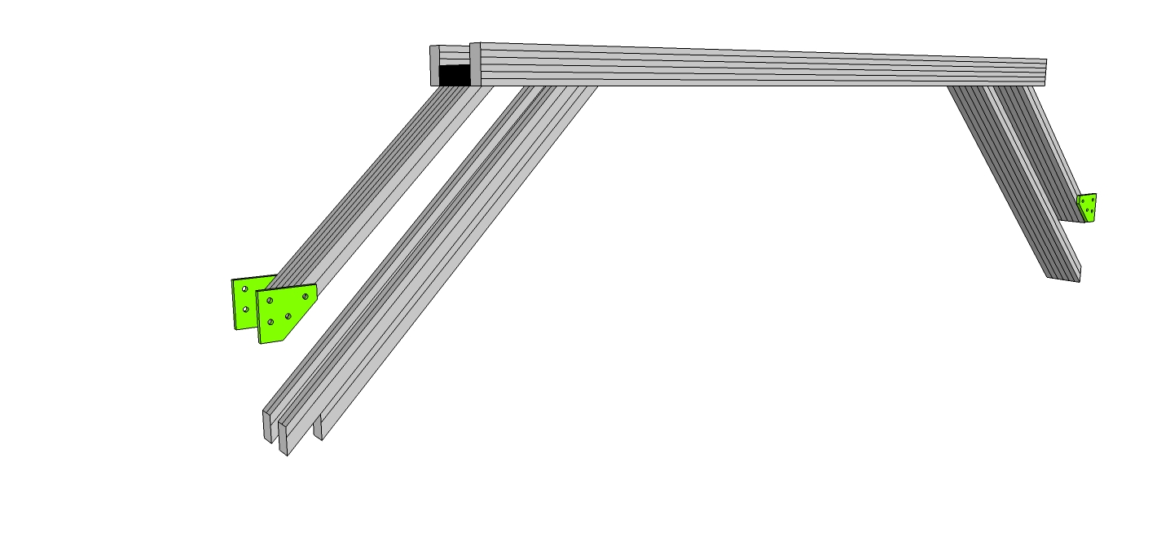

Step #7 Slide the two Main Ends (Front and Back) 9230101 into place thru the still loosened bolts of the 9230111, 9232574, the 9230104 mitre cut supports and through the 4 hole 45 degree joining plates (9234145) as shown. Tighten all bolts once all channels are flush and square. (NOTE: Leave one of the 9230111 profiles offset for the next step.)

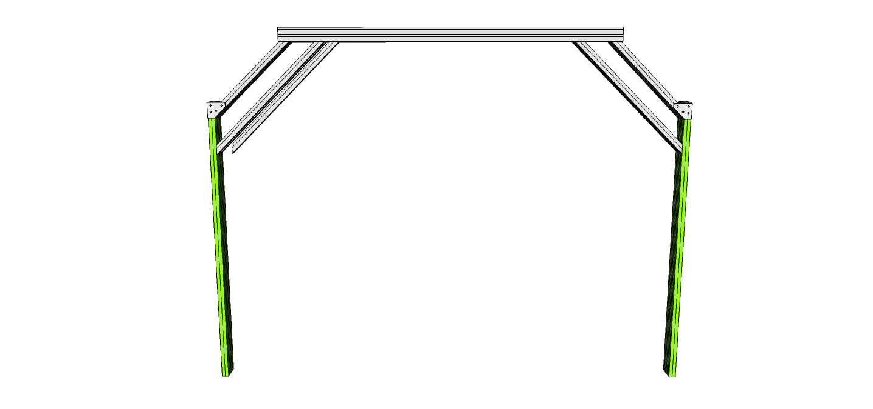

Step #8 Remove the T-Nut from one end of the 1020 mitre cut support (9230112). Prep three (3) of the 3/8" long 1-4"-20 BHSCS (Button head cap screws) + Econ T-nut (9233416). Slide all three into the inside channel of the mitre cut 1020 support (9230112) to affix to the middle inside channel of the 9230101 Main End support. Use the access holes in the 1020 support (9230112) channel to line up and tighten each of the bolts, tightening the T-Nut into the middle slot of the main end 9230101. Alternatively, you may choose to use tape to preset the t-nuts into their appropriate positions before sliding the 1020 support. Additionally, the mitre cut support (9230112) must slide into the loosed bolt from the 24” 45 degree support (9230111). Lastly, use a Drop-in t-nut in the middle channel of the 16.25” 45 degree support (9230104) to affix the 1020 mitre cut profile to (9230112). Tighten all 6 bolts.

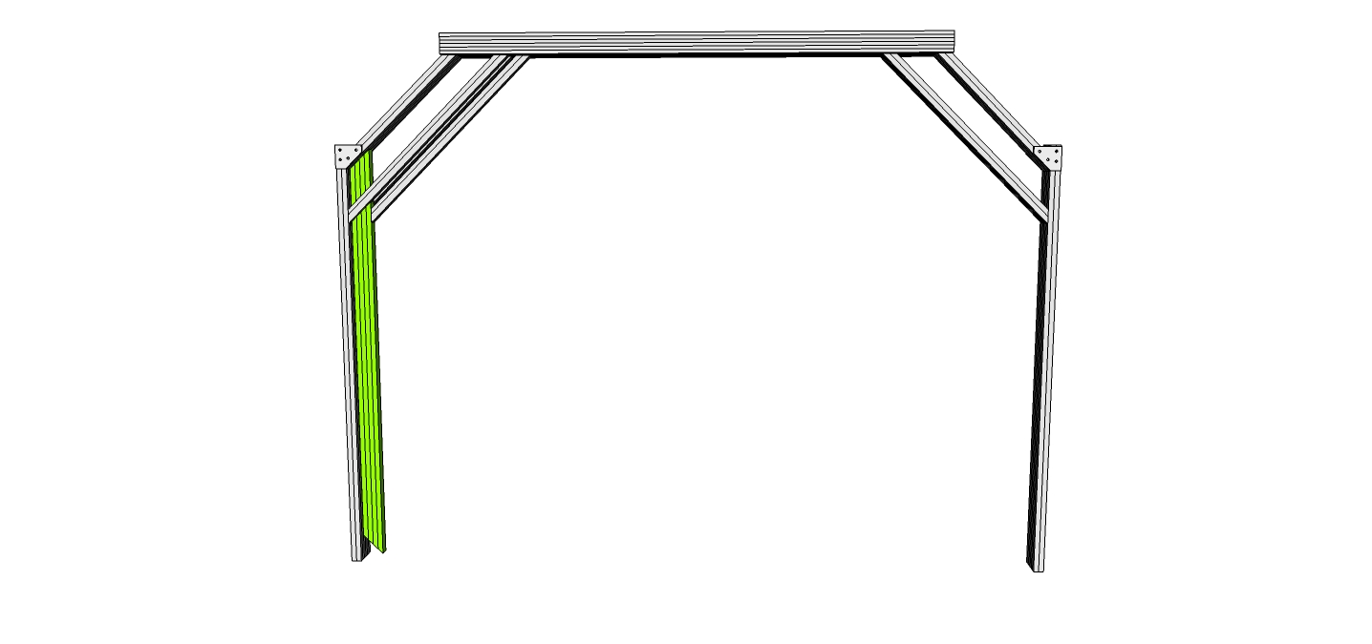

Step #9 Pre-Assemble Roll Actuator Mount as shown:

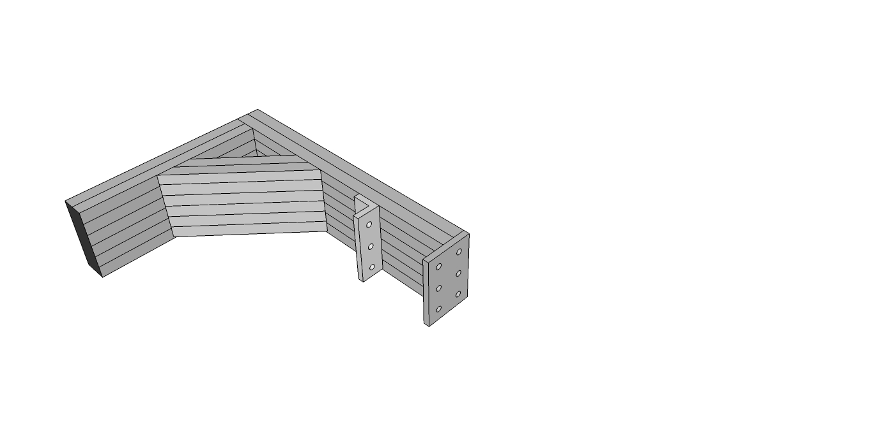

Step 9a – Take the Roll Actuator Mount (9230102). Preload three End Fasteners 9233381 into each of the three tapped holes.

Step 9b – Take the Roll Actuator Mount Support (9232571) 45 degree mitre cut profile, and slide one end into one side of the mount profile from Step 6a (9230102) align roughly in the middle of the profile and slightly tighten.

Step 9c – Take the Roll Actuator Support (Horizontal) (9230105) and slide through the loose T-Nuts of 9232571 and into place with the end fasteners of 9230102. Make sure to align the side with the tightening access holes with the end fastener side of the assembly. Tighten the end fasteners, tighten all 6 bolts on 9232571.

Step 9d – Prep a 6 hole 45 bracket on one side with (used 3393) three T-Nuts and Bolts and slide onto the Roll Actuator Support (Horizontal) (9230105) – Do not tighten.

Step 9e - Prep a 6 hole joining plate on one side with three T-Nuts and Bolts (used 3393). Then place the un-prepped holes over the tapped holes in the end of the Roll Actuator Support (Horizontal) (9230105), Take three of the BHSCS x .75” bolts (3065) and tighten into the tapped holes.

Step #10 – Slide the Pre-assembled Roll Actuator Mount arm into the Main End (Back) as shown. Tighten slightly to keep in place for now.

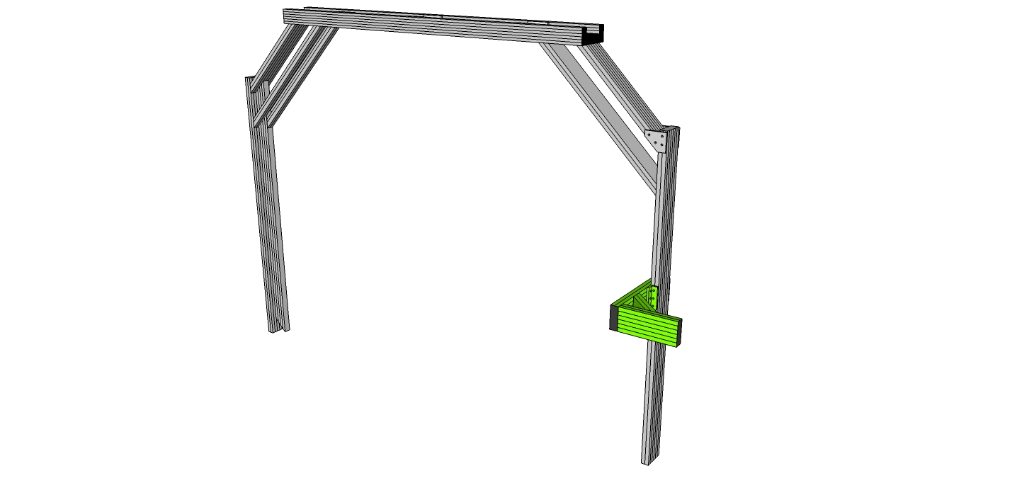

Step #11 Preload a three hole joining strip (9234118) with T-Nuts and 9233393 bolts. Slide three hole joining strips (9234118) to the outside channels of both main ends (Front and Back), (access at bottom of assembly), which will be used as mounting plate for knuckle bearings.

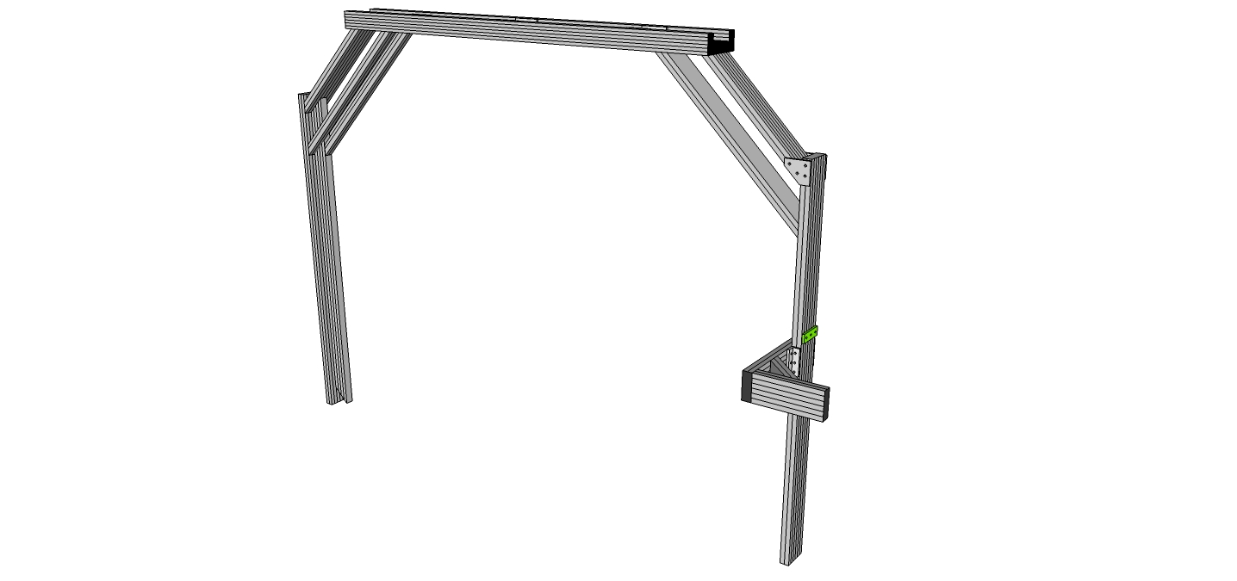

Step #12 – Prep two 6-Hole “L” brackets with T-Nuts and 9233393 bolts and slide into place on roll actuator mount as shown. Tighten into place, Then remove one end of T-Nuts on Rear Structural Support (9230113) – Slide from the bottom through the other side of the two 6-hole brackets and attach as shown to the upper rear 45 degree support. You may choose to use drop in T-Nuts, or loosen the 45 degree member to insert T-Nuts.

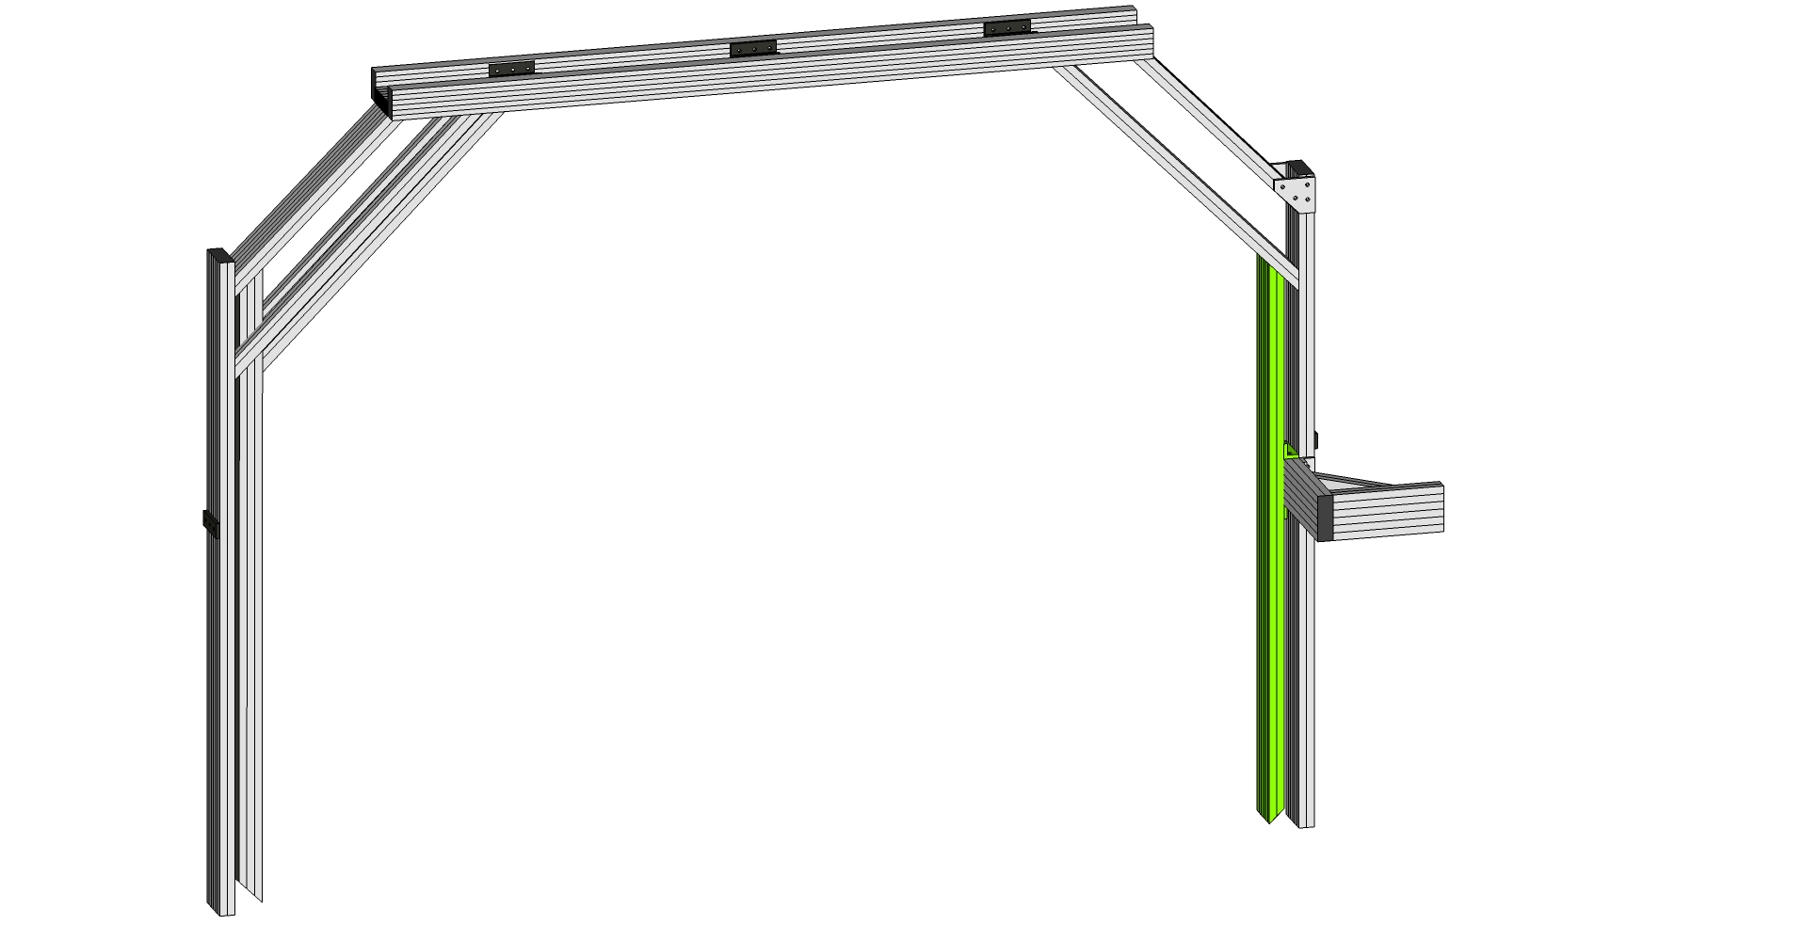

Step #13 – Prep two 6-Hole mounting plates with 4 T-Nuts and 9233393 bolts (on the corner holes as shown) Fix loosely to the rear structural support and the main rear roll member as shown. (Drop in T-Nuts may be used for the top assembly.) Then loosen the T-Nuts on two 6” 45 degree supports, removing the T-Nut from one side completely. Slide the 6” members into the top and bottom channel of the roll actuator mount and fix the other end to a center hole of the 6-Hole mounting plate. Tighten all bolts.

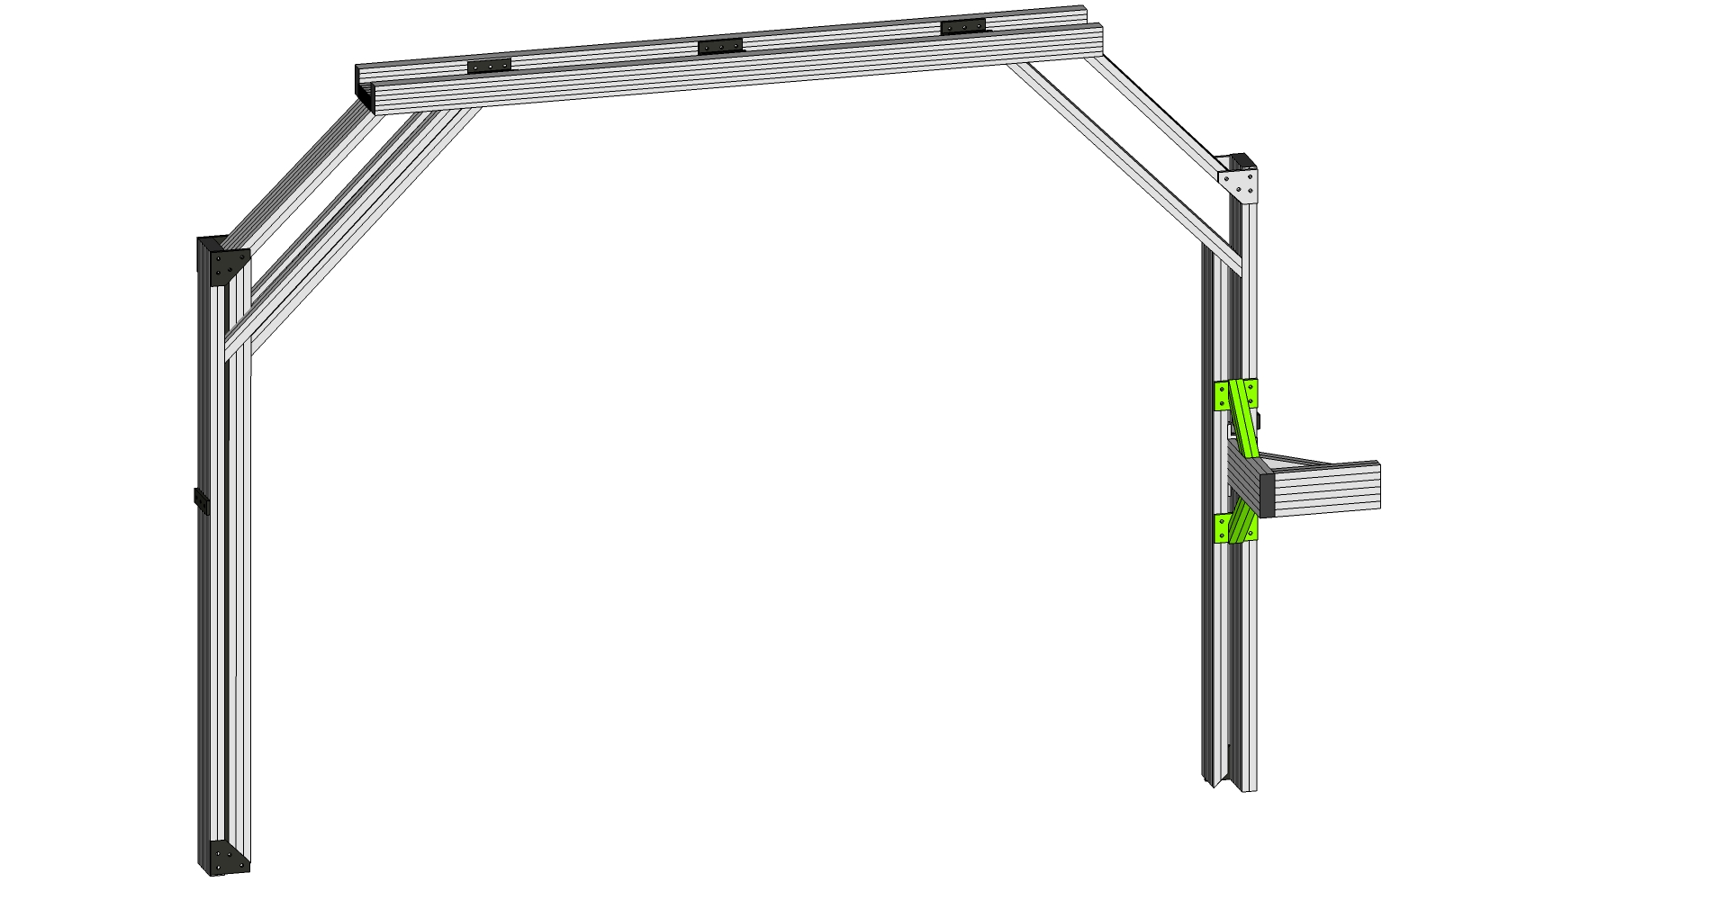

Step #14 Prep four 4 hole 45 degree joining plates (9234145) with four T-Nuts and Bolts (9233393). Then slide two of the prepped t-nuts into plate on the outer channel of the 12” 45 degree supports (9232572). Repeat on both sides of each of the 9232572 supports, four total. Tighten the two bolts that mate with the 9232572 on each, leaving the other two loose for the next step.

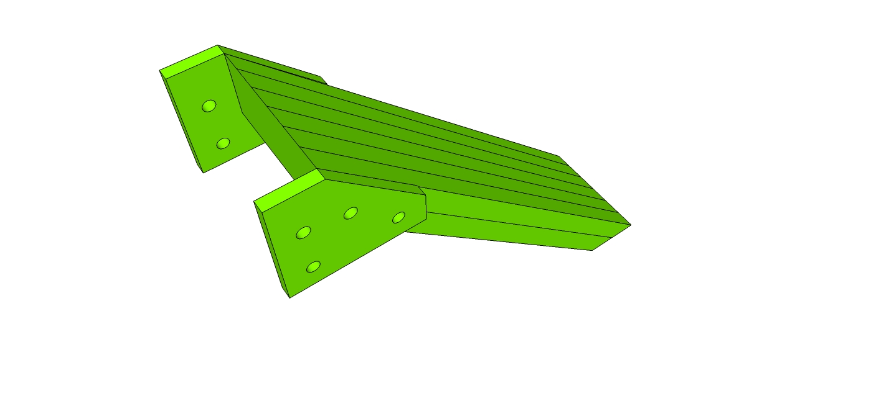

Step #15a Slide one 12” 45 degree support (9232572) into place as shown on the rear, inside member, and two 15” 45 degree supports (1x1 part 9230115) into the two outside slots of the front (inside face) vertical member as shown..

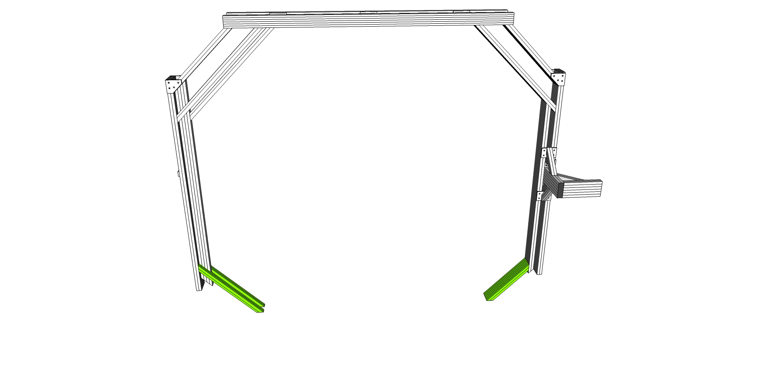

Step #15b Slide 12” 45 degree supports (9232572) with the 45 degree supports pre-mounted from step 14 into place as shown.

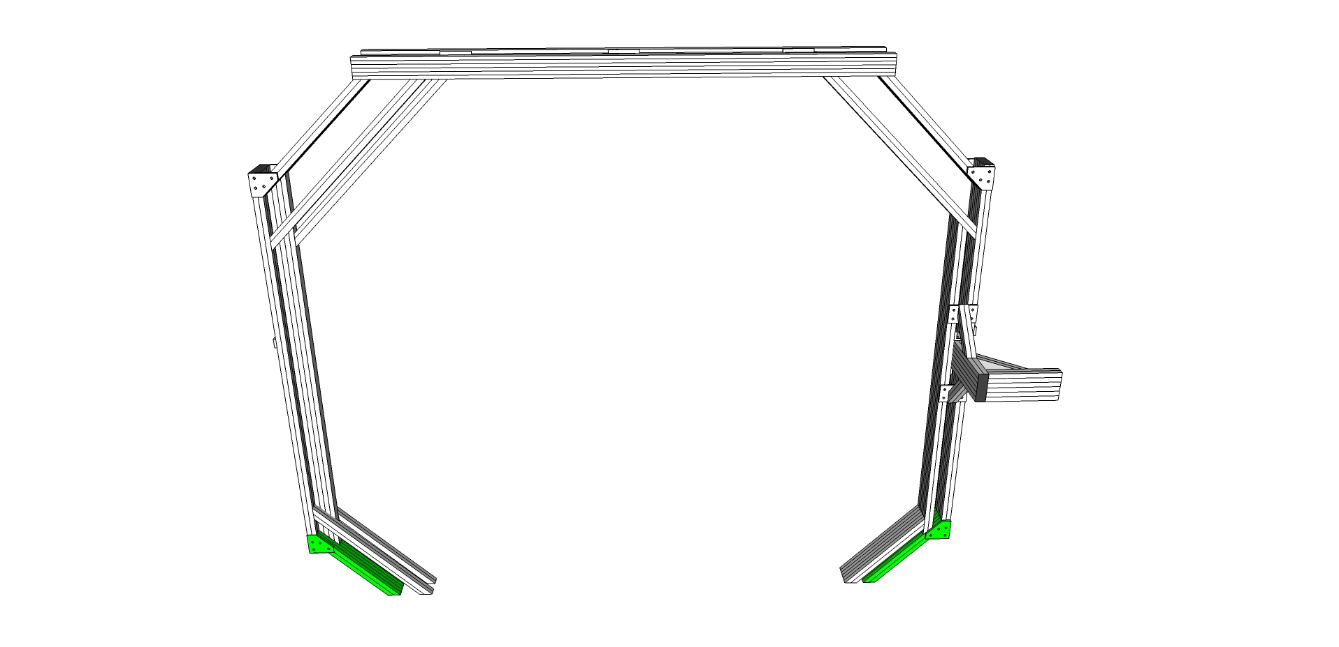

Step #16 Take Main Length (Bottom) (9230103) and slide the six connectors from Step #1 into the two outer T-Slots as shown. Space three connectors on each side evenly distributed. Do not yet tighten.



Step #17 Slide 2 T-Nuts in the top center channel (facing up) of the Main Length (Bottom) (9230103) and tape in place to use later to secure the knuckle. Then Prep ten (10) of the 3/8" long 1-4"-20 BHSCS (Button head cap screws) + Econ T-nut (9233416). Slide 5 on each side to affix the 1020 supports for bottom roll frame 9230110 supports to the main length (bottom) 9230103. Use the access holes in the upper channel of the 9230110 supports to line up and tighten each of the bolts, tightening the T-Nut into the outer slots of the main length (bottom) 9230103. Alternatively, you may choose to use tape to preset the t-nuts into their appropriate positions before sliding the 1020 supports for bottom roll frame (9230110). Additionally, each of the supports for bottom roll frame (9230110) must slide into the six hole connectors from the previous step, three on each side on the bottom T-Slot as show. Tighten all 46 bolts.

Once the three profiles are all secured together, slide the three top center channels of the sub assembly into the 12” 45 degree supports (9232572) on both ends of the roll frame. Tighten all 6 bolts securely.

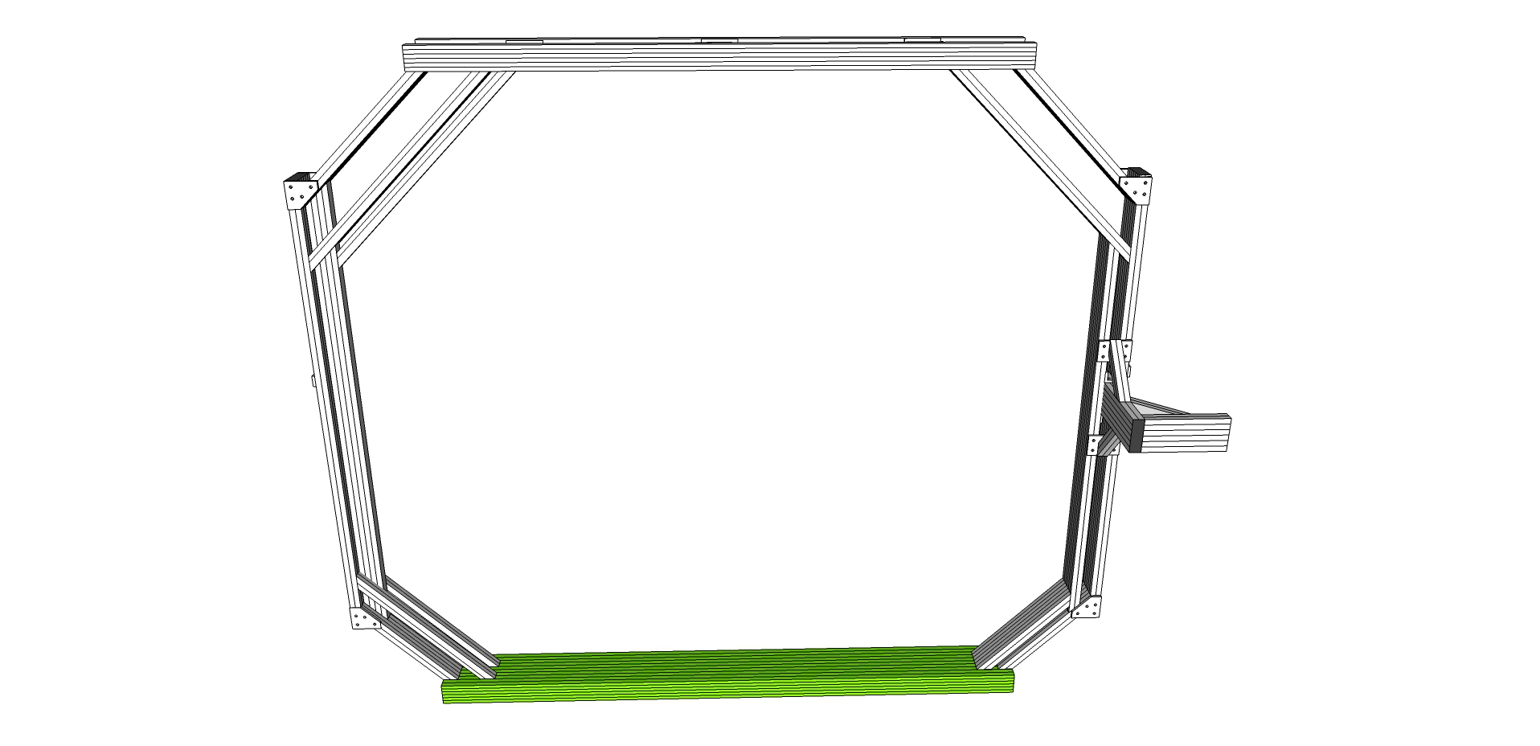

Step #18 Prep and Mount Lower Yaw Actuator Mount

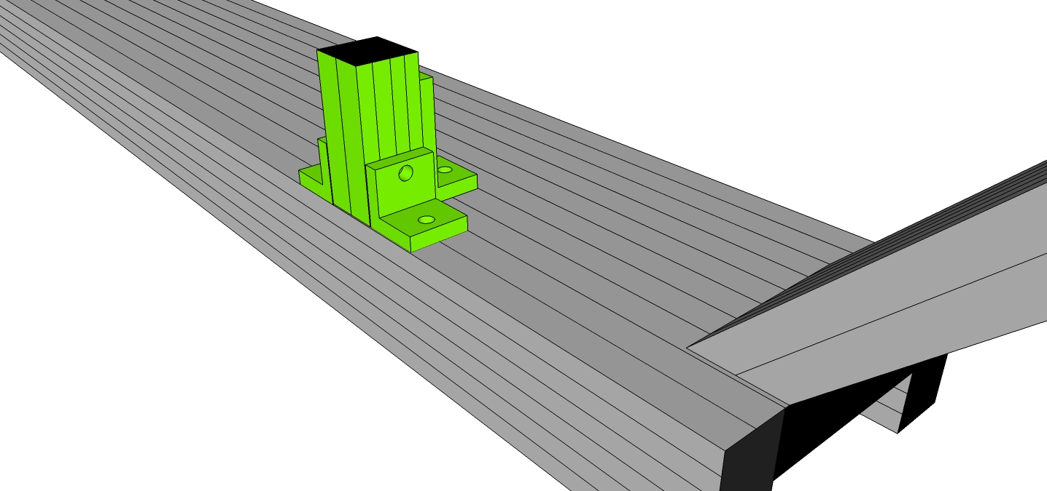

The lower yaw actuator mount is comprised of four parts: three 2 hole corner brackets 9234119, and one Actuator Stud Mount (9230108)

Step 18a – Take one of the 3 hole corner brackets and fix in place using a drop in T-Nut as shown. Tighten slightly.

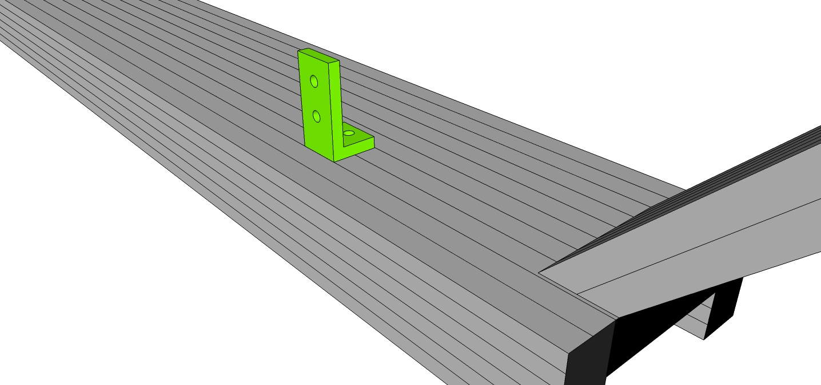

Step 18b – Prep the other three parts. Insert T-Nuts/Bolts into the remaining two 2 hole corner brackets and then slide into place as shown into the Actuator Stud Mount (9230108)

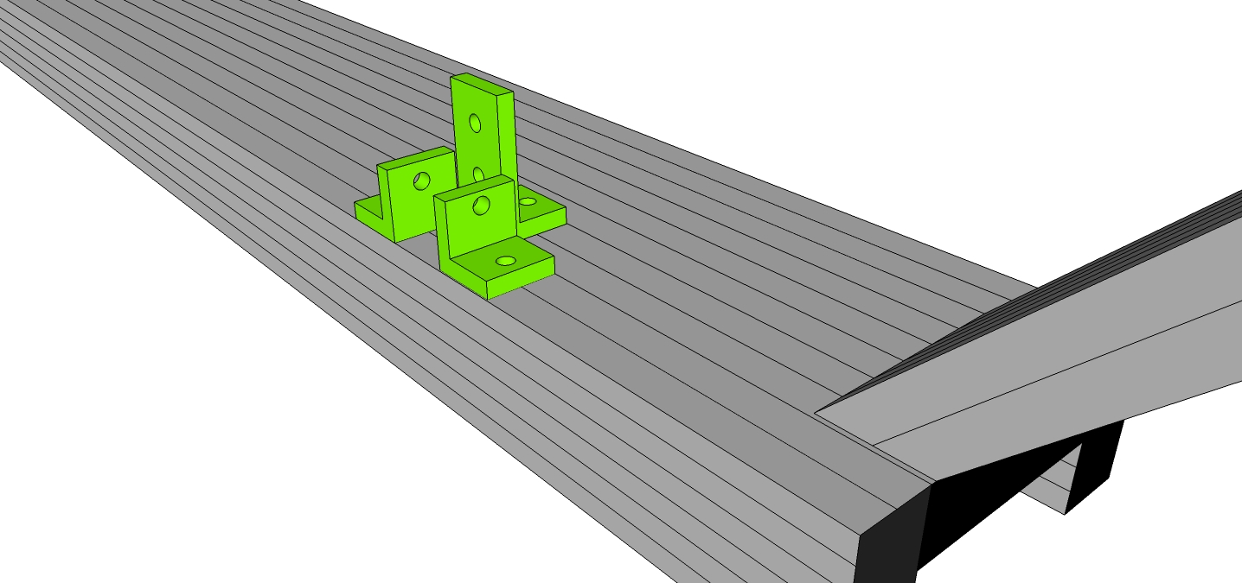

Step 18c – Slide the Stud (9230108) aligning with the 2 hole brackets from Step 16b and three hole bracket from Step 16a. Tighten.

The completed assembly should look like:



# 

# Assembling Pitch/Yaw Frame

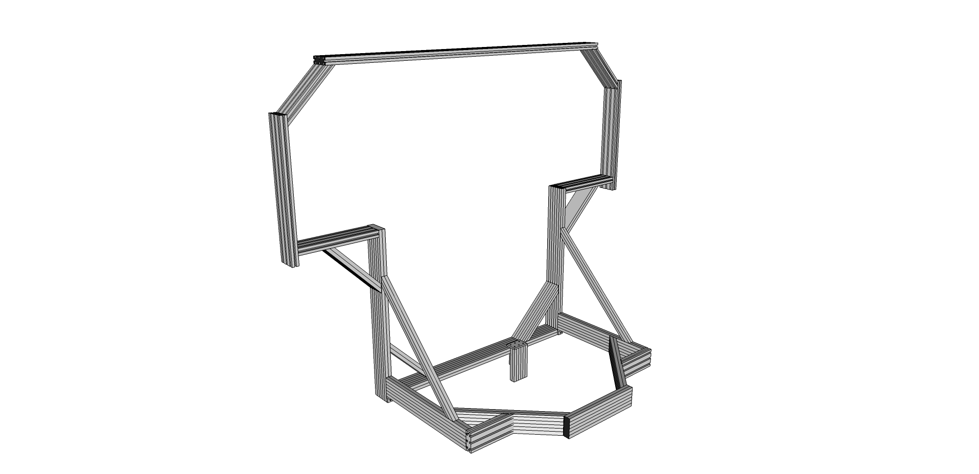

Step #1 – Start by assembling the rear subassembly of the pitch/yaw frame. Take the Back profile (9230207) and two 1x3 45 degree supports (9232573) and slide into place as shown. Square and flush the corners. Tighten.

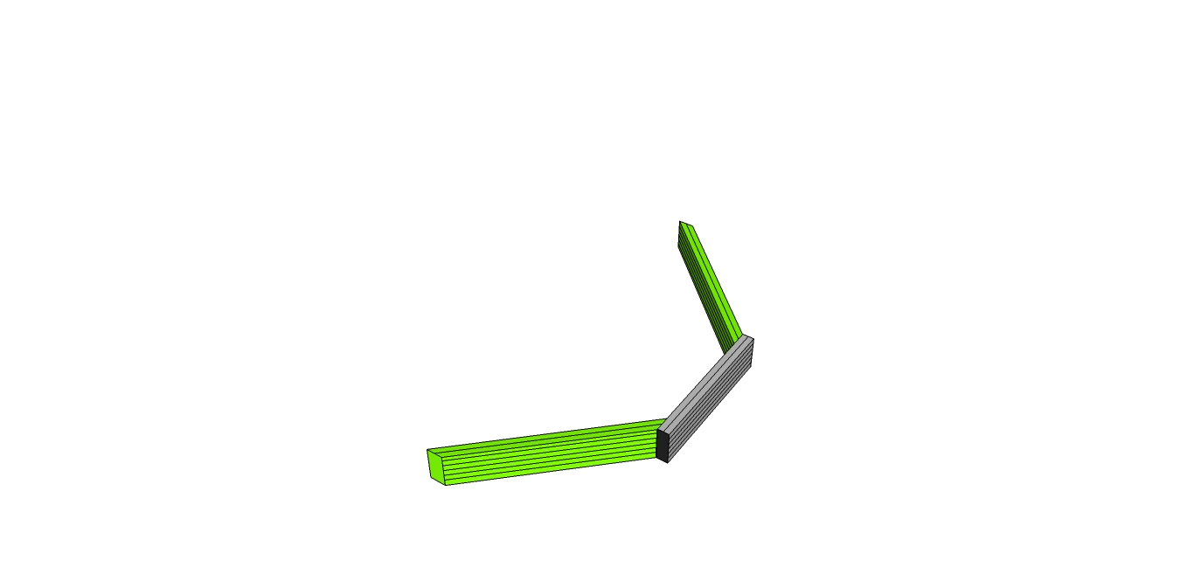

Step #1b – Attach the Lower Triangulated Supports (9230213) as shown. You will need to loosen the T-Nuts and bolts on the mitre cut side of this assembly and slide loosely onto the two 9232573 assemblies from Step #1.

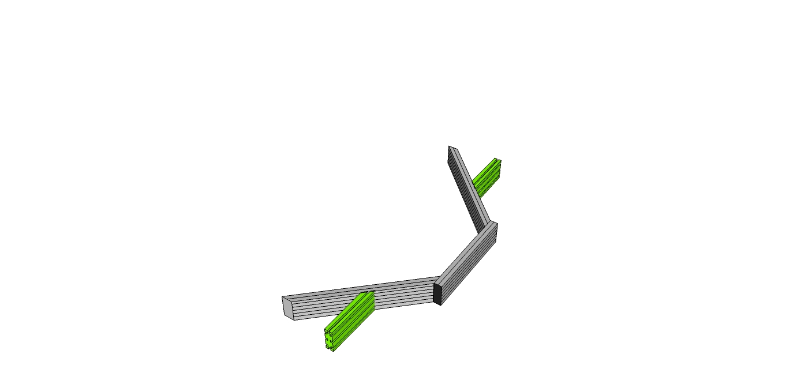

Step #2 – Take the Lower Horizontal Sides (9230210) and slide loosely into place on the 9232573 supports from Step #1. Prep each 9230210 side frame with six end fasteners (three on each end) and then tighten all bolts.

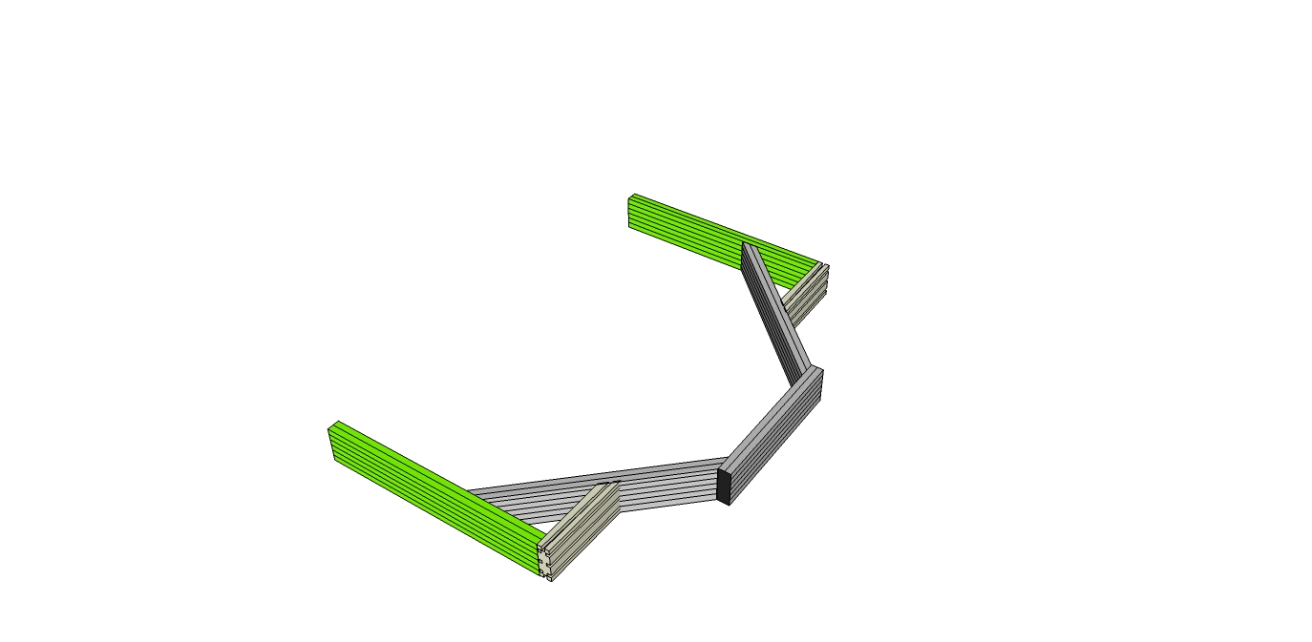

Step #3 – Take the 1x1 45 degree custom supports (9230206) and slide into the top slot of the Lower Horizontal Sides (9230210). Line up the front side faces of 9230206 and 9230210 and tighten. Set aside this sub assembly for now.

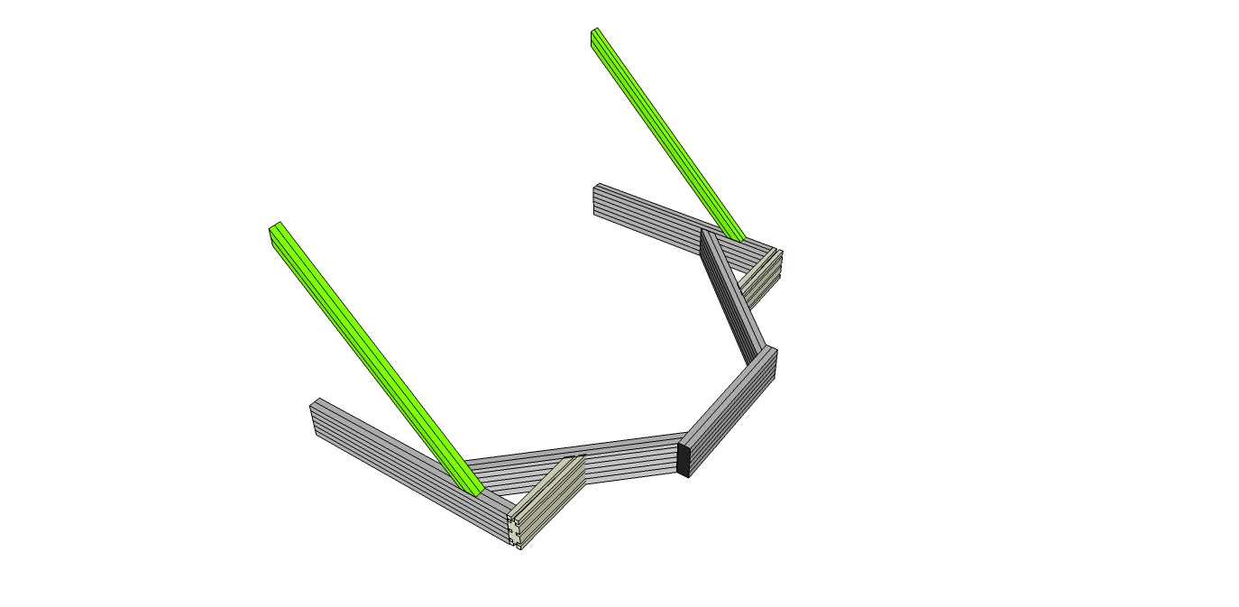

Step #4 – Assemble the front subassembly of the Pitch/Yaw frame. Prep the Upper Yaw Actuator Mount.

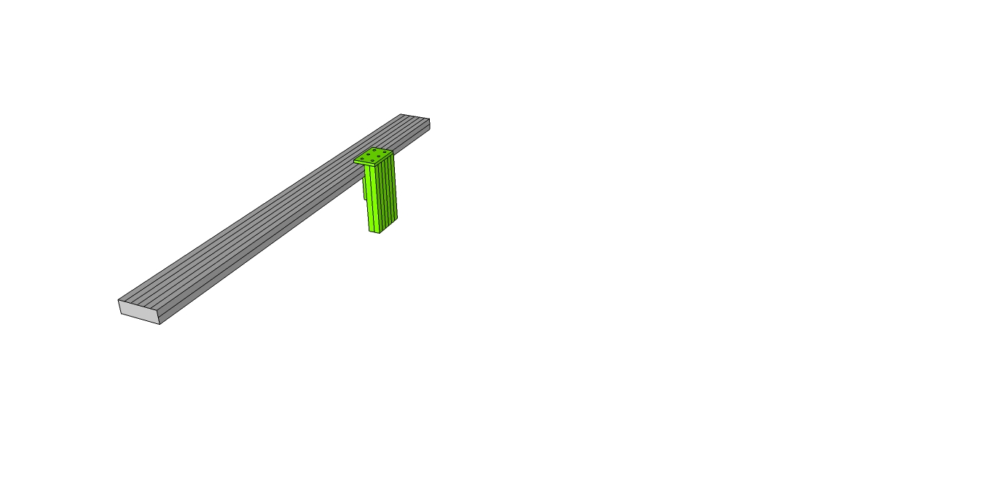

Step 4a – Prep a 6 hole joining plate (9234166) on one side with T-Nuts and bolts(9233393). Slide into the top rear slot of the Bottom (9230202).

Step 4b – Prep the 12 hole inside corner bracket with T-Nuts and bolts (9233393). Slide into bottom center and rear slots and line up with the 6 hole plate from Step 4a.

Step 4c – Slide the Actuator Mount (9230212) from the bottom, thru the 6 T-Nuts of the 12 hole joining bracket and lined up with the 3 open holes of the 6 hole joining plate. Make sure the tapped holes side is up.

Step 4d – Use BHSCS (3065) thru the three open holes and tighten into the tapped holes of the Actuator Mount (9230212) Leave the other bolts/T-nuts slightly loose to allow the mount to slide along the profile for positioning when the actuator is actually mounted.

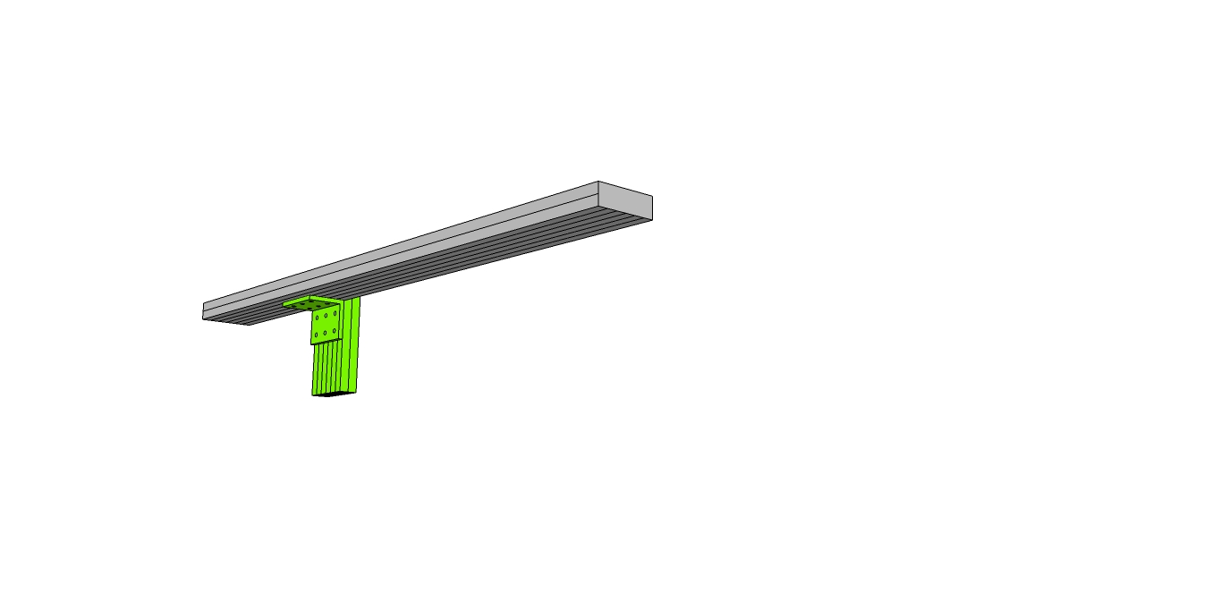

Step #5 – Slide a 12” 1030 45 degree mitre cut profile (9232572) from each end of the Bottom (9230202). Line up the outside faces and tighten.

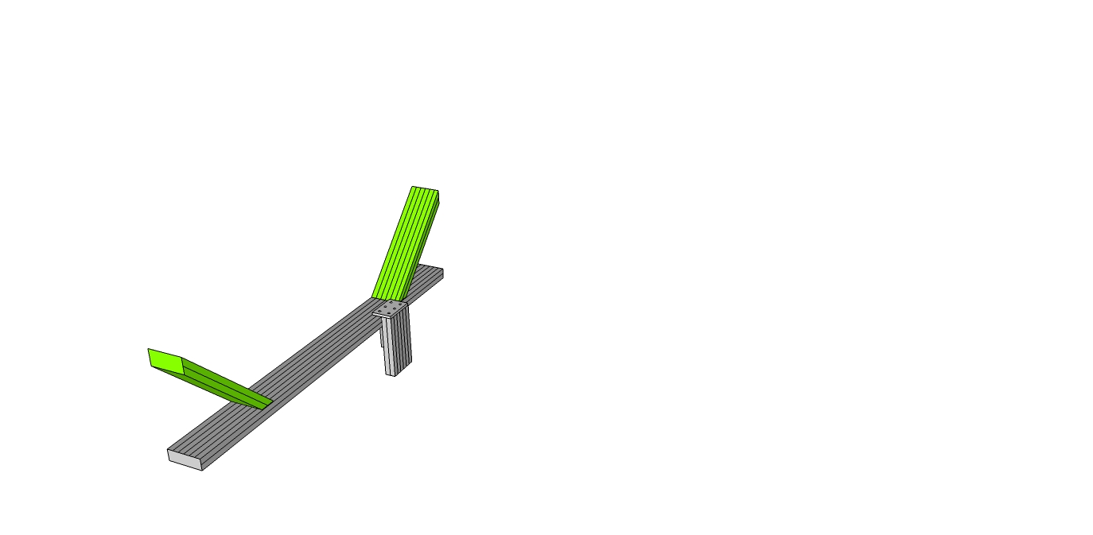

**Important - Slide 2 T-Nuts into the center channel on the bottom side of the 9230202 and tape in place to use later to secure the knuckle.**

Step #6 – Prep the ends of the bottom (9230202) with end fasteners, three on each side. Then slide the Main Lengths (Lower Vertical Sides) (9230201) into place, making flush and square with the Bottom (9230202)

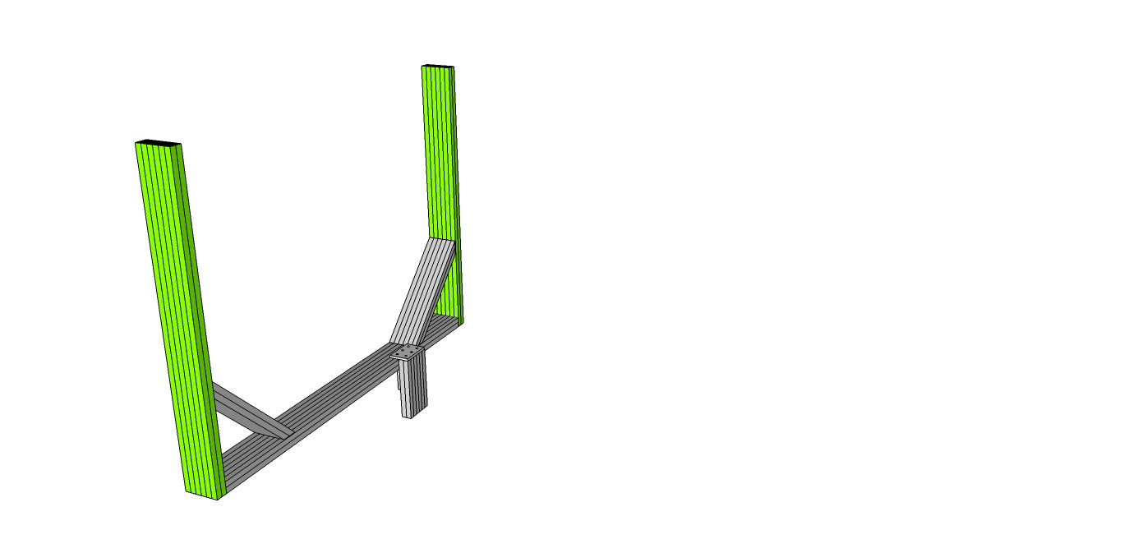

Step #7 – Prep two 2 hole corner brackets with T-Nuts and Bolts. Slide from the bottom on the rear slot of the Lower Vertical Sides (9230201) Make flush and square and tighten.

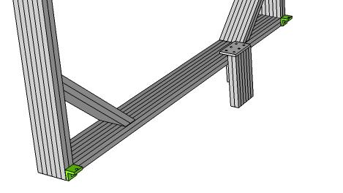

Step #8- Slide two 1x3 12” supports (9232572) into place as shown. Align the top tip of the profile with the top face of the Lower Vertical Sides and tighten.

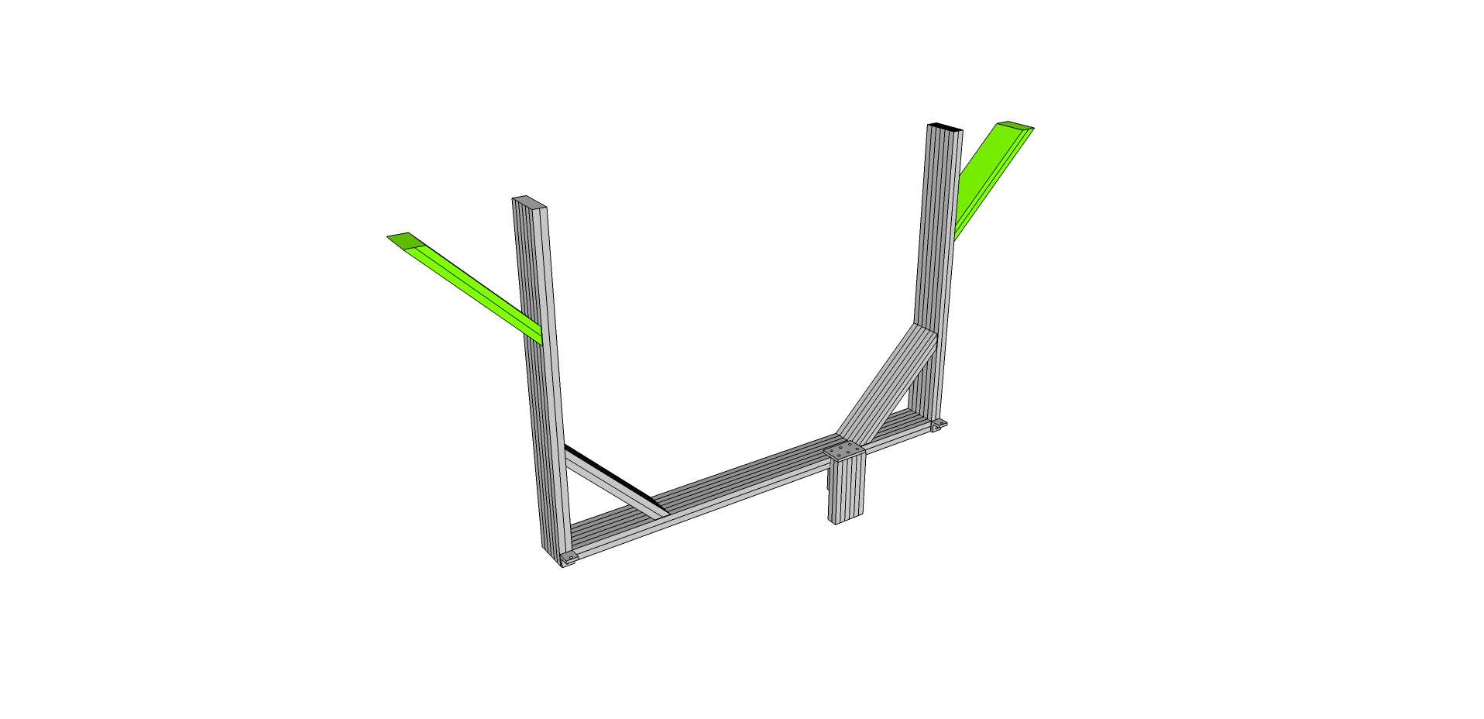

Step #9 – Prep the Horizontal Sides (9230204) with end fasteners on each end. Then fasten as shown to the Lower Vertical Sides and tighten.

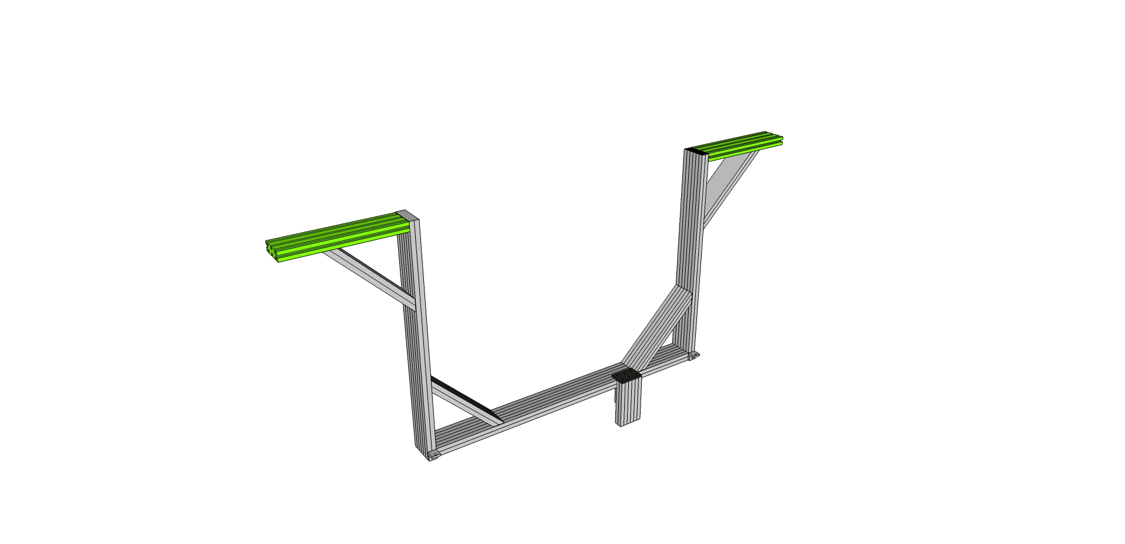

Step #10 – Slide the Upper Vertical Sides (9230211) on either side thru the end fasteners of the Horizontal Sides (9230204) and the T-Nuts of the mitre cut support (9230208) Tighten all bolts. (Make sure that the access holes in the Upper Vertical Sides are aligned with the Horizontal Sides (9230204)

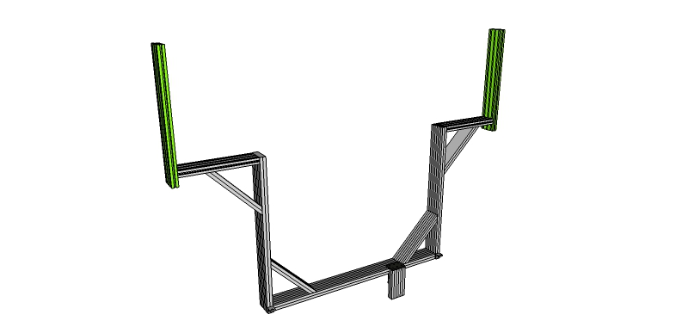

Step #11 – Slide the 10” mitre cut supports (9230209) into the inside slots of the Upper Vertical Sides as shown. Make square and flush and tighten.

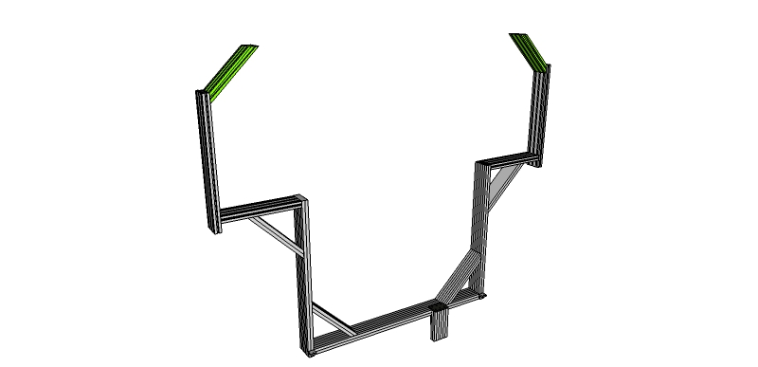

Step #12 – Slide the Top (9230203) into place as shown and tighten.

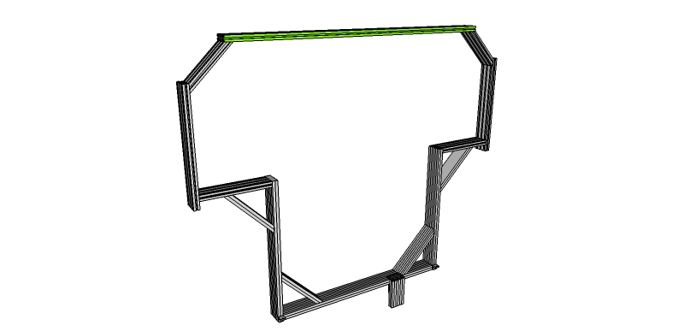

Step #13 – Attach the front and rear subassemblies. You will need to slide the rear subassy onto the front subassy. Make sure the bolts on the custom 1x1 45 degree supports (9230206) have been loosed and that end fasteners are in place on the Lower Horizontal Sides (9230210). It would be easiest to use drop-in T-Nuts for the bottom nut/bolt on the two hole brackets on the Lower Vertical Sides (9230201) Tighten everything, all six end fasteners, two bolts on the custom 1x1 45 degree supports, and two bolts on the underside 90 degree brackets.

Step #14 Attach three hole joining strip (9234118) to be used as mounting plate for knuckle bearings.

Step #14a One is to be installed on the inside of both vertical members to support knuckle bearing for final assembly stage.

Step #14b Pre-assemble three 9233321 T-Nut and Bolt to each plate.

Step #14c Slide plate onto inside of Main Lengths (Upper Vertical Sides) (9230211) - locate using the knuckle bearing to measure the distance for fastening. The knuckle bearing top surface should be flush with the top of the Main Vertical (9230903). DO NOT attach the knuckle bearing at this time. Set aside til later once the three hole plate has been positioned.

Step #14d To tighten place T-handle hex wrench into 9233321 tightening clockwise

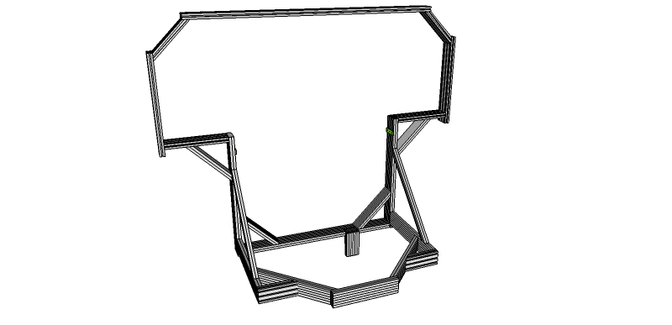

Your Yaw/Pitch frame should look like:

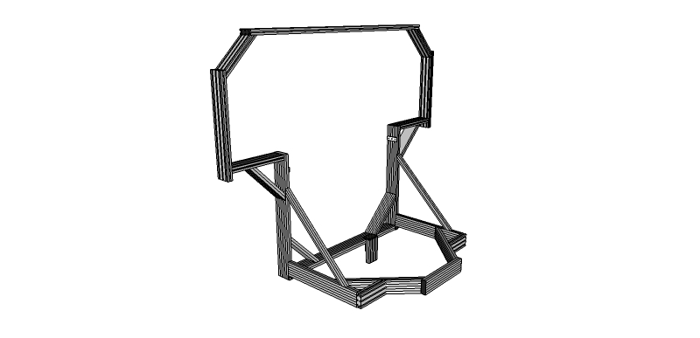

# Cockpit Assembly

The assembly of the cockpit is done in several sub assemblies and is pieced together throughout the build process.

## SubAssy Cockpit Bottom and Front

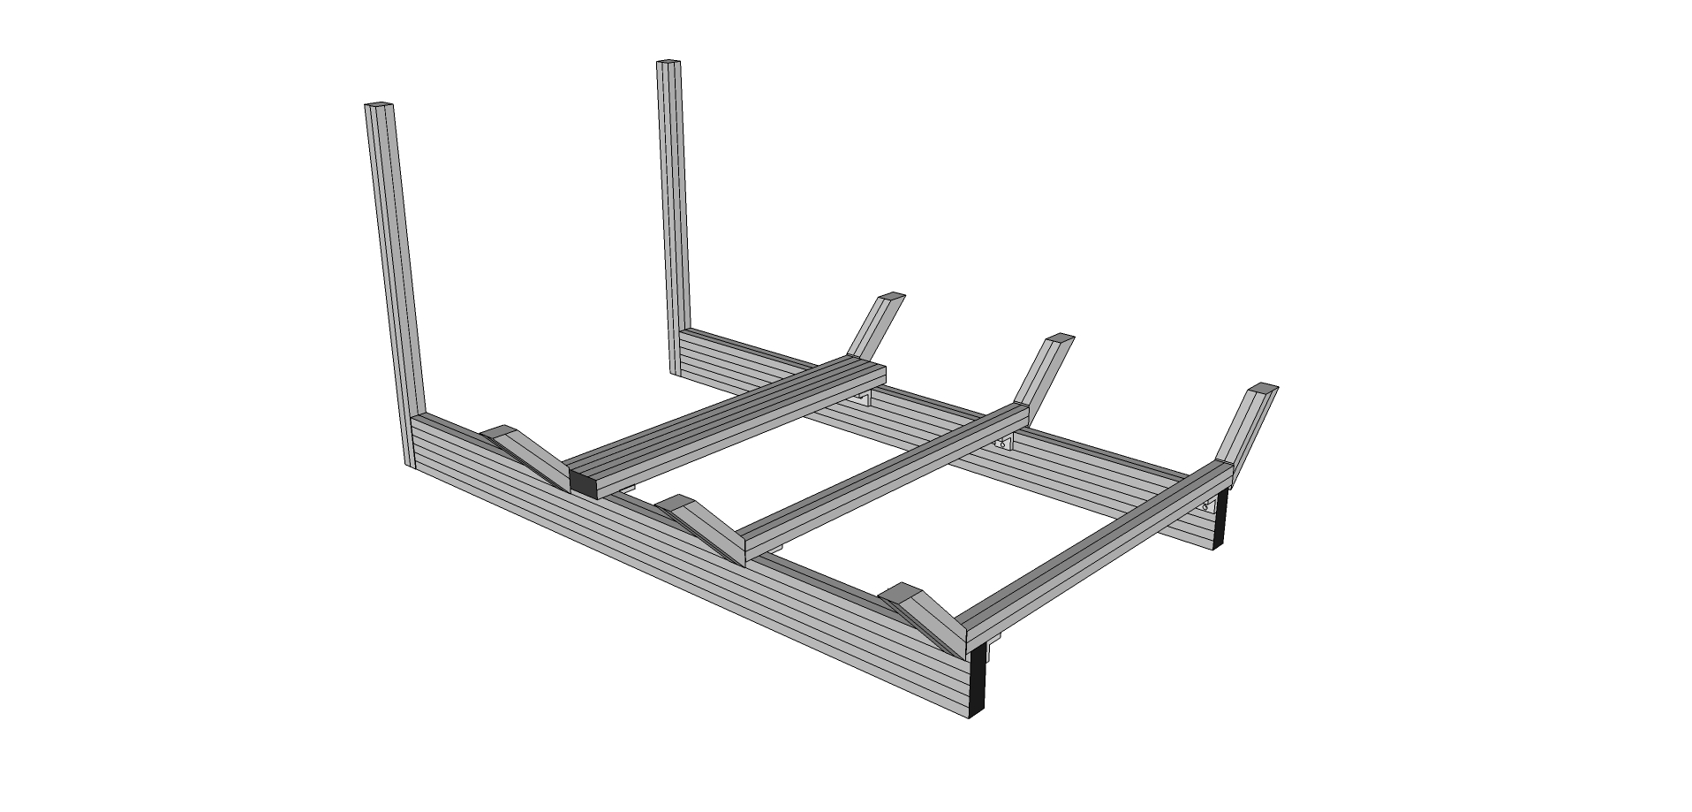

Step #1 Prep Two Bottom Rails Frame (9230301) with 6 End Fastener Assemblies (9233381). Orient the Two Bottom Rails approximately 16” apart on their 1” sides. It is important to make sure the single tapped hole end is the top hole for Step #7 correct positioning.

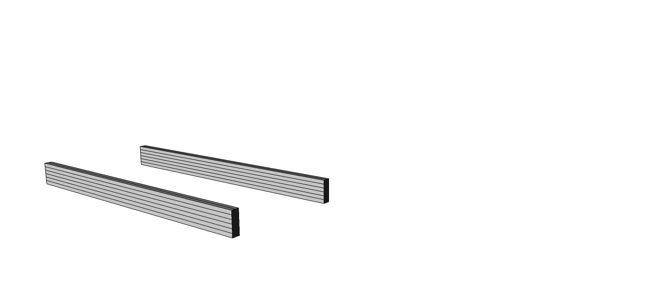

Step #2 With the End Fasteners (9233381) slightly loosened, slide the (Front Vertical) 9230303 into place over the End Fasteners flush to the bottom of rail. When aligned, the access hole on the mating profile should align with the BHSCS. To tighten the connection, place a T-handle hex wrench into access hole until the wrench head inserts into the BHSCS. Tighten all three clockwise until secure forming a 90 degree angle between Bottom Rails 9230301 and Front Verticals (9230303).

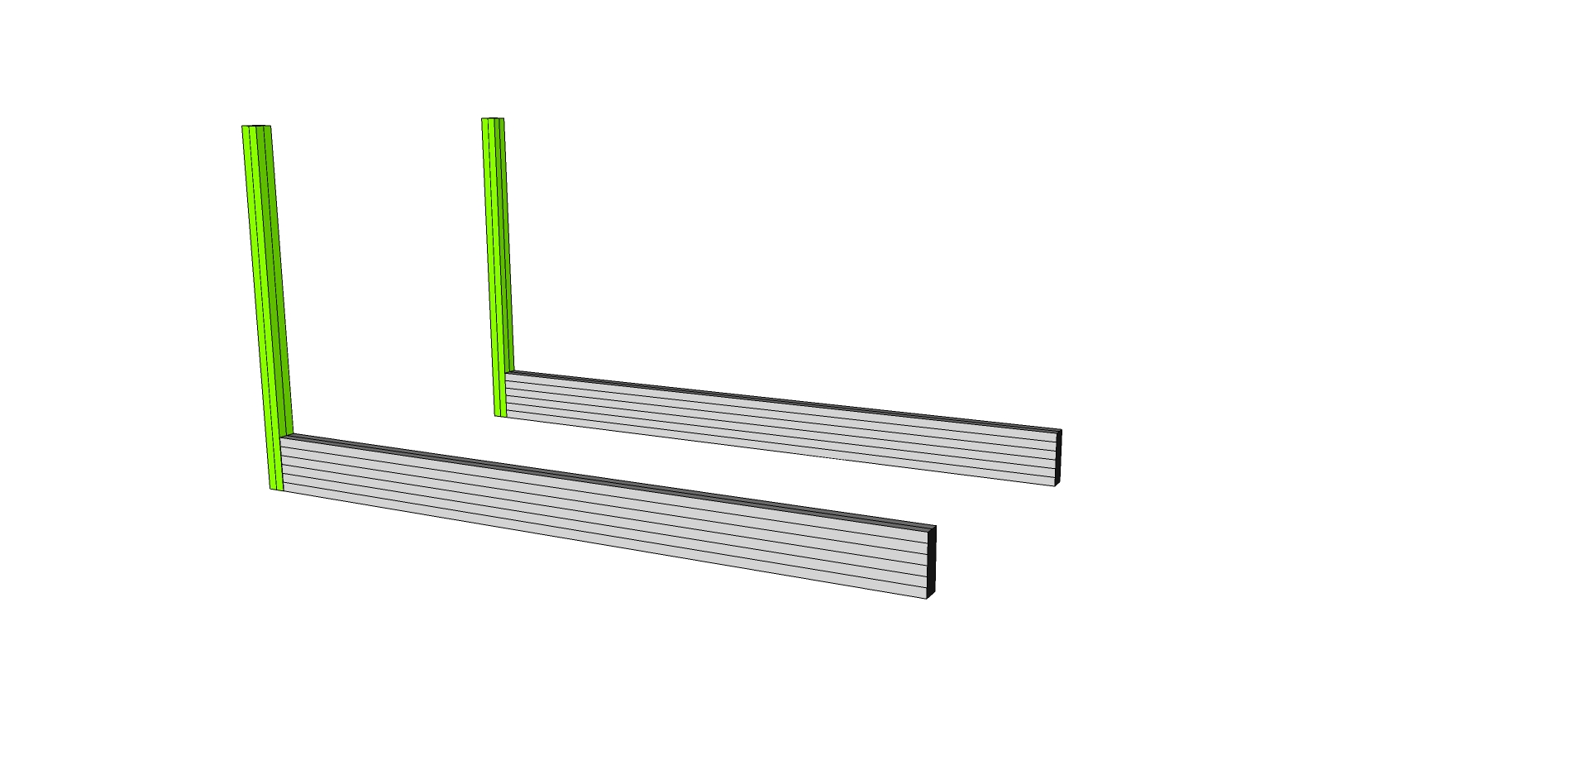

Prep Two Front Verticals (9230303) with the *bolts* of 2 End Fastener Assemblies (9233381) on the top holes. **IMPORTANT: Use only the 9233065 bolt without the Wing Clip.**

Step #3 - Prep four 2 hole inside corner bracket connectors (9234119) with 8 of the Econ T-Nuts and Bolts 9233393 and two 6 hole inside corner brackets (9234015) with 12 of the Econ T-Nuts and Bolts 9233393. Keep the nuts loose to allow sliding into place.

Slide 1 six-hole, then 2 two-hole brackets (9234119) into the top inside channel of each of the Bottom Rails (9230301). Tighten Brackets at 25”, 12 1/2” and 1/2” on center from back of Bottom Rail.

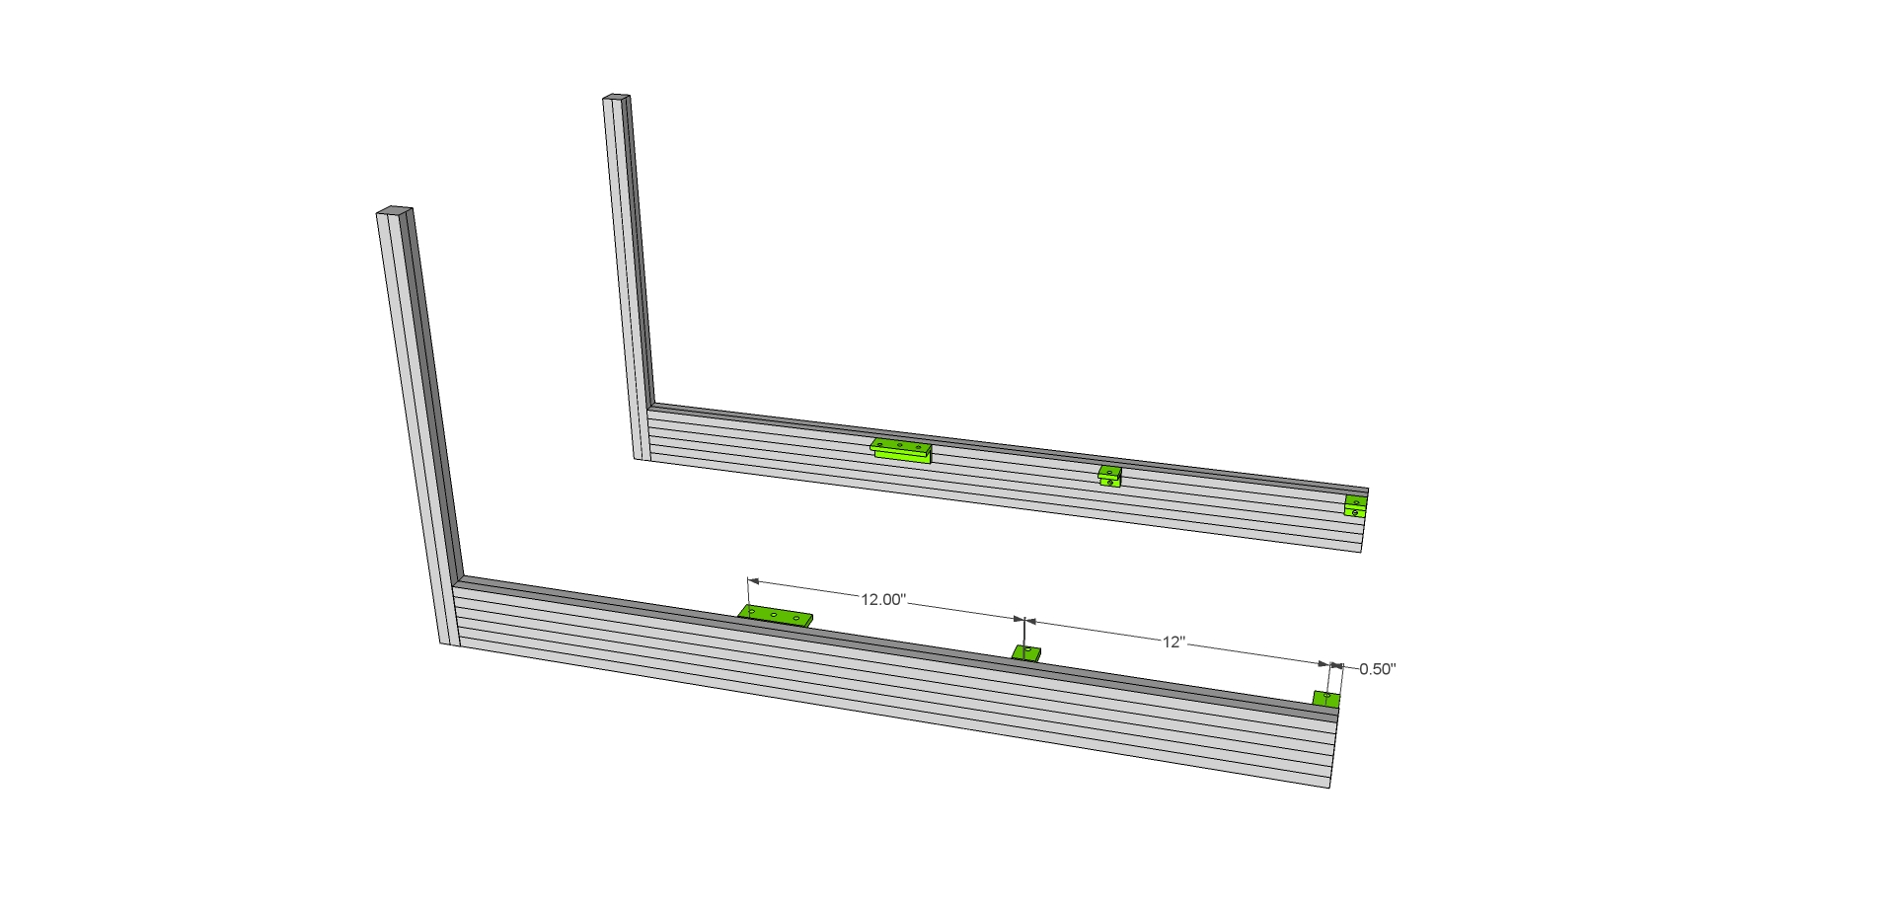

Step #4 With the Econ T-nuts slightly loosened, slide all three (Front, Center, Back) Main Lower Cross Members (9230309 & 9230309F) as shown. Tighten Brackets on Cross Members leaving 3” hanging out on each over the Bottom Rail.

**IMPORTANT: Slide 4 T-Nuts into the top channels of both the rear and the middle cross members. These will be used for seat mounting later and will be trapped inside the channel on the next step. Slide 4 in each if using the normal seat configuration or 2 in each if using the wide seat configuration. Consult the Seat Mounting SubAssy instructions later in this section to determine which seat mounting configuration is right for your seat.**

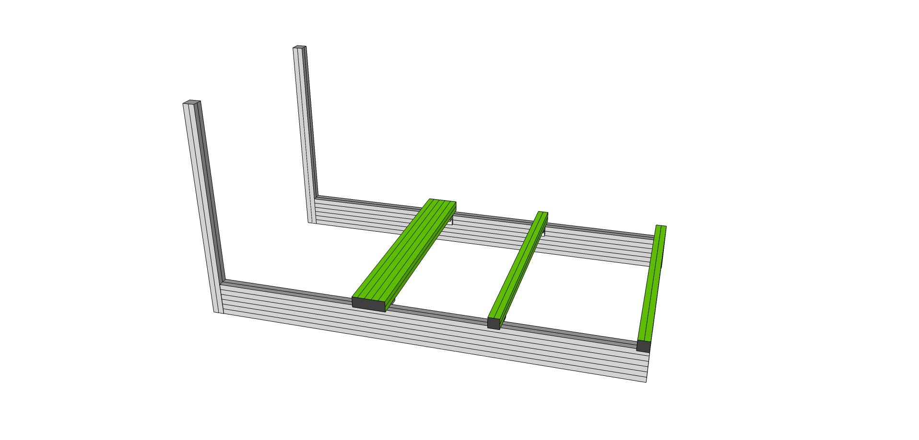

Step #5 Remove Econ T-nut (but leaving the bolt and washer) on six 6” 45 degree supports (9232565) and attach to the Cross Members as shown.

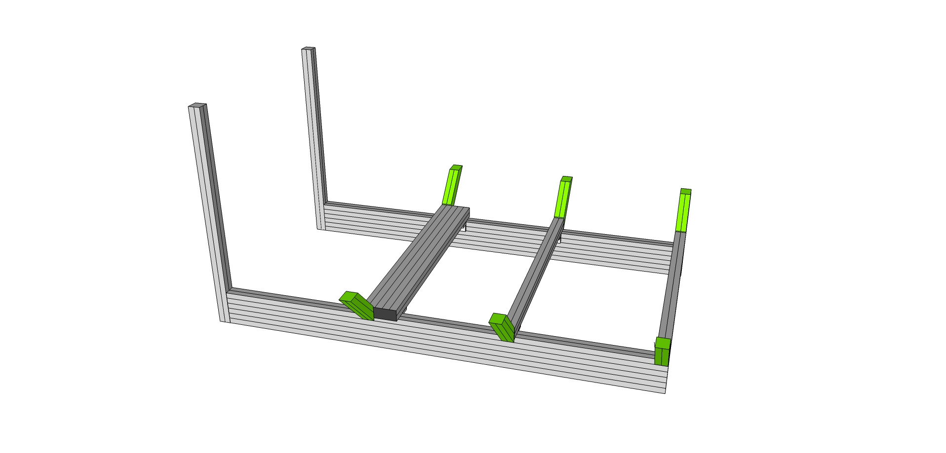

## SubAssy Cockpit Rear

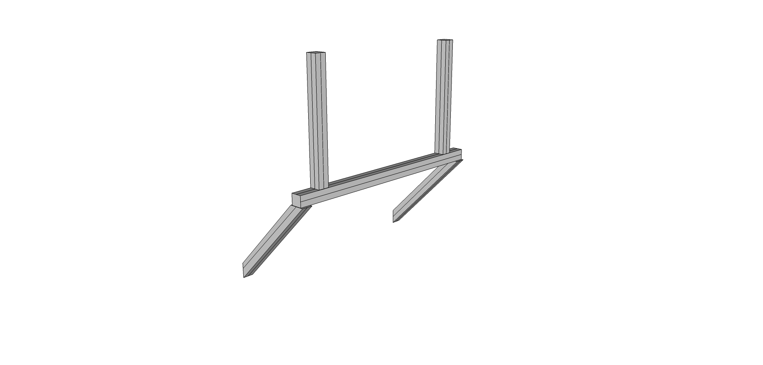

Step #1 Loosen T-nuts on two 12” 45 degree supports 9232570.and slide into the bottom slot of the Bottom Rear Horizontal Cross Member (9230332).and attach as shown. Tighten Slightly.

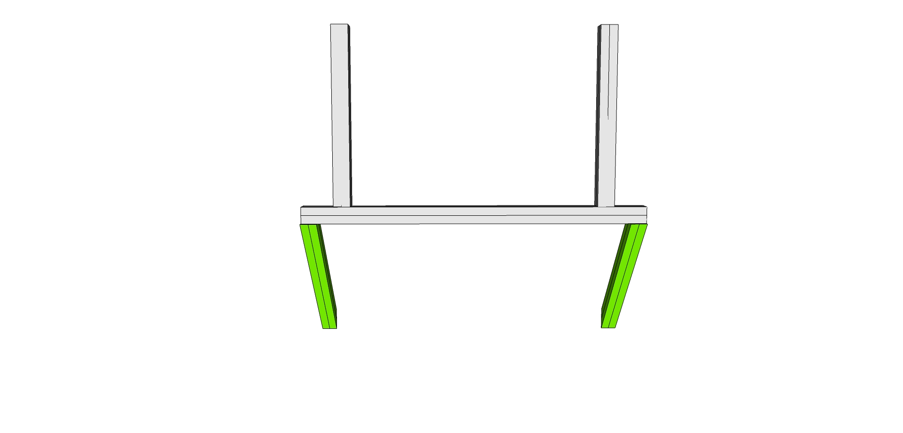

Step #2 Prep Slide three (loose) end fasteners (9233381) in the “top” channel (For the pitch actuator frame) and then with end fasteners (9233381) on the ends, bolt into each pre tapped Rear Vertical (9230310) in place as shown. Tighten.

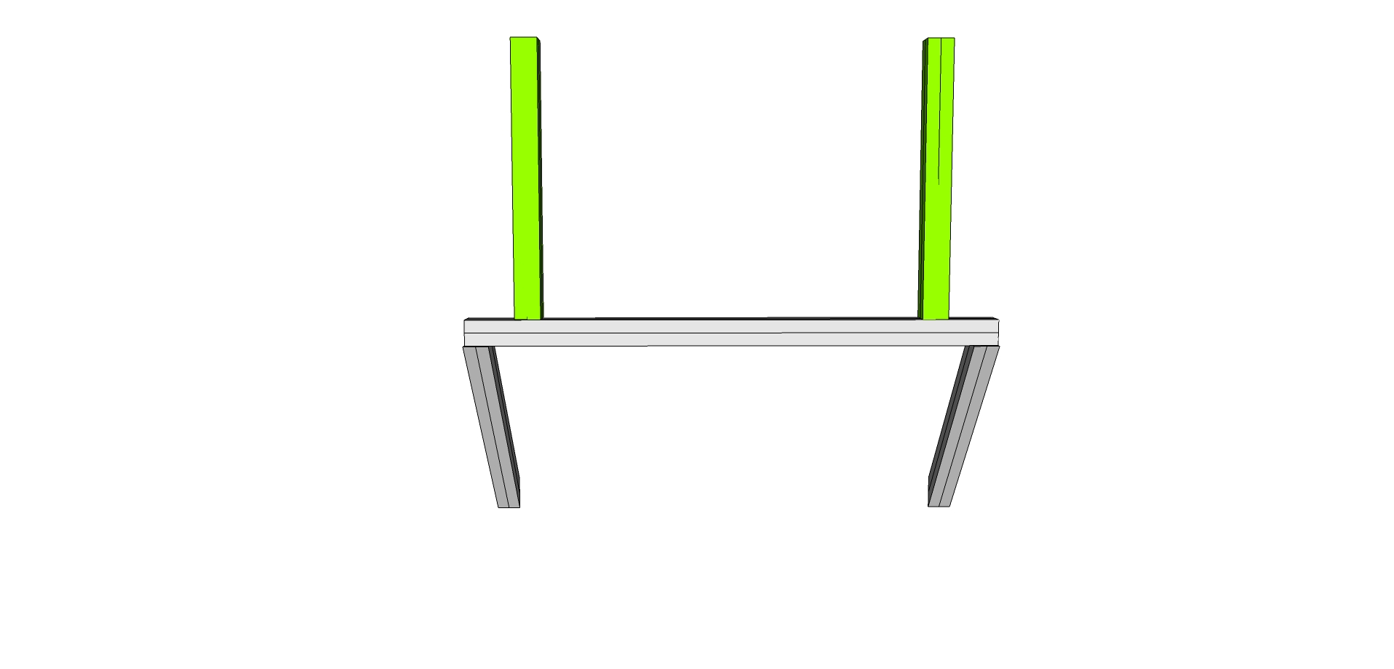

Step #3 Prep Two Rear Verticals (9230310) with the *bolts* of 2 End Fastener Assemblies (9233381) on the top holes. **IMPORTANT: Use only the 9233065 bolt without the Wing Clip.**

## 

## Attach SubAssy Bottom and Front to the Rear

Remove the T-Nuts and bolt the lower half of the rear subassy into each pre tapped top hole of the Bottom Rail (9230301) and attach as shown. Tighten.

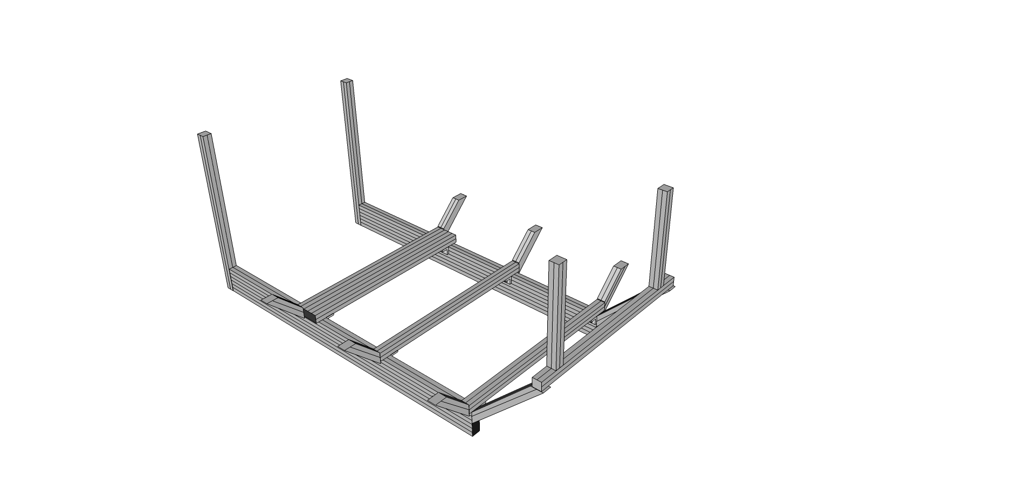

## 

## SubAssy Cockpit Sides – BUILD 2

Step #1 Take four 6” 45 degree supports (9232565) and slide one of the loosened ends onto each one of four Lower Sides (9230314 and 9230314B)

Step #2 Prep all four of the lower sides (9230314 and 9230314B) with End Fasteners (six 9233381 fasteners in total).

Step #3 Slide the pre tapped ends of four of the Main Verticals (9230313) through the loosened 6” 45 degree supports (923265) and into the end fastener of the Lower Sides (9230314 and 9230314B) forming a 90 degree angle as shown. Two of the assemblies will use the 9230314 lower side with counterbores, the other two will use the standard 9230314 part without the counterbores for the anchor fasteners. (The channels with the counterbores for the anchor fasteners should be oriented toward the front and back, and not outside/inside.) Tighten the end fasteners. You should have four assemblies that look like:

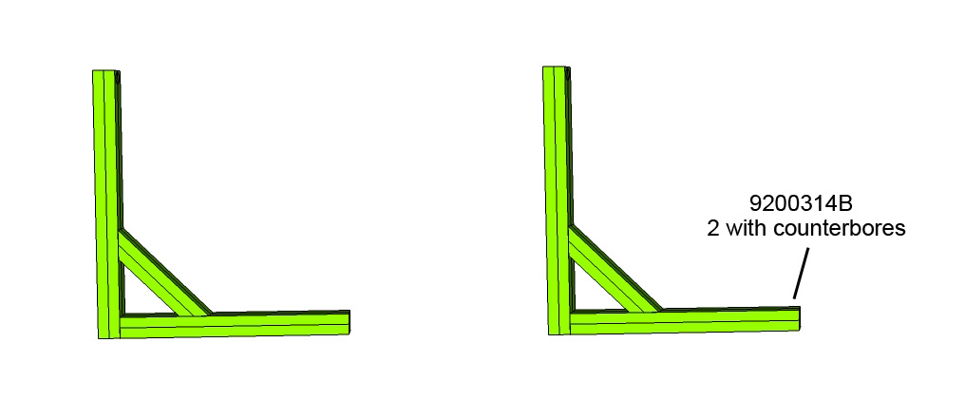

Step #4 Take the two remaining main verticals (9230313) and attach two 12” 45 degree supports (9232570) as shown. Make sure the access hole is on the bottom and the anchor fastener end is at the top. (The channels with the counterbores for the anchor fasteners should be oriented toward the front and back, and not outside/inside.)

Step #5 You should have two assemblies that look like:



Step #6 Take one of the four assemblies from the previous steps and one of the assemblies from the last step, attach using the end fastener in the lower side, through the main vertical as shown

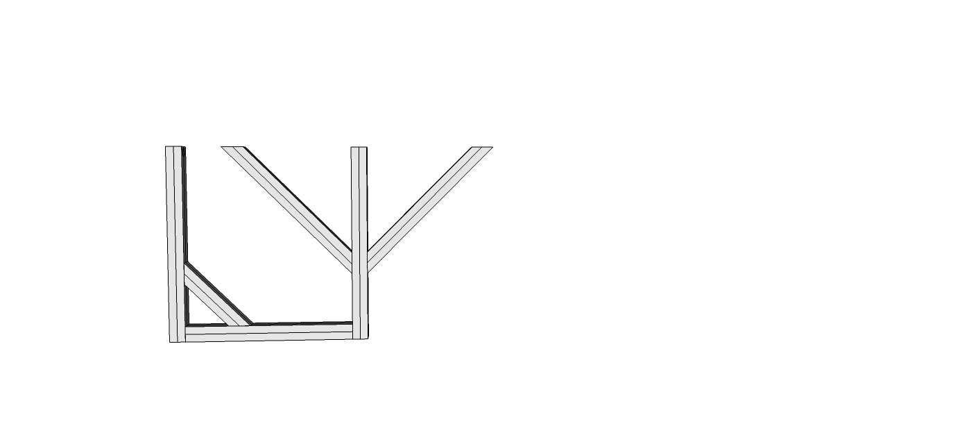

Step #7 Then, attach another one of the four assemblies and fasten to the other side as shown using two anchor fasteners (9233395) in each.

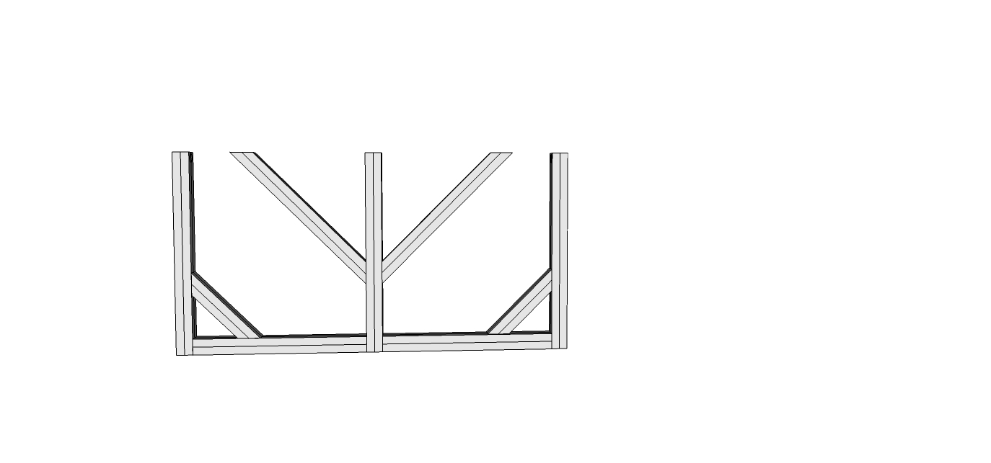

Step #8 Repeat with the other assemblies to end up with two sides that look like the assembly in the previous pic, then attach the sides to the cockpit assembly using the 6 bolts from the 6” 45 degree supports (9232570), bolted into the tapped ends of the main verticals (9230313) as shown.

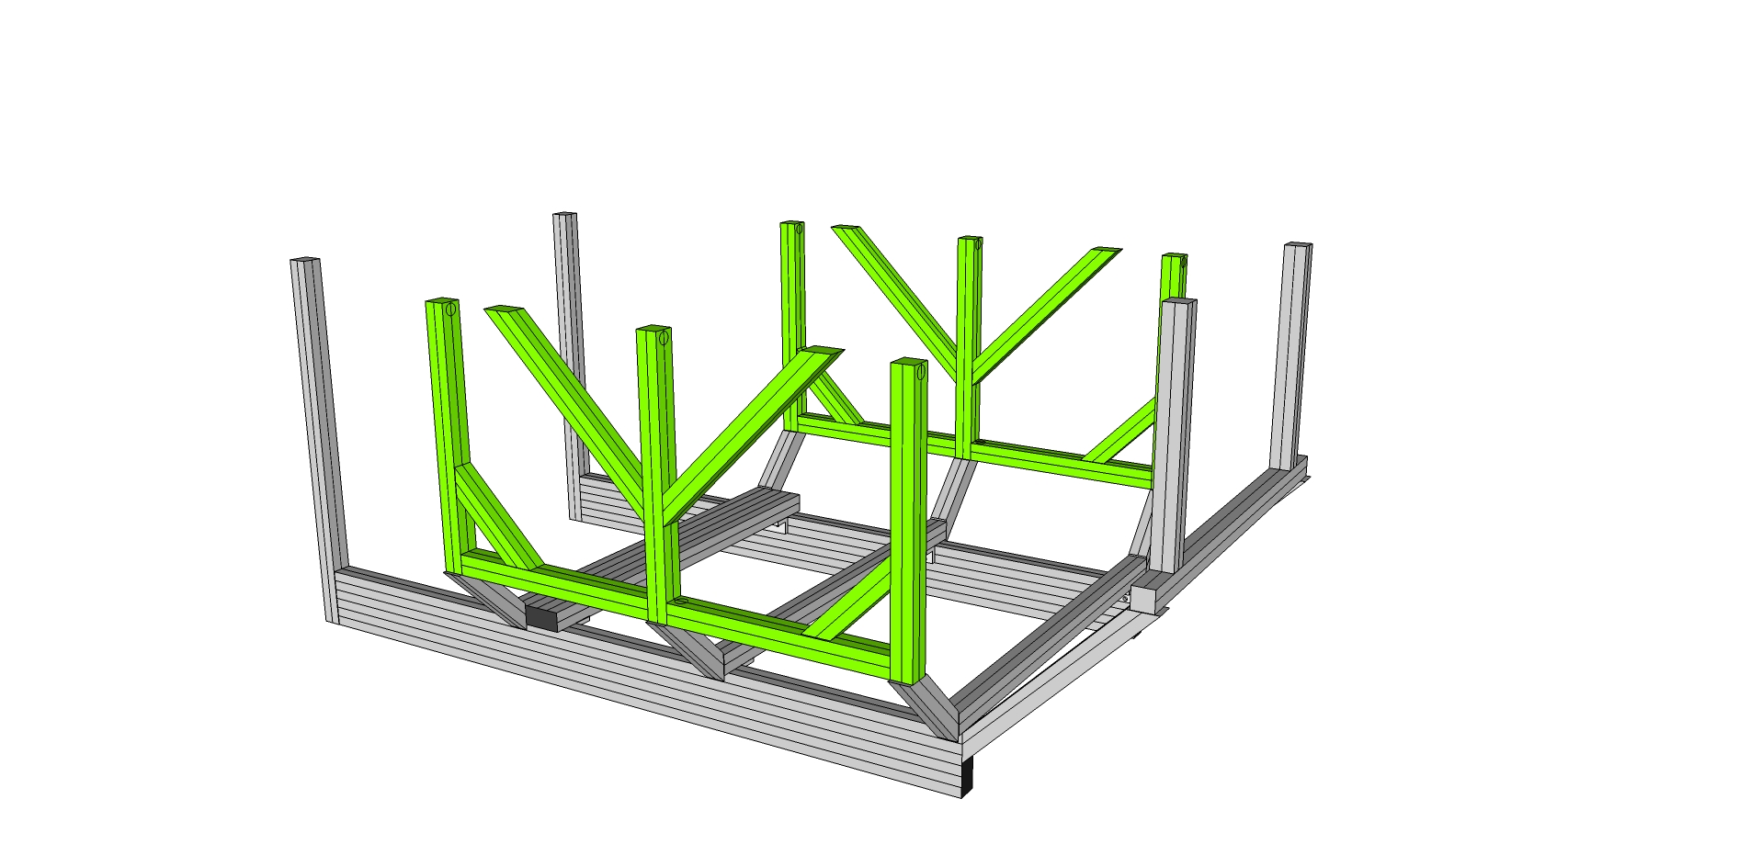

## Connect Top frames to rest of the cockpit Assembly

Step #1 Prep twelve anchor fasteners (9233395) for the top of each Main Verticals (9230313). Anchor Fasteners are composed of three parts: The Head Cap, Screw, the Anchor Cam, and the T-nut. Your Anchor Fasteners should ship Pre-assembled. If assembly is needed, refer to the photo (Note: offset tapped hole in T-nut)

Step #2 Load the assembled anchor fastener into the counterbore hole of all six main verticals (9230313), two in each. Be sure to position the T-nut with the offset hole oriented toward the top of the fastener.

Step #3 While holding the Anchor Fastener in the counterbore hole, slide the Main Upper Side (9230318) over each and over each Econ T-nut from the 12” 45 degree supports (9232570) in place ending ~ 1.25” past flush with rear main vertical. Leave slightly loose until later.

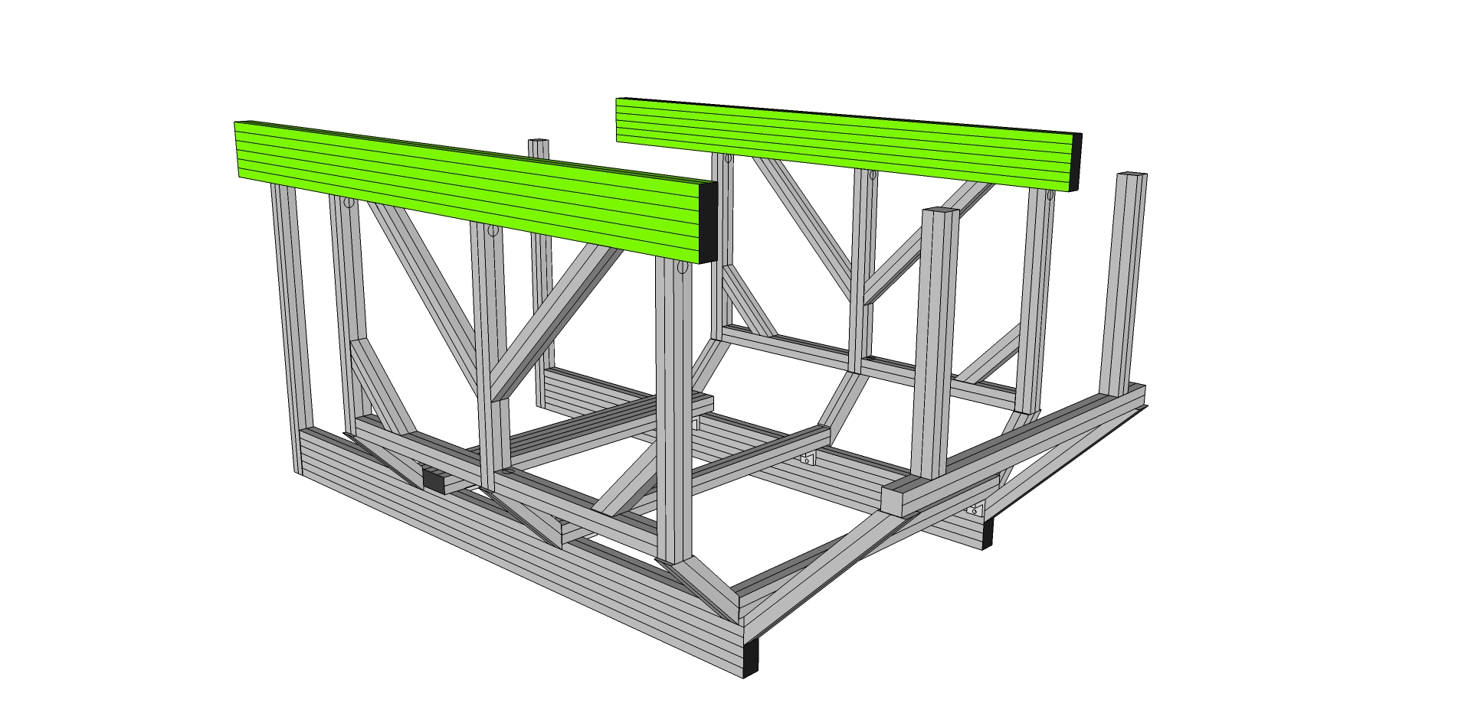

Do not tighten yet.

Step #4 Loosen pre-assembled Socket Head Cap Screw (SHCS) and remove Econ T-nut on four 12” 45 degree supports (9230323). (Parts that were set aside earlier, two have access holes drilled 2” from end (REAR) and two have holes 5” from end. (FRONT))

Step #5 With the Econ T-nuts removed from 9230323, slide the preloaded bolt head on each Rear Verticals (9230310) and Front verticals (9230303) into the lower channel.

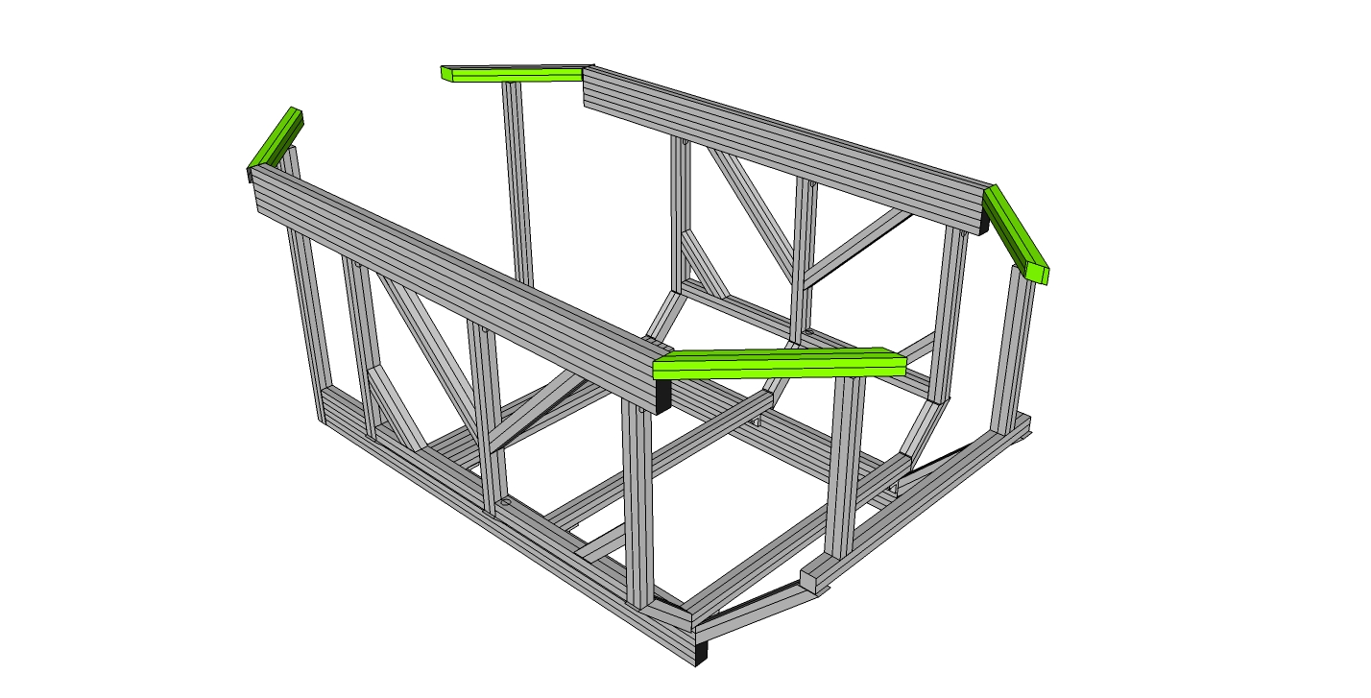

Step #6 Screw the four supports (9230323) into the main upper side (9230318). For the rear two supports (with the access hole 2” from the end), orient the access holes 2” from the inside end and screw the supports into the TOP hole on the end of the main side rail (9230318). ). For the front two supports (with the access hole 5” from the end), orient the access holes 5” from the inside end and screw the supports into the BOTTOM hole on the end of the main side rail (9230318) as shown. Tighten.

Step #46 Bolt the Rear Horizontal Cross Member (9230333) and Front Horizontal Cross Member (Top) (9230325) into place. Keep in mind the orientation of the access holes for the pitch actuator mount in the rear. They should be up and down.

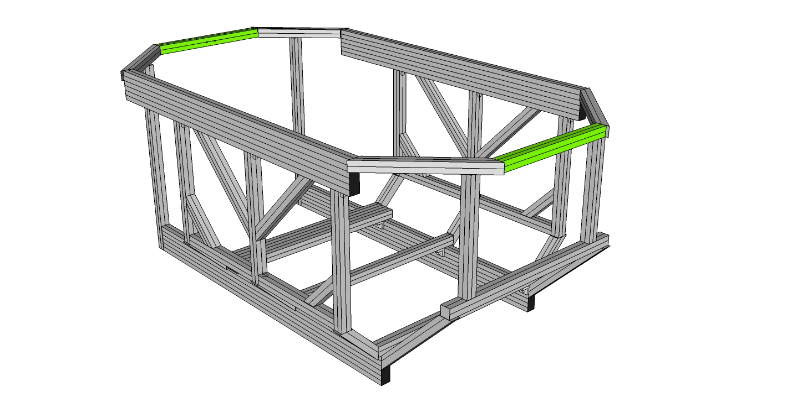

Square and align the mating profiles for the anchor fasteners in the main verticals to the main sides and the Main Upper Sides (9230318). Using a T-handle hex wrench, tighten the screw in a clockwise motion until the profiles are securely affixed. Tighten all. Check all bolts on the cockpit and tighten.

## SubAssy Pitch Actuator Mount

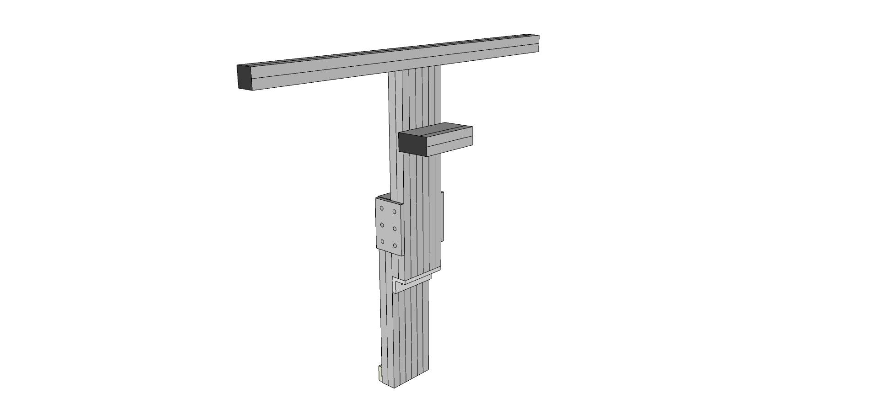

Step #1 Prep two 6-hole joining plates (9234166) with 12 BHSCS (9233393) and 12 Econ T-nuts. Keep the nuts loose to allow sliding into place. Prep one 6-hole inside corner bracket connectors (9234015) with 3 of the Econ T-Nuts and Bolts 9233393. Keep the nuts loose to allow sliding into place and leave one row of three holes empty.

Step #2 Slide Three T-nut assemblies into Actuator Mount Offset (9230331).

Step #3 Slide Actuator Mount Offset (9230331) aligning T-nuts into Pitch Actuator Frame Mount (9230326), align based on pitch actuator stroke length when mounting actuators. Tighten slightly through access holes. You will align this later.

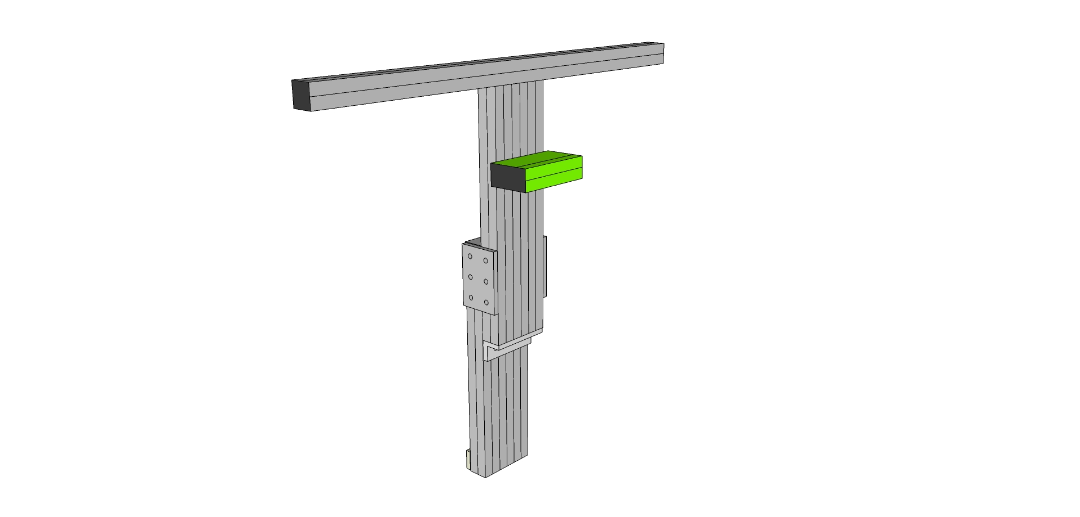

Step #4 Prep top of Pitch Actuator Frame Mount (9230326) with 3 End Fastener Assemblies (9233381)

Step #5 Slide Wing (9230327) onto Pitch Actuator Frame Mount (9230326) with access holes upright. Tighten.

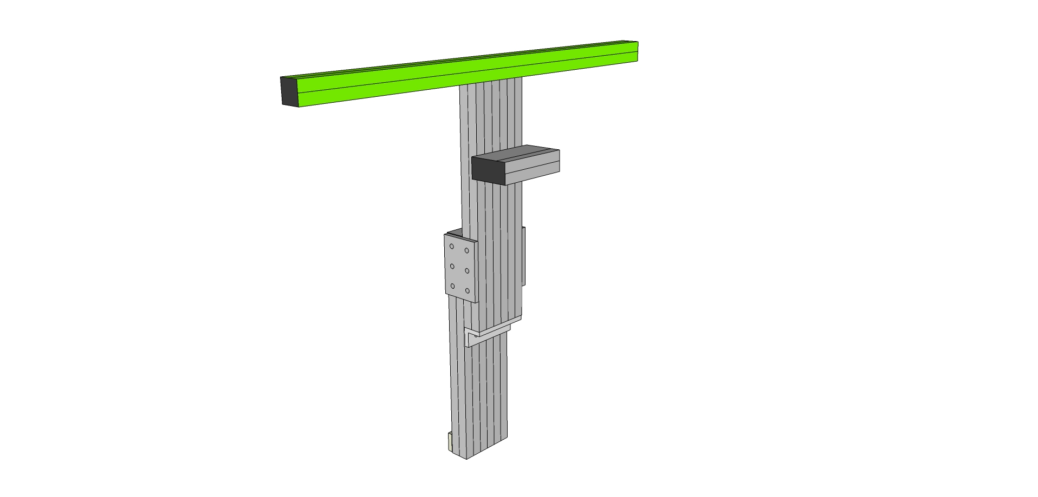

Step #6 Slide the 6-hole mounting plates into place on Pitch Actuator Frame Mount (9230326), then affix the 6-hole corner bracket on the bottom of the Pitch Actuator Frame Mount (9230326) with three BHCS (92303393) Slightly tighten.

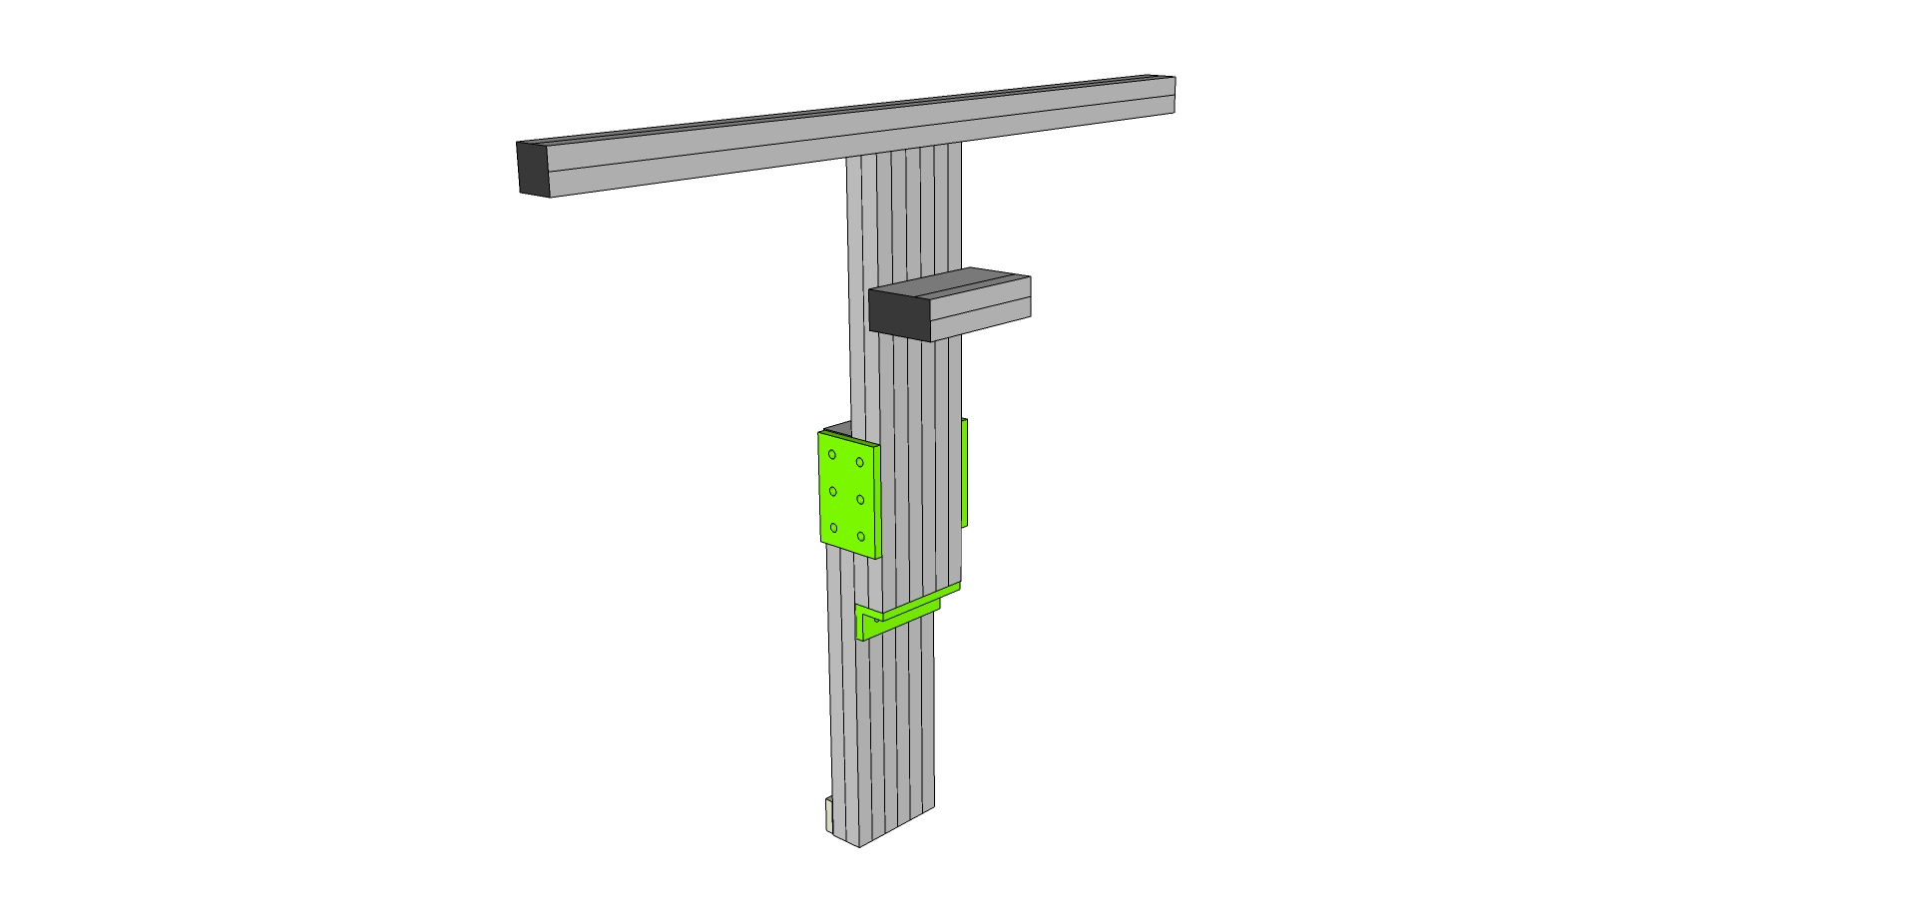

Step #7 Take the second Pitch Actuator Frame Mount (9230326) member and slide into place through the three T-nuts in the corner bracket, and then through the six t-nuts on the 6-hole mounting plates, three on each side. Position does not need to be exact. Tighten all bolts.

## Attach Pitch Actuator Mount Assy to rest of Cockpit

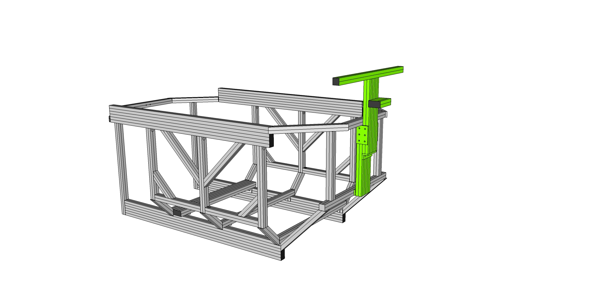

Step #1 Prep the three top holes in the lower Pitch Actuator Frame Mount (9230326) member with end fasteners. Prep a three hole joining strip with T-Nuts and 5/18” bolts (9233822) and slide into the bottom of the Pitch Actuator Frame Mount (9230326) member. This strip will be positioned between the lower cross member and the pitch actuator mount subassy.

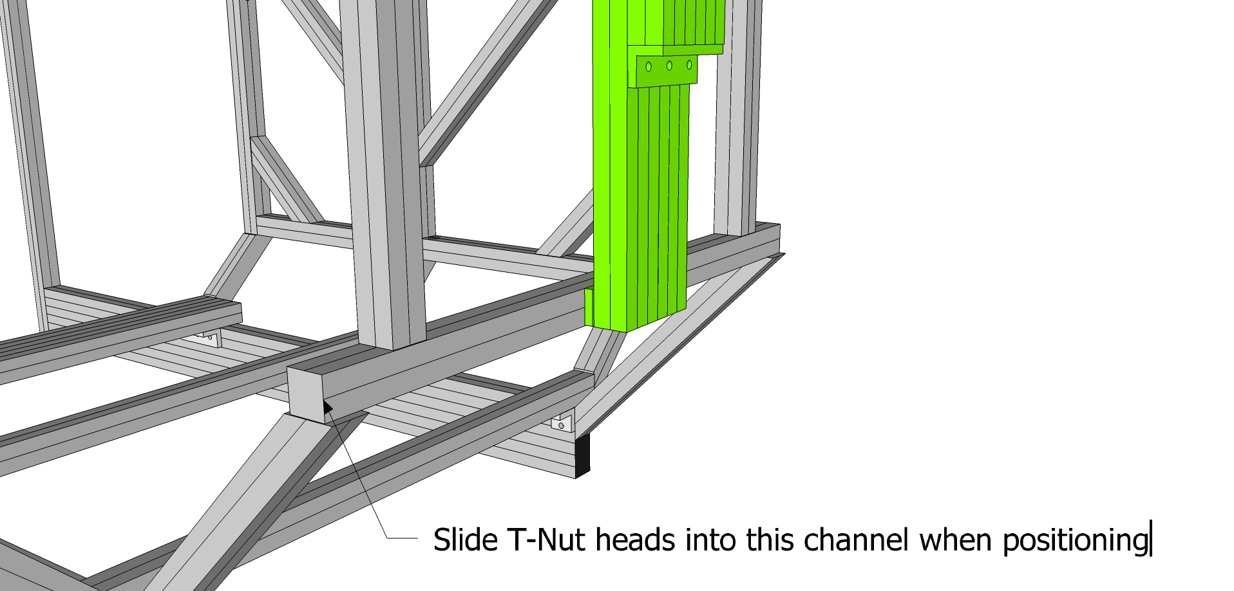

Step #2 When aligning the subassy to the rest of the cockpit, slide the heads of the T-Nuts in the three hole joining strip into the back channel of the Bottom Rear Horizontal Cross Member (9230332) as shown.

Step #3 Using the access holes in the Bottom Rear Horizontal Cross Member (9230332) and Rear Horizontal Cross Member (9230333), tighten the three end fasteners and three T-Nuts, affixing the subassy to the rest of the cockpit.

## SubAssy Seat Mount

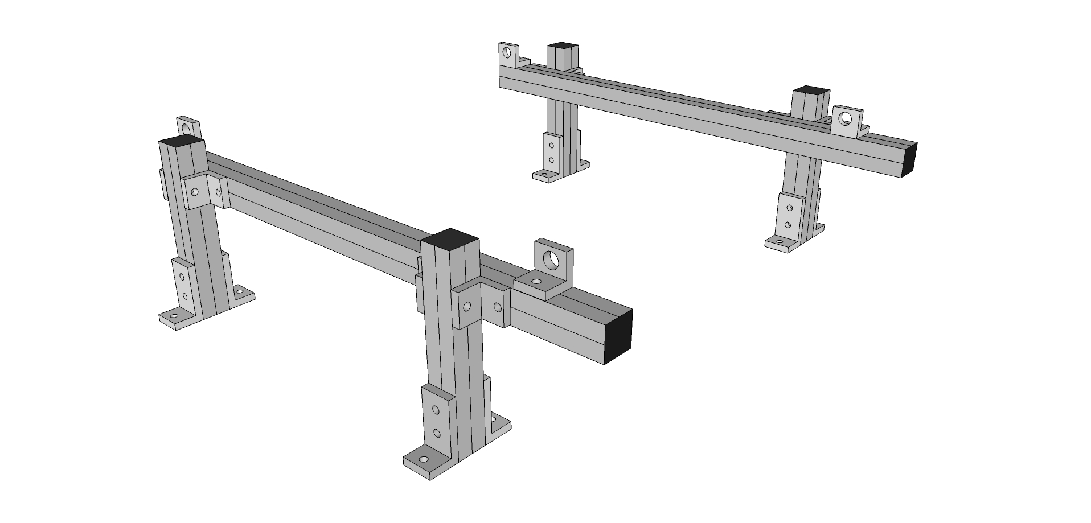

Depending on the type of seat you will be using, you should follow the relevant steps below pertaining to your seat. You may also obtain the seat bracket produced by your seats manufacturer and use instead of this subassy. Measure your seat or find dimensions online before beginning this subassy.

## Normal Configuration vs. Wide Configuration

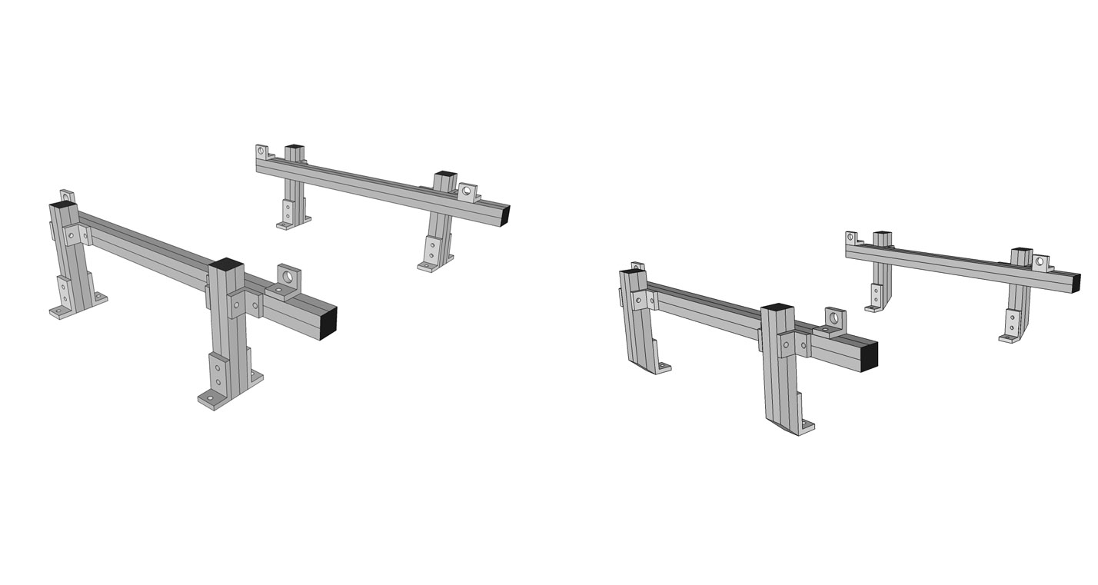

Select one of the configurations, normal or wide.

Step #1 Prep Eight (Normal) or Four (Wide) 3 hole inside corner bracket connectors (9234176) with Econ T-Nuts and Bolts 9233393. Keep the nuts loose to allow sliding into place. **IMPORTANT: only put bolts in the lower (single) hole side as we prepped the cross members already with T-Nuts.**

Step #2 Affix the three hole corner brackets (9234176) on the four seat posts (9230311a for wide or 9230311b for normal) Aligning Econ T-nuts to Slide Two Seat Posts with corner brackets onto Center and Back Lower Cross Members (9230309), each outside edge of bracket flush to each end. To tighten place T-handle hex wrench into SHCS tightening clockwise until secure.

**NOTE: For WIDE configuration, the 3 hole inside corner bracket connectors (9234176) on the outside (four of them) are not needed. This will allow the four posts to be positioned flush with the outside edge of the Center and Back Lower Cross Members (9230309).**

Step #3 Prep eight 2-hole inside corner bracket connectors (9234119) with 16 of the Econ T-Nuts and Bolts 9233393. (Keep the nuts loose to allow sliding into place.)

Step #4 Slide four of the 2-hole brackets (9234119) into the same channel of two Seat Rail (9230312) sides, as shown. (Make 2)

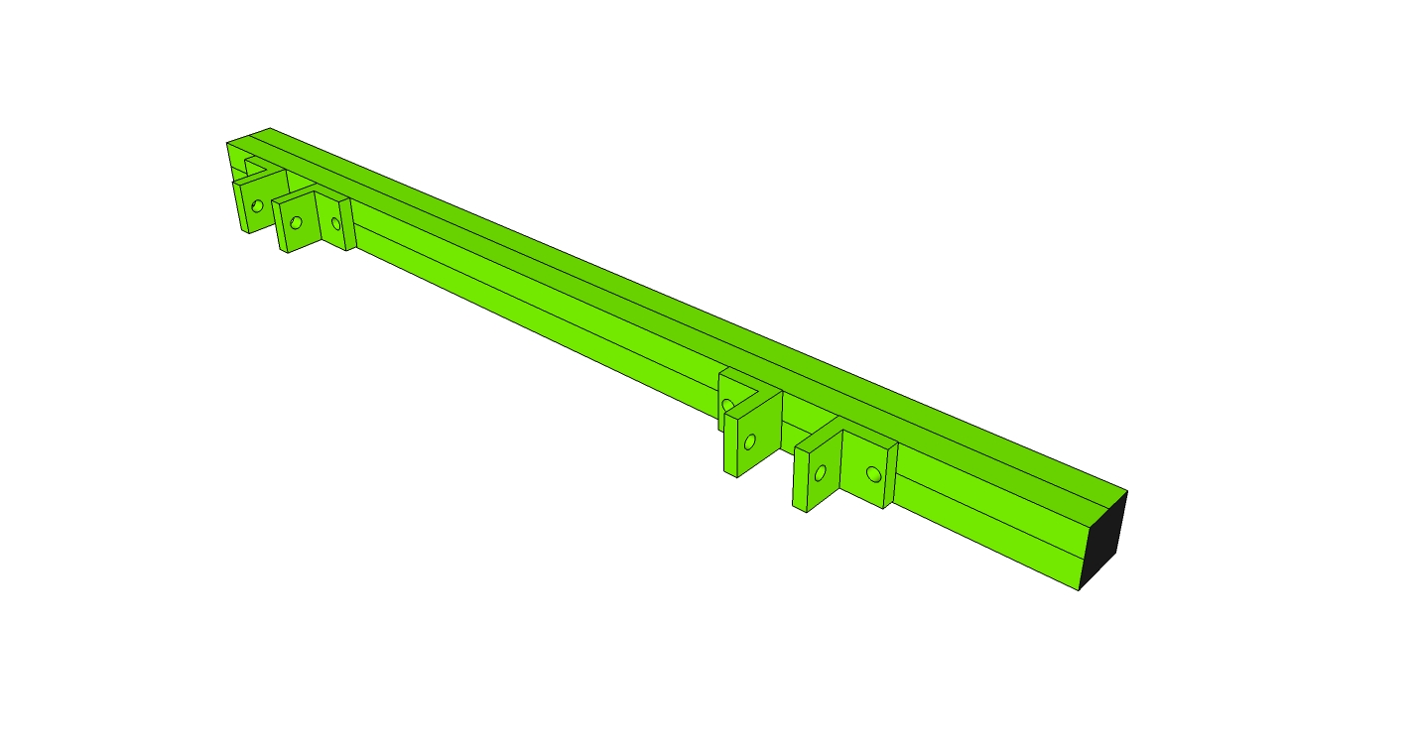

Step #5 Slide seat rails over the seat posts one 2 hole bracket per side of post 2 hole inside corner bracket connectors (9234119) and tighten slightly. Some adjustment will be needed as you integrate your seat.

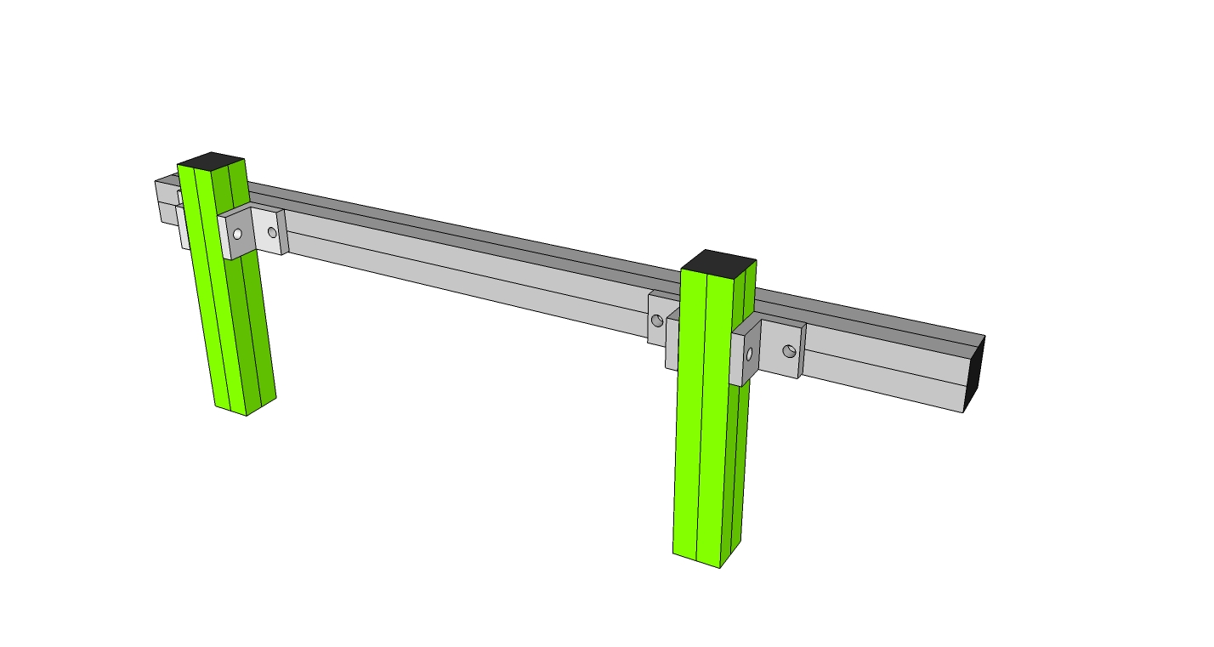

Step #6 Prep the 2 hole standard transition inside corner bracket (9234503) with one T-Nut and Bolt in the ¼ hole. The other hole will be used to bolt into your seat.

Step #7 Slide your transition inside corner brackets (9234503) into place. Both side mount or bottom mount orientations are possible as shown below.

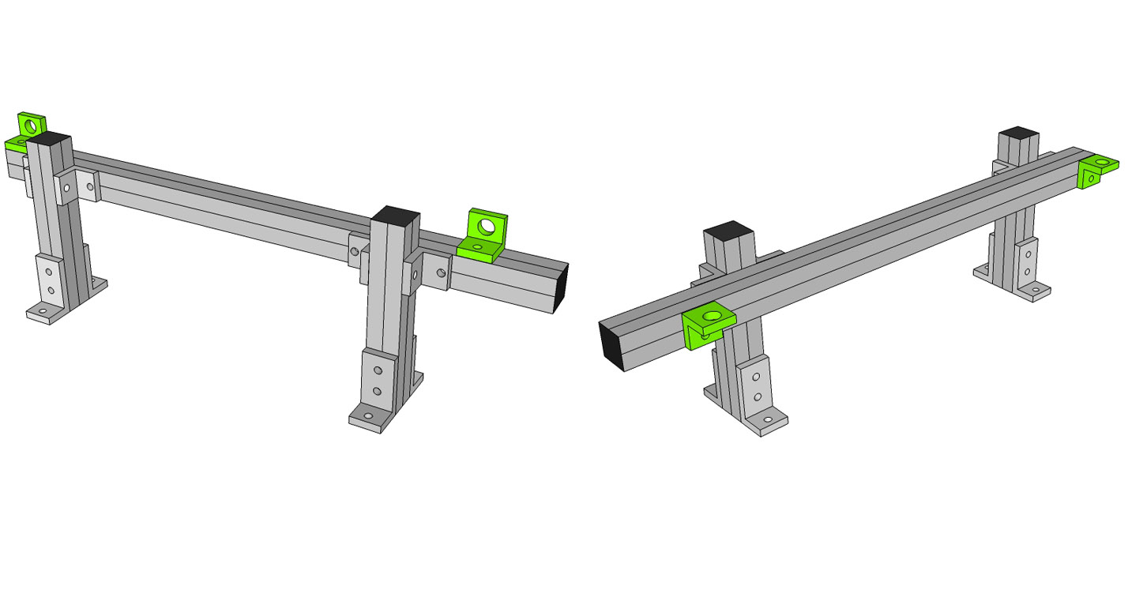

## Integrating the seat mount subassy into the cockpit

*For Wide configuration*

Step #1 Remove T-Nut on the mitre cut end of the four seat posts (9230311a).

Step #2 Place a drop-in T-Nut inside the top channel of the 6” 45 degree supports as shown and attach subassy to the cockpit.

Step #3 Slide the preloaded T-Nut in the inside channel and affix the three hole corner bracket to both the Center and Back Lower Cross Members (9230309) as shown. Tighten the bolts to fix in place.

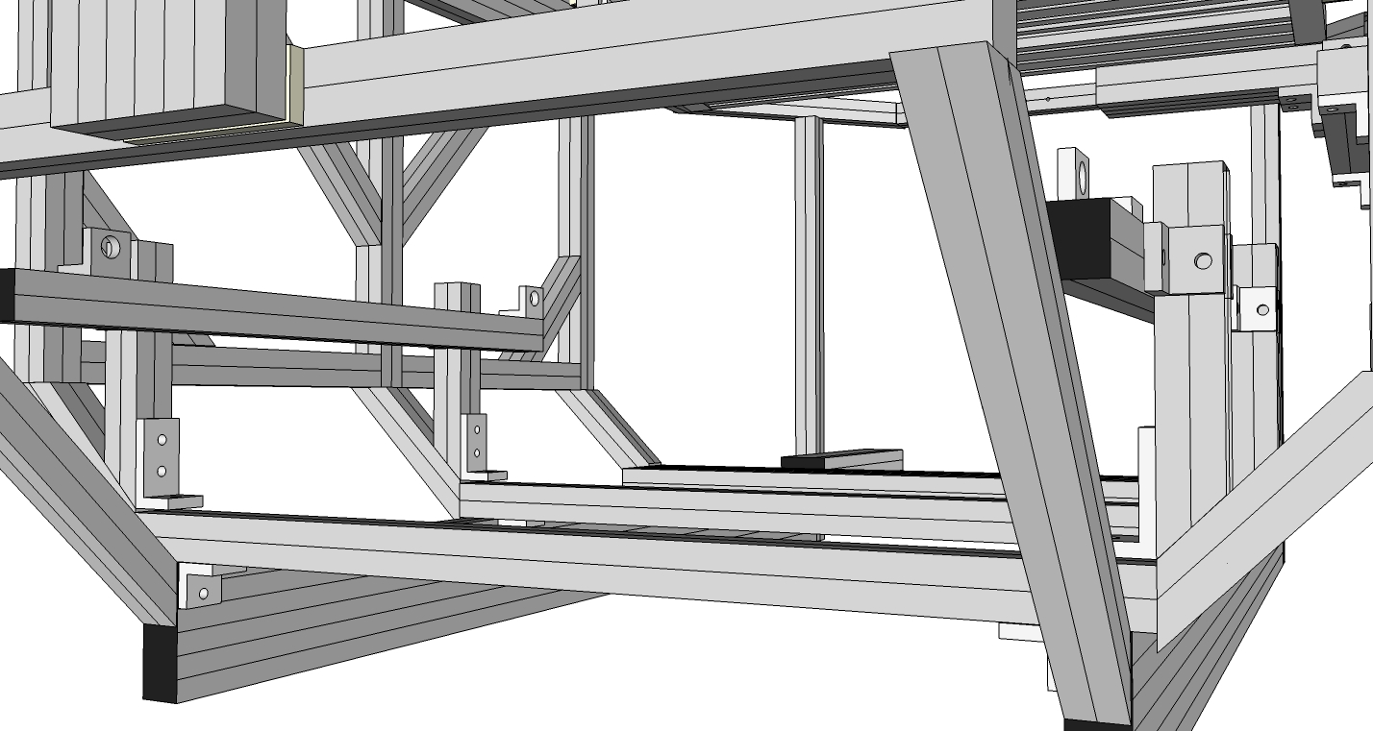

*For Normal configuration*

Step #1 Position the preloaded T-Nuts into place and attach the lower portion of the three hole corner brackets to the chassis as shown. Leave the bolts and T-Nuts loose for seat fitting.

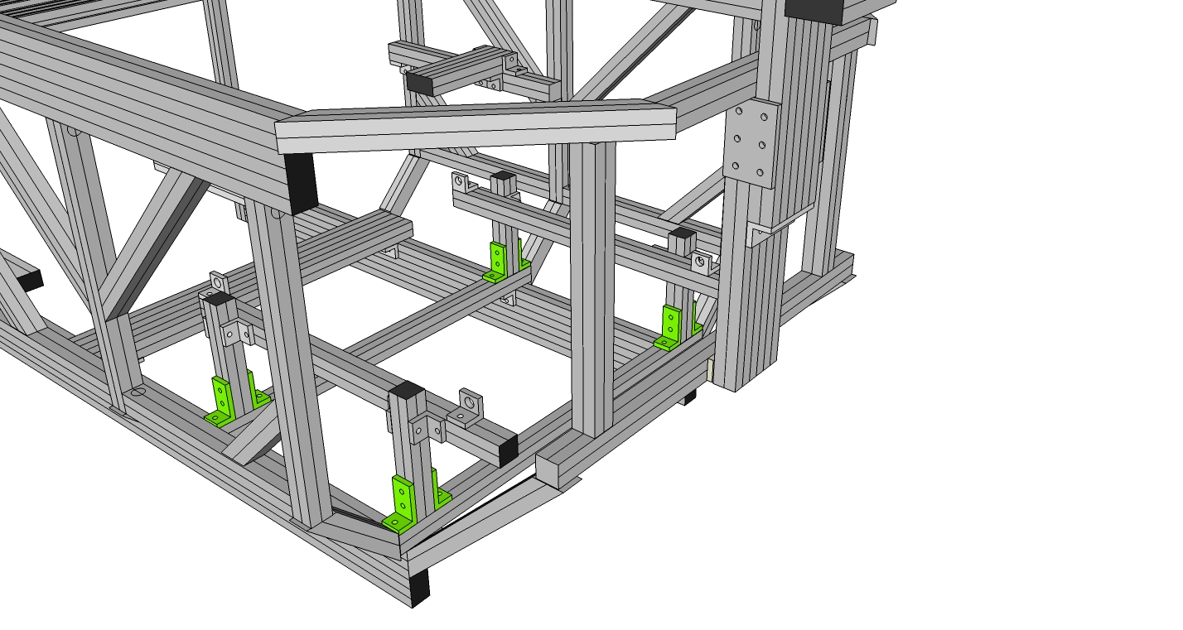

## SubAssy Wheel Shelf

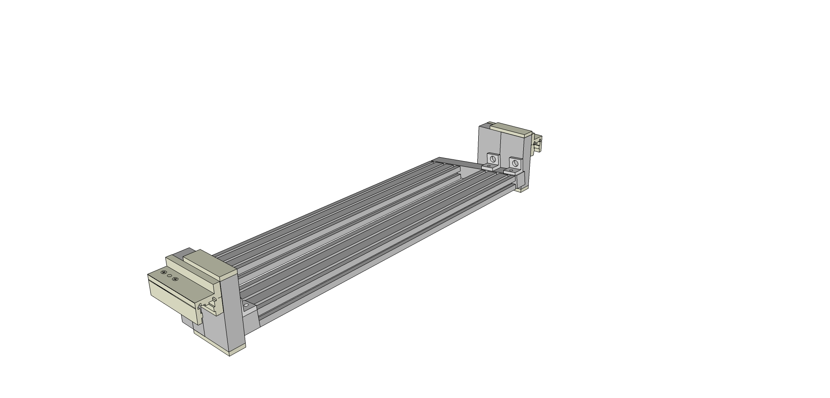

Step #1 Prep four 2 hole inside corner brackets with T-Nuts and Bolts.

Step #2 Slide the four 2 hole inside corner brackets into the Steering Wheel Studs (9230336), two on the right and two on the left channel. Tighten slightly. Set aside

Step #3 Prep both Steering Wheel Bar (9230334 x 2) ends with end fasteners, eight in total.

Step #4 Slide the Steering Wheel Side Rails (9230335) into place over the end fasteners of the Steering Wheel Bars (9230334) as shown. Tighten through access holes in the side rails.

Step #5 Repeat on the other side, attaching the other side rail to the other end of the Steering Wheel Bars.

Step #6 Now take the Prepped Wheel Studs and slide into place as shown. Tighten slightly. Repeat on the other side.

Step #7 Preload the linear slide bearings (9236416) with four 5/8” Bolts and T-nuts (9233822) along the top row of mounting holes.

Step #8 Affix the L-Handle brake (9236850) to the top hole of each of the linear slide bearings (9236416)

Step #9 Slide the linear slide bearings (9236416) into place on the outside of the pre-assembled Steering Wheel Studs (9230336) as shown and tighten.

Step #10 Take two tree hole mounting plates and affix one on the top and one of the bottom of the combined Studs. (Use 9233305 bolts) Repeat on the other end.

Step #11 Set aside until the monitor mounting stage.

## SubAssy Pedals :: Top Hinge or Bottom Hinge

***Top Hinge***

Step #1 Prep six 3-hole inside corner brackets (9234176) with 18 the Econ T-Nuts and Bolts 9233393.

Step #2 Slide onto the Top Hinge Rails (9230909) as shown. (Make 2)

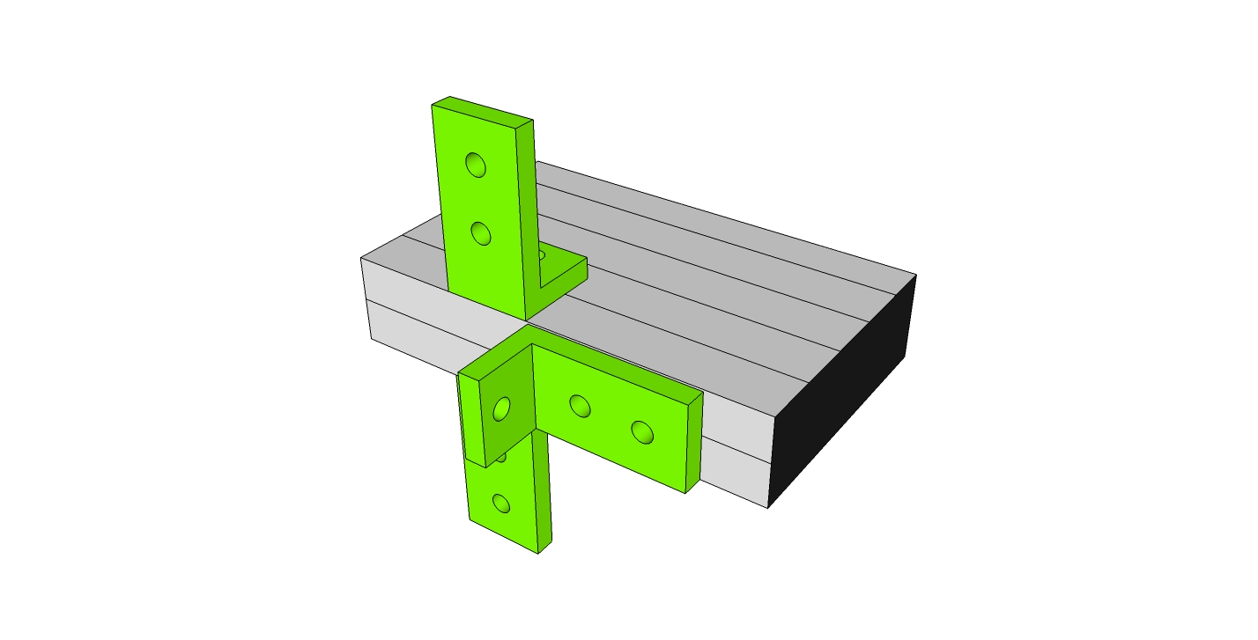

Step #3 Slide onto front verticals (9230303). Once pedals are mounted, adjust to desired height. Use drop-in t-nuts for the front channel bolts.

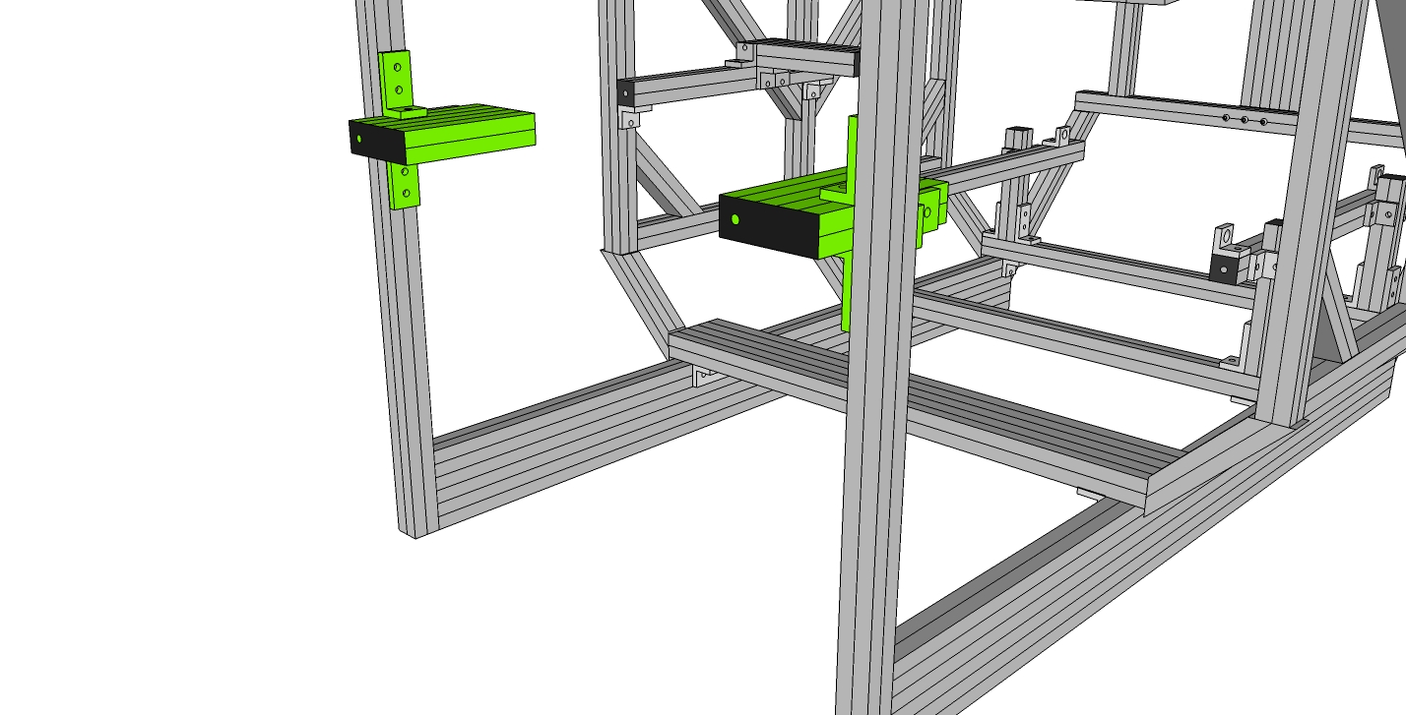

***NOTE:*** For taller users, the 3-hole inside corner brackets (9234176) mounted on the single, horizontal sides of the subassy can be switched to the outside slot, allowing for longer pedal adjustability.

## 

## Bottom Hinge

Step #1 Prep Two Pedal Support Front/Back Rails (9230906) with 4 End Fastener Assemblies (9233381) and Prep Two Pedal Support Center Rails (9230907) with 4 End Fastener Assemblies (9233381) Prep two Center Rails (9230907) with end fasteners (9233381) on each end.

Step #2 With the End Fastener (9233381) slightly loosened, slide the Center Rails (9230907) onto Front/Back Rails (9230906). It is important to orient Center Rails with access holes oriented the same way. When aligned, the access hole on the mating profile. (Approximately 4 1/2” from each end which should align with the BHSCS.) Tighten the connections, place a T-handle hex wrench into access hole until the wrench head inserts into the BHSCS.

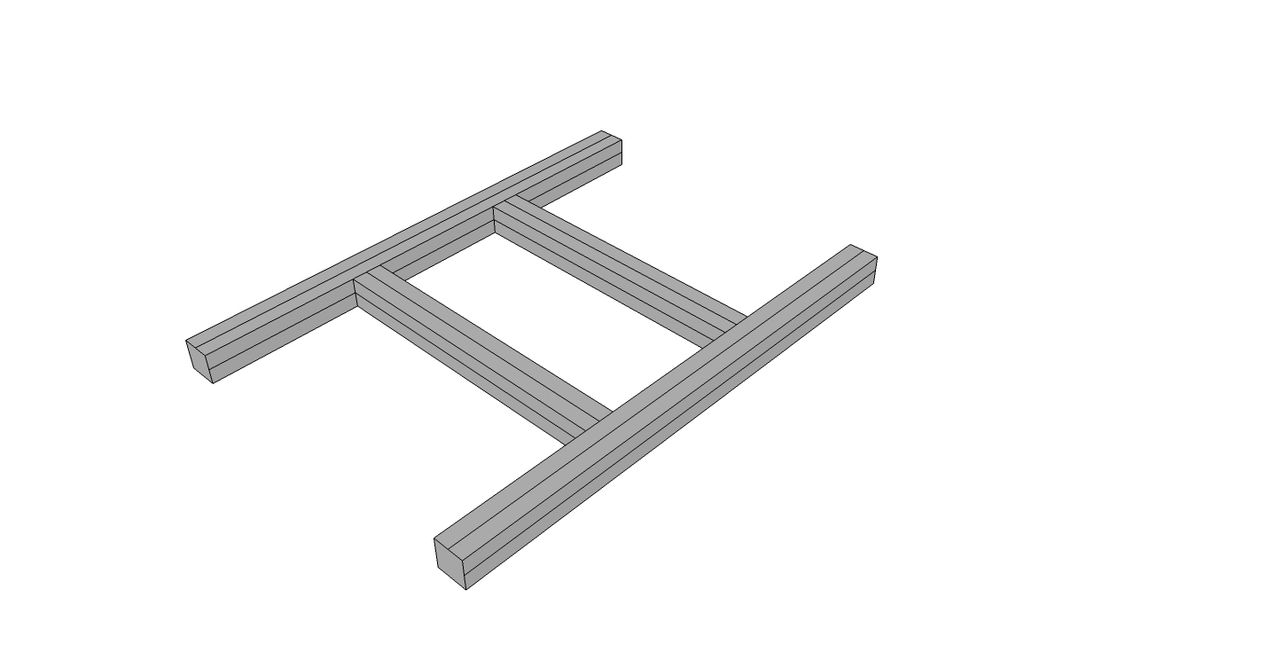

Step #3 Prep Front/Back Rails (9230906) with end fasteners on each side.

Step #4 Slide Pedal Side Supports (9230908) on each side of Front/Back Rail (9230906). It is important to orient access holes approximately 4 1/2” from end to the tapped ends. To tighten the connection, place a T-handle hex wrench into access hole until the wrench head inserts into the BHSCS. Tighten all four clockwise until secure. IMPORTANT, make sure the tapped hole end of the side supports (9230906) are both on one end.

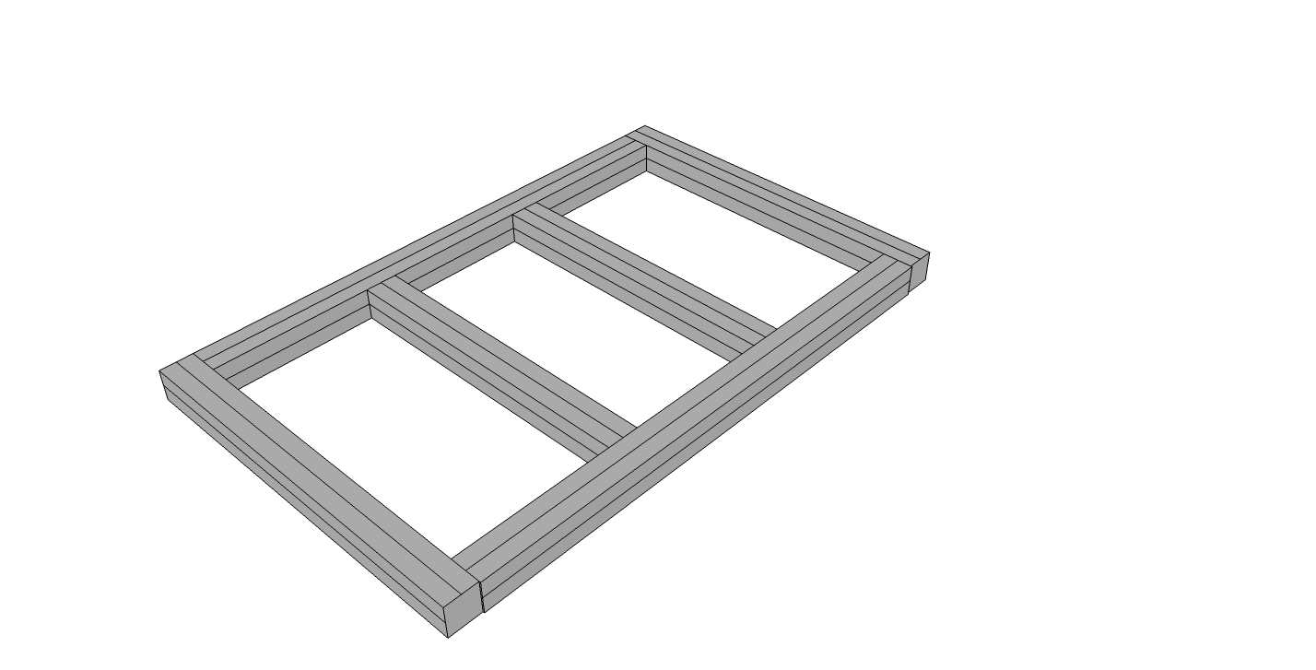

## 

## Integrating the pedal mount subassy into cockpit

Step #1 Determine your preferred pedal location. You can mount the supporting 2 hole brackets on the top or any of the side channels of the cockpits bottom rails. Prep Two 2 hole inside corner bracket connectors (9234119) with 2 of the Econ T-Nuts and Bolts 9233393. (One nut/bolt in each, leaving the other hole open.) Keep the nuts loose to allow sliding into place. For the top channels, use drop-in T-Nuts. For the bottom two channels, you can slide T-Nuts in from the back of the cockpit.

Step #2 Slide the two brackets from the previous step onto the desired channel of each inside Bottom Rail (9230301). Slide from the back to the front if needed.

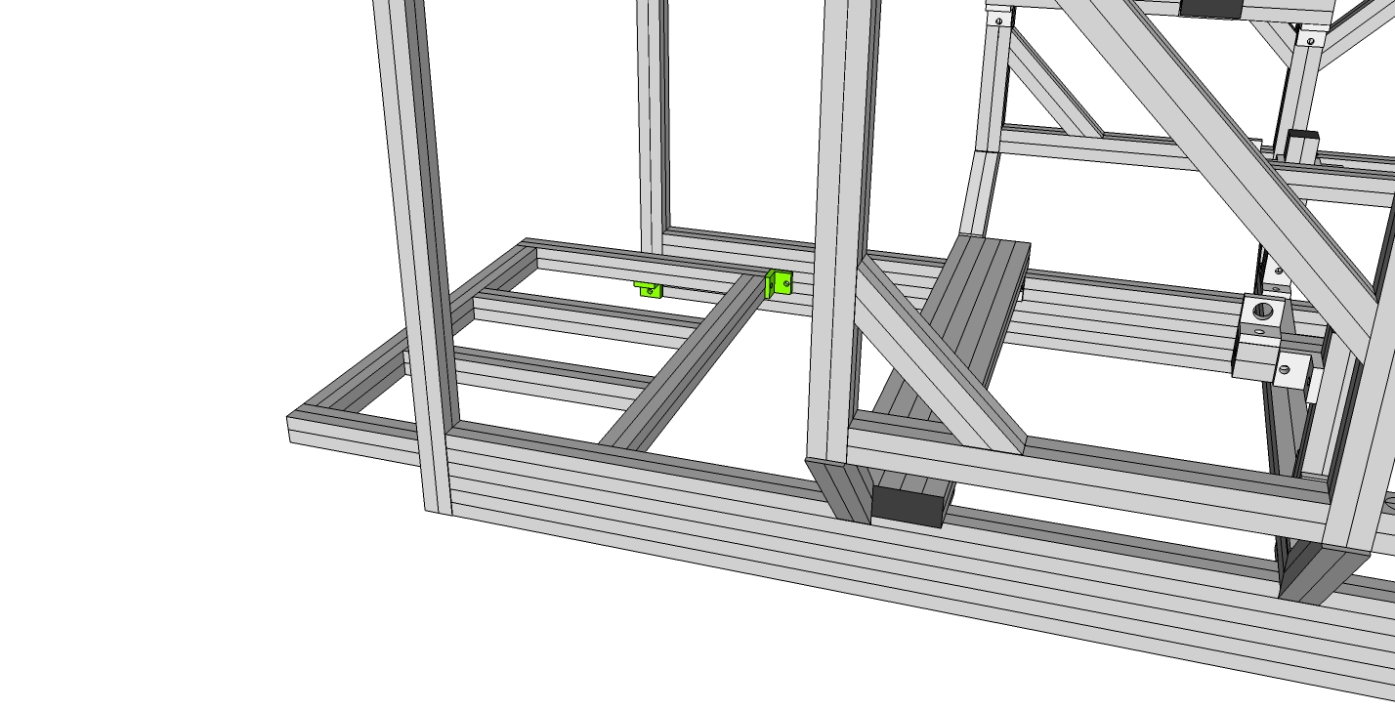

Step #3 Attach Pedal Side Support Rails to connectors (9234119) by inserting two bolts (9233393) through the two-hole bracket (9234119) and into pre tapped hole in the end of Pedal Side Supports (9230308).

Step #4 Prep Two 2 hole inside corner bracket connectors (9234119) with 4 of the Econ T-Nuts and Bolts 9233393. (One nut/bolt in each hole.) Keep the nuts loose to allow sliding into place.

Step #5 Slide 2 hole inside corner bracket connectors (9234119) into the bottom of the Pedal Side Supports (9230308) then into the bottom of the Front Vertical Supports (9230303) as shown. To tighten the 9234119 place T-handle hex wrench into SHCS tightening clockwise until secure forming a slight angle of the pedal support. You should wait to fully tighten until you can test the pedal position once the seat is installed. Position will also depend on the type of pedals you will use. If using top-hinge pedals, this assembly can act as a heel plate as shown below.

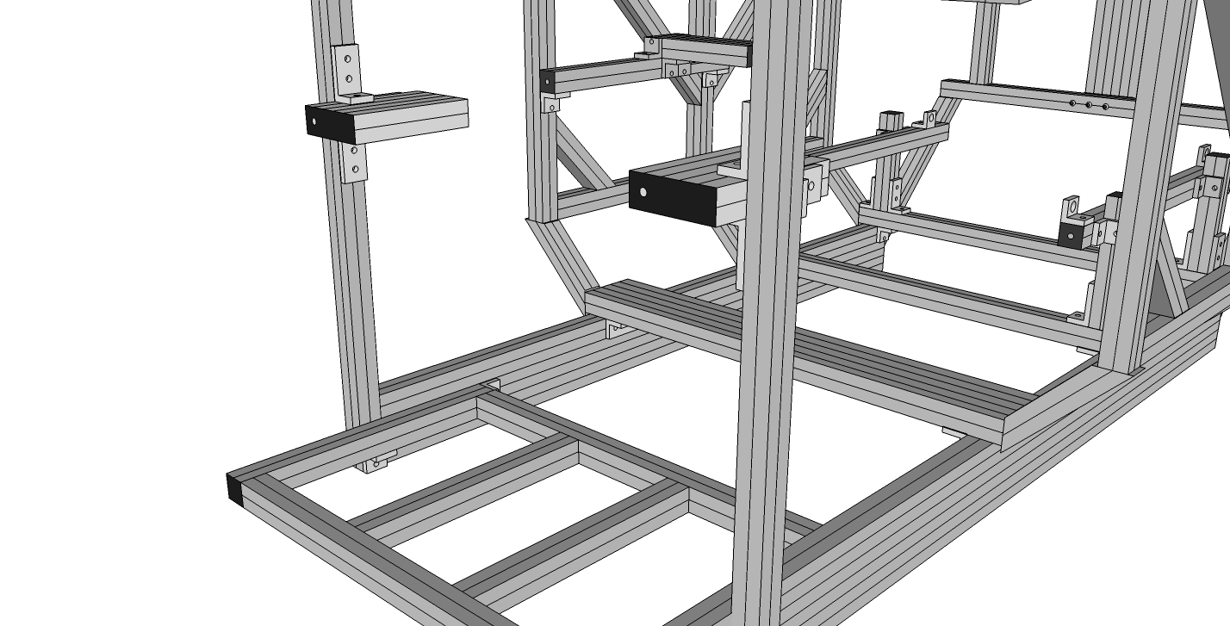

## SubAssy Shifter Mount

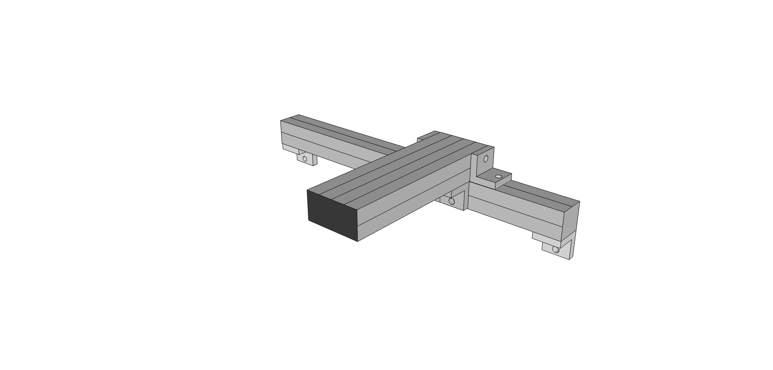

Step #1 Prep six 2-hole brackets (9234119) with Econ T-Nuts and Bolts 9233393

Step #2 Slide onto bottom channel of the Shifter Rail (9230315)

Step #3 Slide Shifter Rail (9230315) with Fasteners aligned over the left or right front Two Main Verticals. (Depending on whether your shifter will be left or right mounted.) Tighten. Use Drop-in T-Nuts in the cockpit verticals as needed.

Step #4 Slide connectors (9234119) onto Shifter Rail Bar (9230316). Tighten. Then Slide Shifter Rail Bar (9230316) with Econ T-Nuts and Bolts 9233393 aligned onto Slide Shifter Rail (9230315). Adjust to desired position.

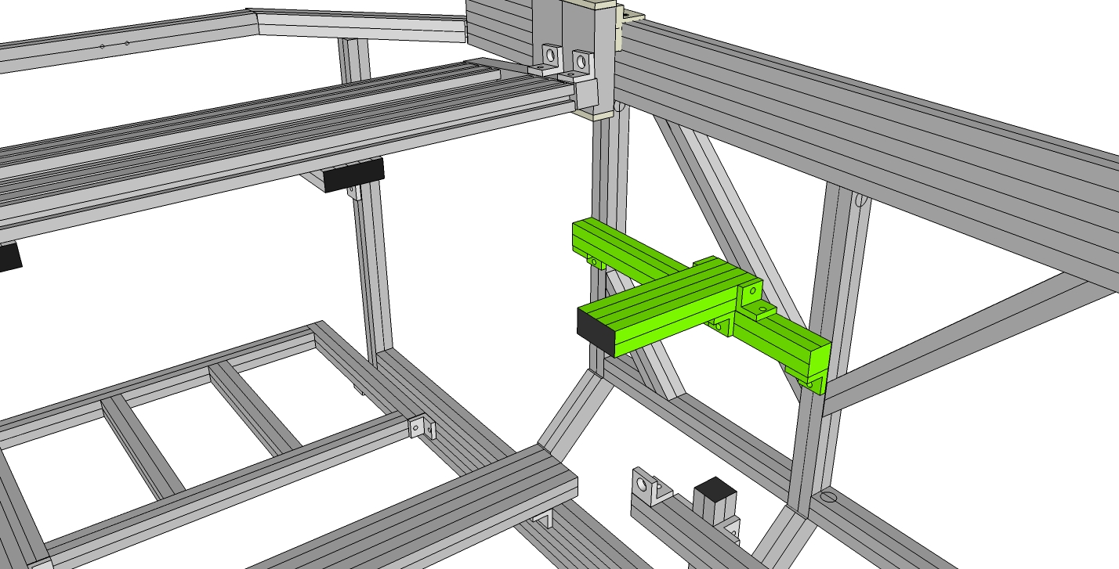

## SubAssy Monitor(s) Mount

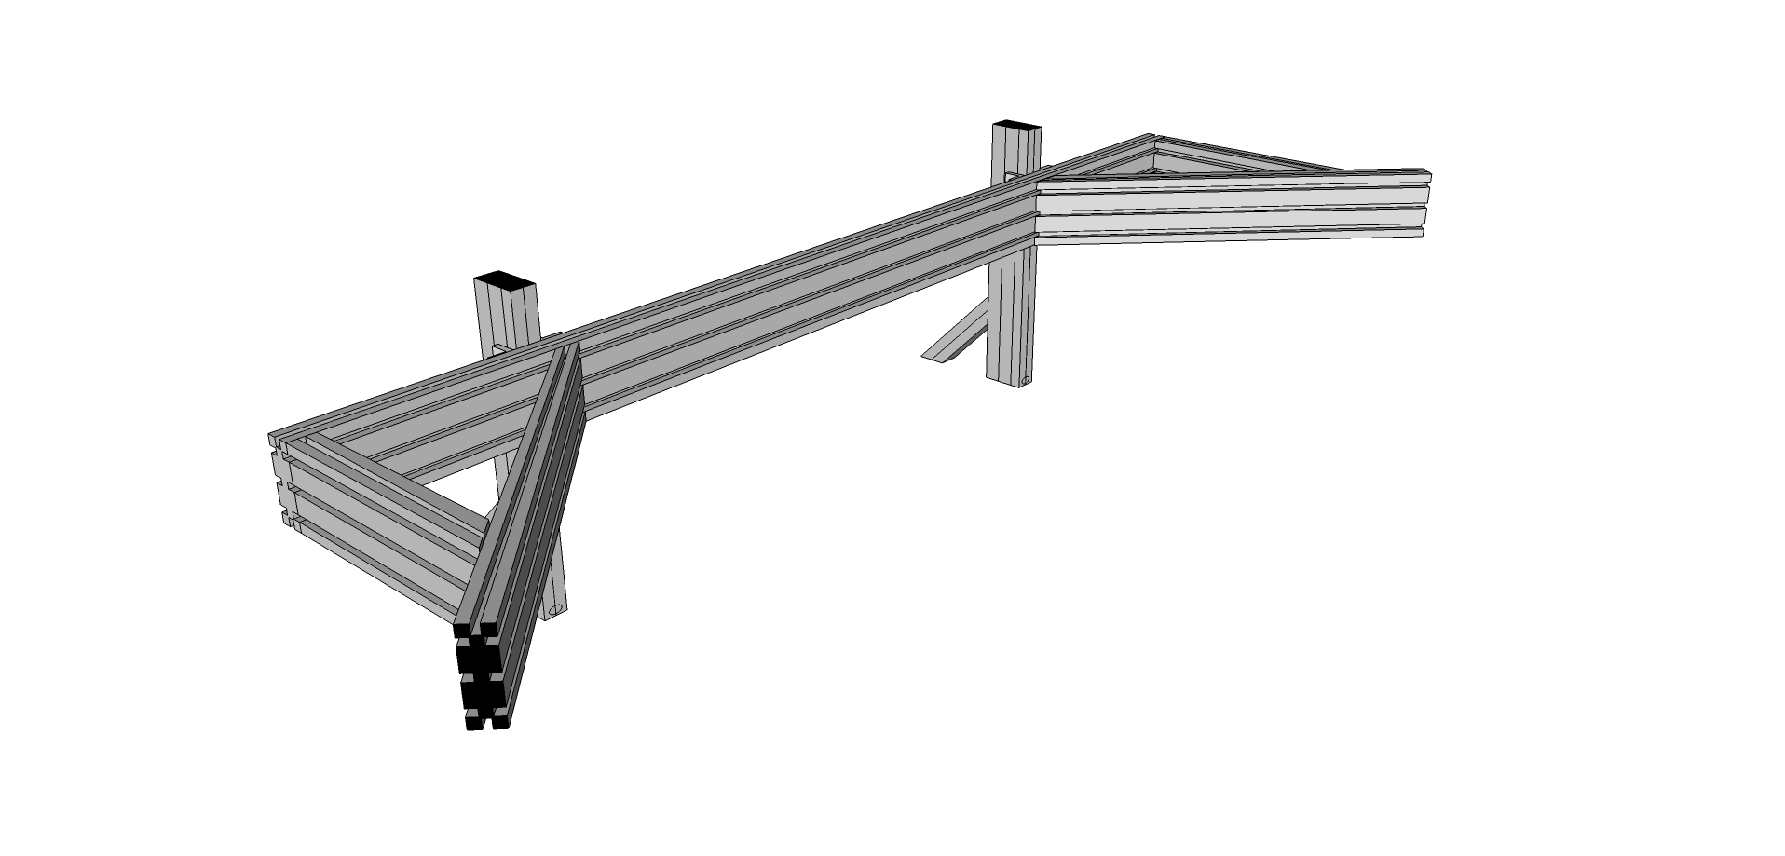

Step #1 Prep four 6-hole corner brackets (9234015) with T-Nuts and bolts (9233393) leaving the T-Nuts loose for inserting and sliding in the T-Slot.

Step #2 Slide two of the four 6-Hole corner brackets onto the monitor vertical posts (9230340) as shown below. Tighten slightly and repeat on the second post.

Step #3 Loosen the Econ T-nut (but leaving the bolt and washer) on one six 6” 45 degree supports (9232565) and attach to the Post as shown. Repeat on the second post.

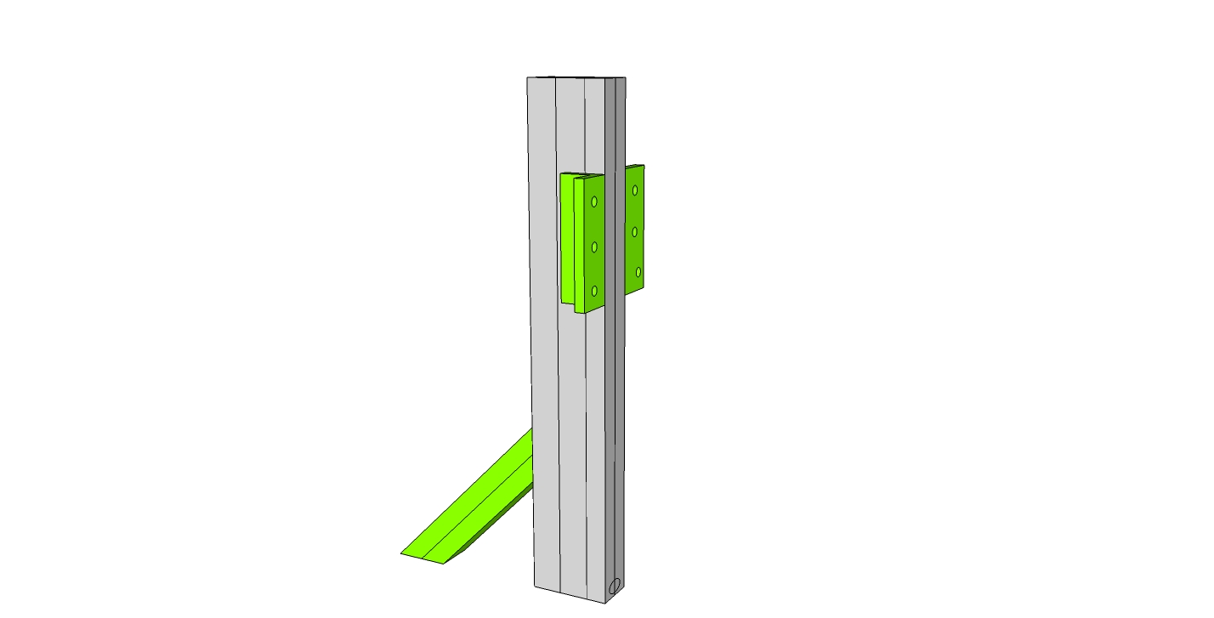

Step #4 Slide the main cross member into place as shown and slightly tighten all twelve T-Nuts in the four 6-hole corner brackets on the backside. The posts should have a distance of about 27.5” between them. This distance can be adjusted when affixing this subassy to the main cockpit assembly.

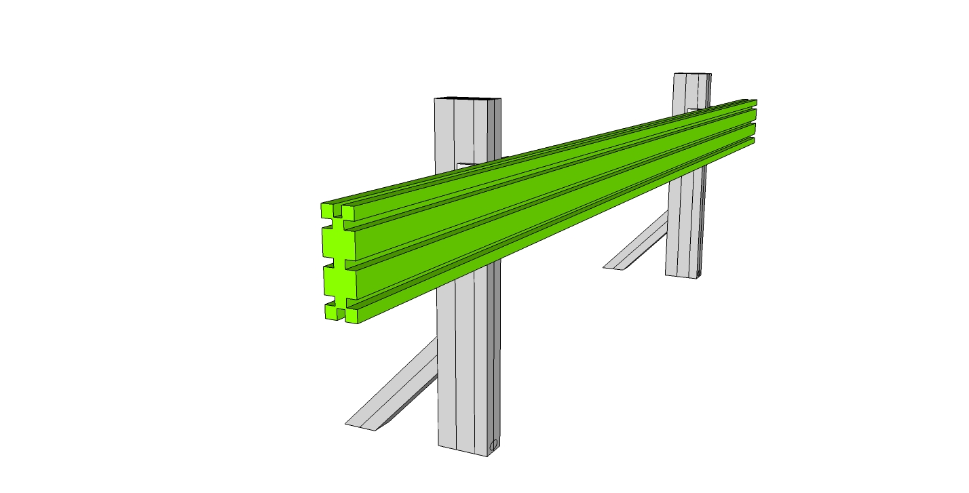

Step #5 Prep both 9230337 side supports with end fasteners, the attach the mitre cut end to the longer diagonal support (9230338) as shown below. Position the left side faces in the drawing below in a same plane manner. Loosen the T-Nuts in the longer support.

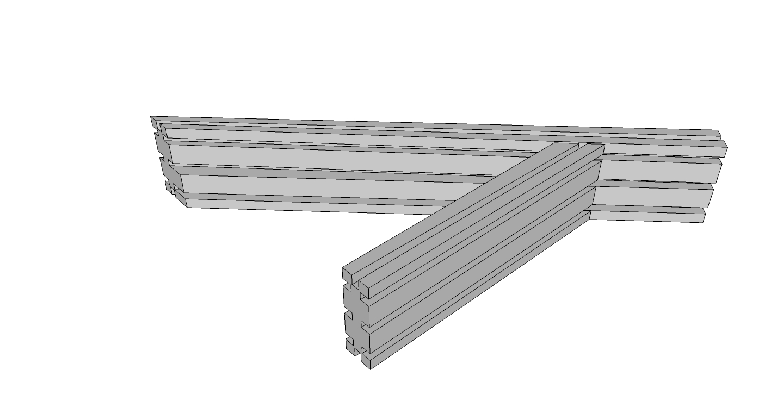

Step #6 Attach the subassy of Step #5 to the rest of the monitor mount subassembly by sliding the t-nuts in the longer diagonal support into the front facing channels of the rest of the monitor mount subassembly. Align the three access holes on the end of the main cross member to the end fasteners in the side supports. Tighten the three end fasteners and the three t-nuts. Repeat on the other side.

## Integrating into the rest of the cockpit assembly

Step #1 Prep four anchor fasteners (9233395) for the bottom of each monitor vertical post (9230340). Anchor Fasteners are composed of three parts: The Head Cap, Screw, the Anchor Cam, and the T-nut. Your Anchor Fasteners should ship Pre-assembled. If assembly is needed, refer to the photo (Note: offset tapped hole in T-nut)

Step #2 Load the assembled anchor fastener into the counterbore holes of monitor vertical posts (9230340), two in each. Be sure to position the T-nut with the offset hole oriented toward the top of the fastener.

Step #3 Remove the front 45 degree supports and the front cross member.

Step #4 Before mounting the monitor support, retrieve the wheel mount sub assy and slide the linear bearings onto the top of the Upper Sides (9230318) as shown.

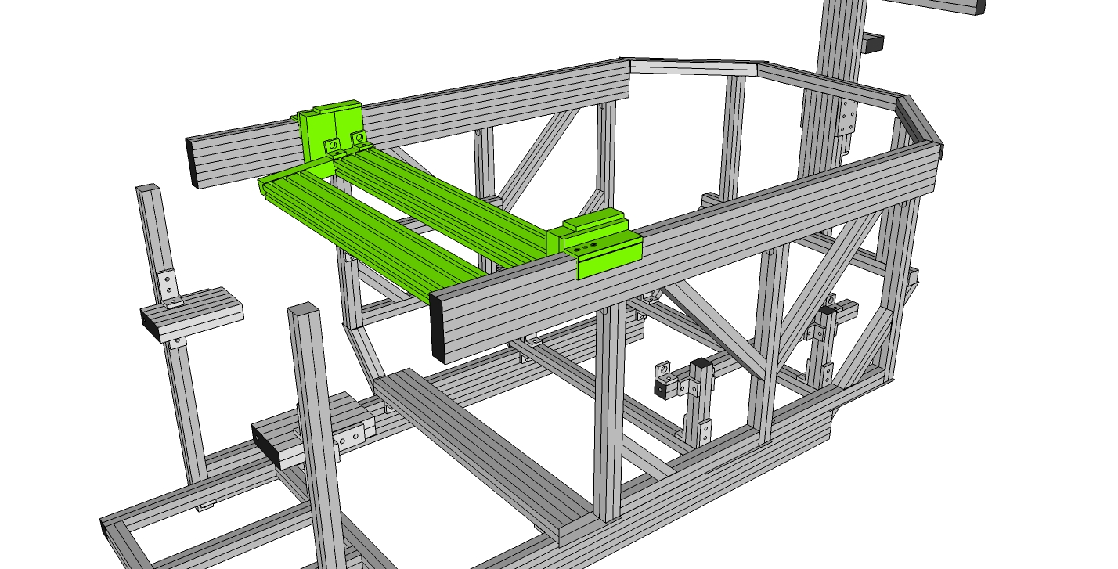

Step #5 While holding the Anchor Fastener in the counterbore hole, slide the monitor subassy into the top channel of the Upper Side (9230318), then feed in the T-Nut from the 6” 45-degree support. Tighten all bolts once in place.

Step #6 Replace the front 45 degree supports and the front cross member.

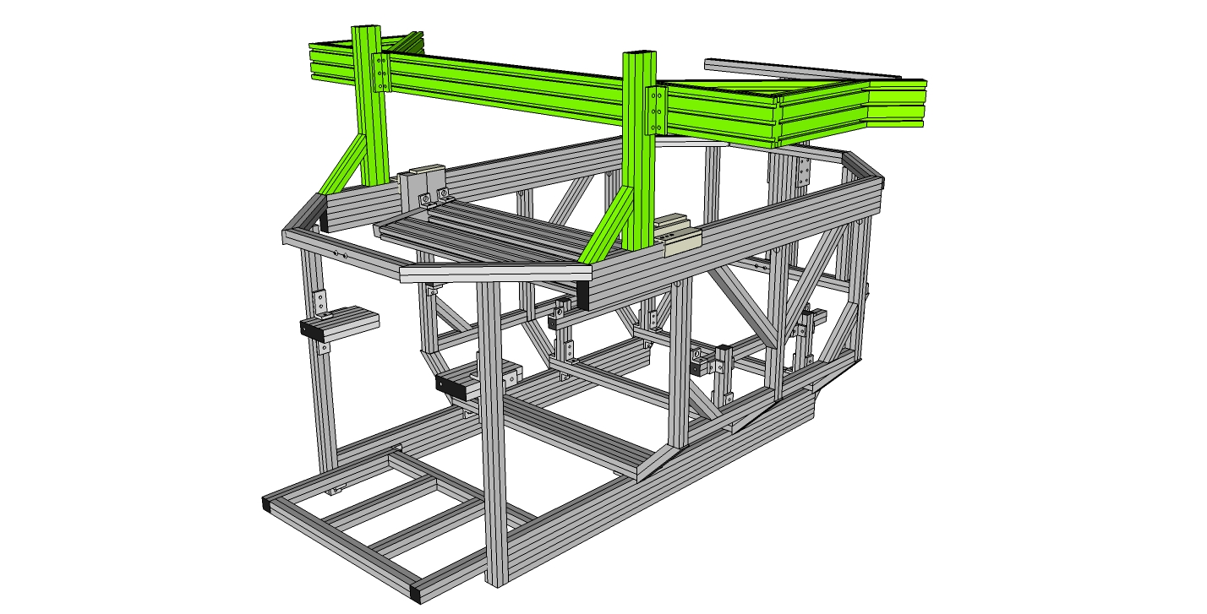

# 

# Final Assembly

The final steps of assembly can be done in different orders. If you have plenty of “lifting help”, you may choose to mount everything in the cockpit, (seat, monitor, controls) before assembling the cockpit, roll frame, and base cradle. Keep in mind that everything added to the cockpit while it sits on the floor adds more weight for when you will need to lift it into place on the rest of sim.

## Finishing the Cockpit

### Mounting the Seat

For side mount seats, (RECARO Pole Position, Corbeau FX-1 Wide) use the four 2-hole transition inside corner brackets (9234503) along with four 9233393 Bolts/T-Nuts.

Step #1 put seat in place and using the 4 bolts supplied for your seat, bolt in place, through the 9234503 holes and into seat.

Positioning the seat: It is of vital importance that the seat NOT contact any part of the cockpit chassis structure, other than the seat mounting structure. Do not rest the back of the seat on the rear top cross member behind the seat. Also, using a seat slider under the seat is not recommended.

### Mounting the Monitors

Step #1 Using T-Nuts and 3321 bolts, prep the monitor mounting plate holes and then slide the T-Nuts into the monitor assembly. Use Drop-in t-nuts as needed.

Step #2 Tighten the bolts once the plate(s) is properly positioned.

Step #3 Place monitor(s) on the mounting plate and affix using supplied hardware.

### Mounting the Wheel, Shifter and Pedals

Step #1 using the built in clamps for the G25/G27 shifter, mount the shifter to the shifter mount in the cockpit.

Step #2 using the built in clamps for the G25/G27 wheel, mount the wheel to the center of the wheel bar. Make sure to tighten the clamps as tight as possible. Use a set of rubber tipped pliers if needed. (you will need to run wiring from the pedals and the shifter, so it may be appropriate to wait until the wiring is completed before tightening down fully.

Step #3 If you are using the Logitech G25/G27 pedals, use the two supplied M6 x 40mm bolts (9236540). Put the bolts up through the access holes in the bottom of the center rails in the pedal “shelf”, and tighten. The access holes should line up with the center line hardened mounting holes in the bottom of the G25/G27 pedal set.

### Mounting the Cannon GT Pedals

Step #1 You will be placing the pedals inside the 5” Cannon Pedal Framing installed on Step #24 of the cockpit assembly. (You may need to adjust the width of the black side framing on the pedal set to fit snug in between these two frames. To do so, simply loosen the collar locks holding the frames in place on the two cross rods on the assembly and slide into place. The outside dimension for the Cannon framing should be 13” to fit snug inside the 5” Cannon Pedal framing mountings.)

Step #1a Prep the pedal set with four 1.25 bolts and T-Nuts (9233307). Do not fully tighten the four T-Nuts as they will slide into the inside channel of the 5” Cannon Pedal Framing.

Step #1b Place the pedal set into place and tighten the four T-Nuts.

Step #1c Adjust the pedals into the appropriate position. You may choose to use the pedal shelf for the G25/G27 pedals as a heel plate.

**Mounting the Cannon F1 Pedals**

## Roll Frame to Base

The first step to put all three of the major chassis assemblies together is to attach the roll frame and base frame together. To accomplish this, you are going to need the assistance of a friend.

Step #1 Make sure your three hole mounting strips are in place on both the base and roll frames and that you have positioned the strips and tightened the bolts to the desired location.

Step #2 Insert two T-Nuts into the inside center channel of the Main Verticals of the base frame. (You will only need to attach two bolts/nuts to each side of the knuckle bearings.) Attach knuckle bearings to cockpit using two 9233393 bolts.

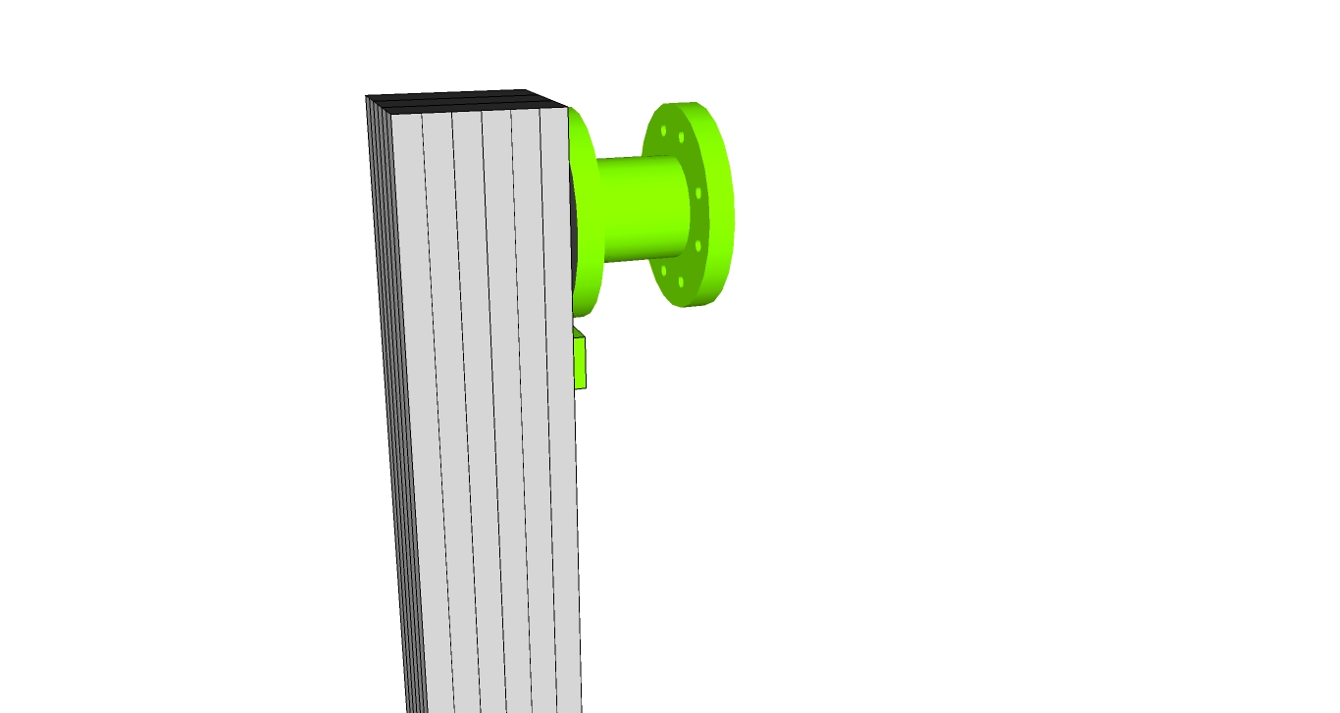

Step #3 With one person on each side of the roll frame, pick up the roll frame, orient the roll actuator mount side of the roll frame to the back. You can use the three hole strips to help support the frame.

Step #4 Insert two t-nuts into the middle outside channel of the roll frames vertical members. Using two 9233393 bolts, attach the knuckle bearing to the roll frame and tighten.

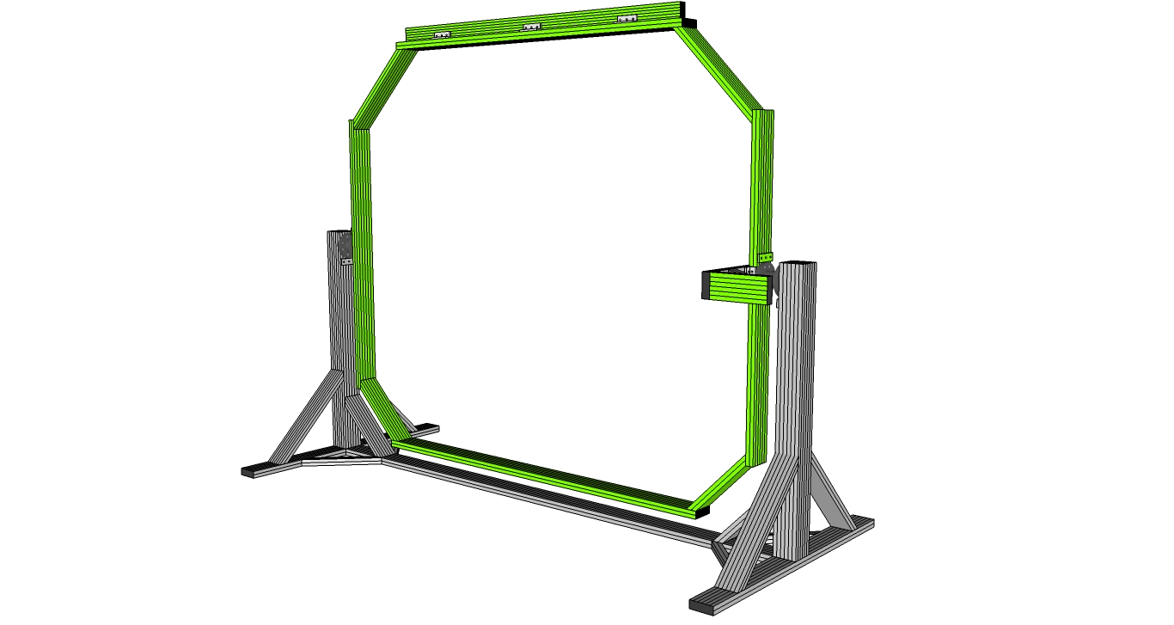

The roll frame should rotate freely and easily.

Step #5 Attach the YAW knuckle bearings to the top and bottom of the roll frame using two 9233393 bolts and the T-Nuts inserted into the center previously during Roll frame construction. Reference drawing below for placement of the bearings. Tighten.

**\*\*\*NOTE: YAW knuckle bearings are now the same bearings as used on roll and pitch, they are no longer slightly larger as may be depicted below**

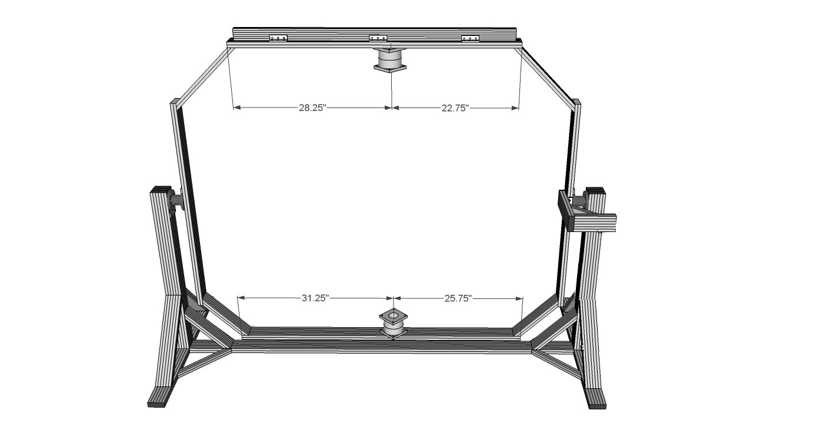

Step #6 Make the lower yaw actuator mount subassy using two 2-hole inside corner brackets and one 3-hole inside corner bracket.

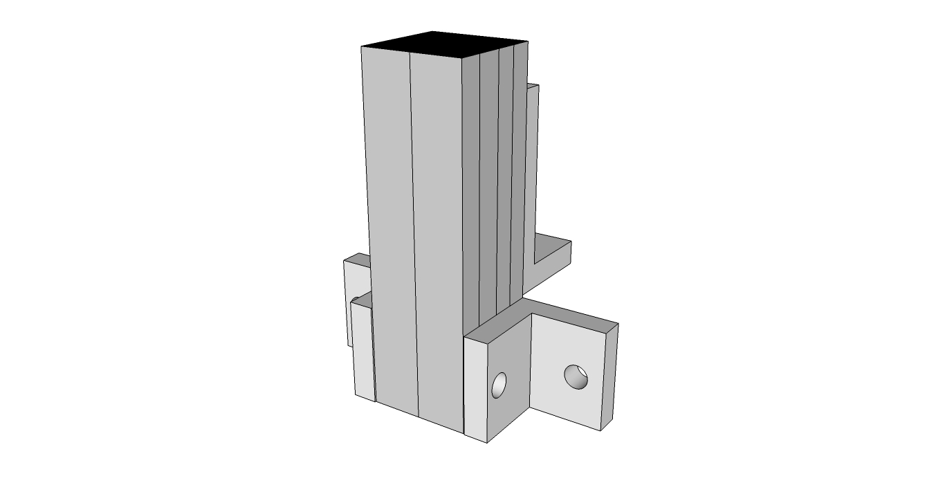

Step #7 Slide the subassy into place on the front right bottom of the roll frame as shown using drop-in T-Nuts as needed. Attach a 6-hole mounting plate to the underside of the subassy once in place, using the tapped hole in the bottom of the stud.

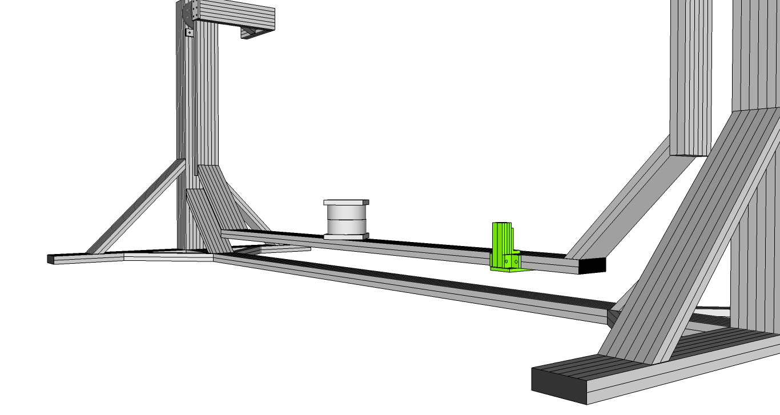

Step #8 Attach the roll actuator top mount by sliding two T-Nuts into **the center channel** of the Roll Actuator Mount frame, positioned on the backside of the roll frame. (It is important that you use the center channel to mount the top of the roll actuator. In addition, **do not use drop in style T-Nuts for actuator mounting.**)

Step #9 Using two ¼-20 X 7/8” (.875”) bolts, secure the hinge base.

Step #10 Secure an actuator mount offset to the rear main end of the base cradle frame by prepping an offset with two T-Nuts and bolts.

Step #11 Slide into place in the 1st and 3rd channel of the rear main end of the base cradle, and use the access holes in the offset, securing into place directly below the hinge base secured in Step #2.

Step #12 Slide two T-Nuts into the top channel of the lower offset, then using two ¼-20 X 7/8” (.875”) bolts, secure the hinge base.

Step #13 Slide the hinge pin into the rod end for the roll actuator top and bottom and secure the pin in the base using a ¼” washer and M6 bolt which came with the pre-assembled hinge pin and base.

At this time you may choose to hook up the motion control box to the roll actuator and power on to hold the actuator in place. This might aid in keeping the chassis steady during the rest of the assembly process.

## Pitch/Yaw Frame to Roll Frame

Step #1 Slide two t-nuts in the top center rail of the top cross member in the pitch/yaw frame. (The bottom two were preloaded during assembly of the pitch/yaw subassy.)

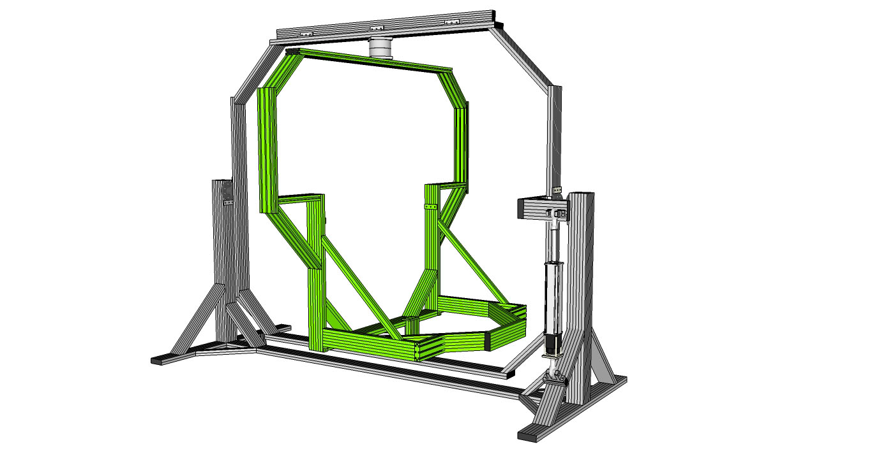

Step #2 Using the help of a friend, pick up the pitch/yaw frame subassy and position into place between the two yaw knuckle bearings. Attach the subassy to the bearings using two 9233393 bolts. Tighten.

The yaw frame should rotate freely and easily.

Step #3 Prep the yaw/pitch frame with three hole mounting strips and the pitch bearings as shown.

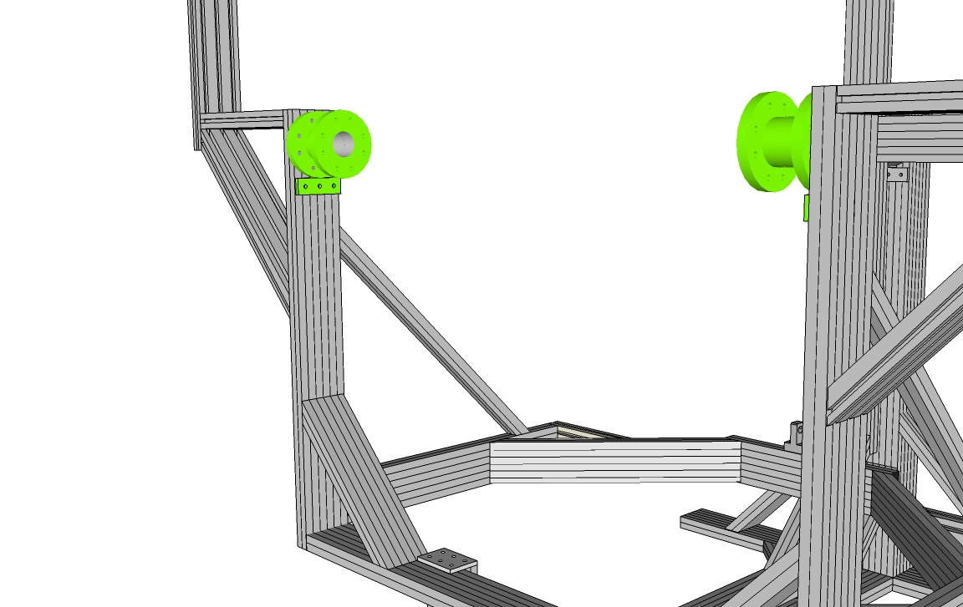

Step #4 Secure the lower pitch actuator hinge base to the pitch/yaw frame. Using two ¼-20 X 7/8” (.875”) bolts, secure the hinge base.

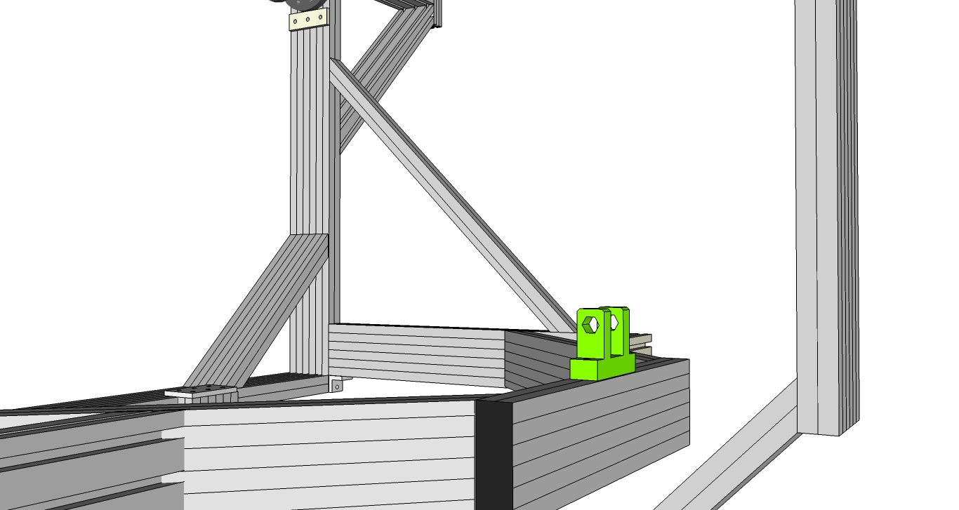

Step #5 Rotate the yaw/pitch frame 90 degrees for cockpit loading.

## Cockpit to Pitch/Yaw Frame

You’ll need a couple of friends for this step.

Step #1 Insert two T-Nuts into the outside center channel of the Main Sides of the cockpit.

Step #2 With one person at either end of the roll frame / cockpit assembly, lift the cockpit assembly into place on the pitch/yaw assembly aligning the cockpit between the pitch knuckle bearings. The center of the knuckle should be about 15 inches from the rear edge of the Main Upper Sides of the cockpit.

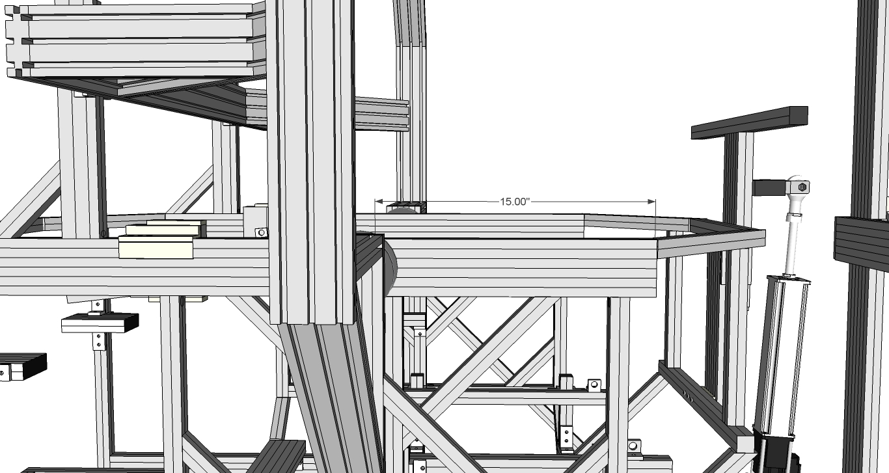

Bolt in place using two 9233393 bolts on each knuckle bearing.

Step #3 Rotate the pitch/yaw frame (and now the cockpit as well) back into proper alignment with the roll and base frames.

Step #4 Attach the upper yaw actuator hinge base on the yaw/pitch frame. Follow the previous steps for attaching the other hinge bases.

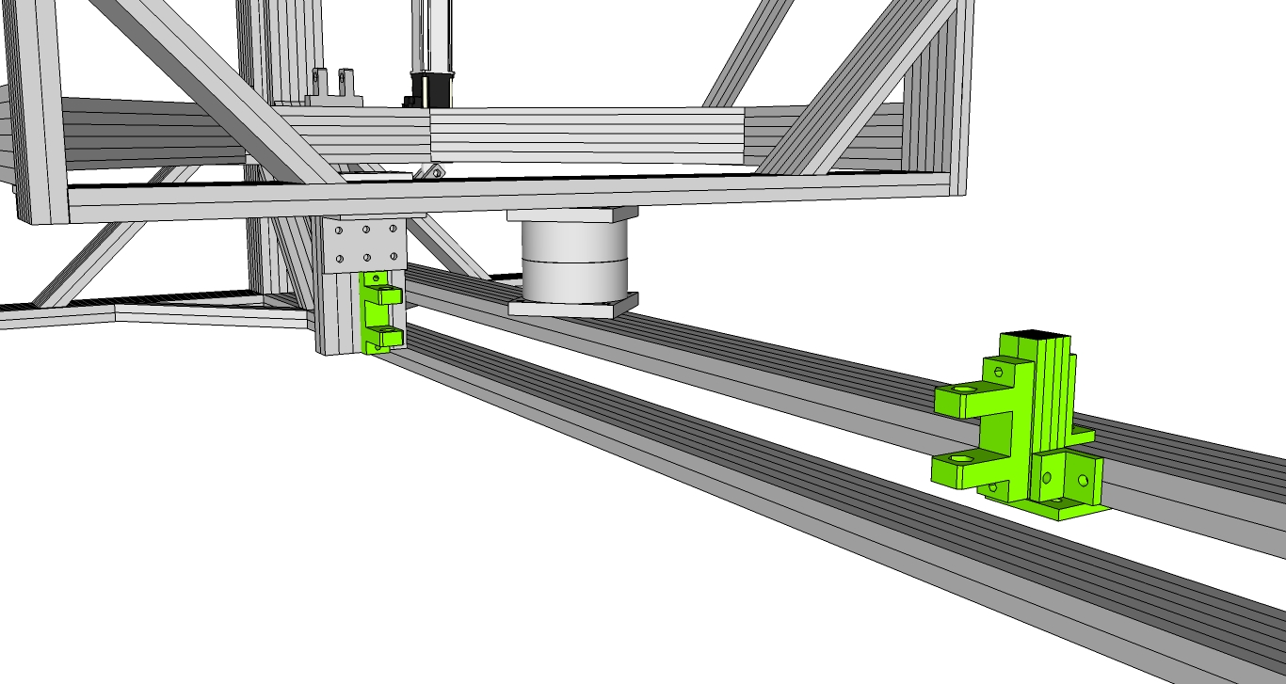

Step #5 Attach the yaw actuator. Follow the steps you followed for attaching the roll actuator. You will want to unpower the motion box at this time, connect the yaw actuator and then repower the box. This will keep the yaw and roll axes in place for the next steps.

## Balancing the Sim

Once the frames are all securely bolted together, and the cockpit components are all mounted, including the monitor, seat, and controls, you may choose to test the pitch balance. For optimal performance, the location of the cockpit in relation to the front and back of the sim – within the roll frame – may need slight tweaking. This is a trial and error process and is something that can be performed after some sim usage. You will know you may need some adjustment if pitch down on breaking or pitch up on accelerating seems sluggish.

To test, climb into the seat and put yourself in the proper position as if you where racing or flying. (Keep in mind that the frames are all freely rotating as you perform this step so be very careful when climbing into and out of the sim.)

Once you are in position in the seat, take note of the pitch position of the sim. As long as the position of the cockpit (the pitch angle) is within the range of motion of the sim and the cockpit rear or cockpit nose is not severely pointed downward (and you are relatively at equilibrium) then the default pitch knuckle bearings position is suitable. Should the sim not be at or near equilibrium during this test, which may be the case for some users, you will need to adjust the cockpit location within the pitch knuckle bearings. To adjust, simply loosen the four bolts, two on each side, on the pitch knuckle bearings to free up the T-Nuts. Loosen only the two bolts on the INNER halves of the pitch knuckle bearings. Do not loosen the other four bolts that connect the pitch knuckle bearings to the outer roll frame, only the inner four bolts, and do nut loosen to the point where the T-Nut is freed from the bolt, just enough to allow the cockpit chassis to slide towards the front and rear. Adjust slightly, tighten and retest the equilibrium position of the pitch axis.

Once this step is done, mount the pitch actuator using the previously described process and steps.

## End Caps

There are three sizes of end caps which are inserted by pushing a plastic screw through the holes in the end caps and into the holes of the various aluminum profiles. Using the appropriate sizes of end caps, walk around the sim and install end caps on each exposed end of aluminum.

## Wiring

Take a little extra time to run the wires and cables neatly from the various components of your sim to the PC. Your sim may have been provided with extension cables, use them were applicable. The channels of the aluminum extrusions can be very handy for running cables and hiding them in some cases. Refer to the wiring diagram in Appendix B if you have any questions regarding running wires to the PC.

# Appendix A – Listing of Parts

|  |  |  |  |  |
| --- | --- | --- | --- | --- |
| **DESCRIPTION** | **8020 Part #** | **SimCraft Part #** | **Qty** | **Len (in)** |
| **BASE Cradle Chassis (9230900)** | | | | |
| **Framing** |  |  |  |  |
| Center Frame (Floor) | 1030 | 9230901 | 1 | 79 |
| Main Verticals | 1030 | 9230903 | 6 | 35 |
| Main Ends (Floor) | 1030 | 9230902 | 2 | 38 |
| Actuator Mount Stud (1010) | 1010 | 9230904 | 1 | 4 |
| mitre cut 1030 support | 2572 | 9230114 | 1 | 11.25 |
| 1x1 inch (1010 profile) 45 degree supports (12") | 2570 | 9232570 | 4 | 12 |
| 1x3 inch (1030 profile) 45 degree supports (18") | 2573 | 9232573 | 4 | 18 |
| 1x3 inch (1030 profile) 45 degree supports (12") | 2572 | 9232572 | 1 | 12 |
|  |  |  |  |  |
| **Connectors** |  |  |  |  |
| three hole joining strip | 4118 | 9234118 | 2 |  |
| 1/4-20 x .5" w/ econ T-Nut | 3321 | 9233321 | 6 |  |
| 10S End Fastener W/ 1/4-20 | 3381 | 9233381 | 24 |  |
| Drop in T-Nuts | 3376 | 9230305 | 12 |  |
|  |  |  |  |  |
| **Roll Chassis (9230100)** | | | | |
| **Framing** |  |  |  |  |
| Main Length (Bottom) | 1030 | 9230103 | 1 | 57 |
| Main Length (Top) | 1030 | 9230106 | 1 | 51 |
| Main Ends (Front and Back) | 1030 | 9230101 | 2 | 44.5 |
| 1x3 inch (1030 profile) 45 degree supports (custom) | 1030 | 9230104 | 2 | 16.25 |
| Roll Actuator Support (Horizontal) | 1030 | 9230105 | 1 | 11.5 |
| Roll Actuator Mount | 1030 | 9230102 | 1 | 7.5 |
| Actuator Mount Stud (1010) | 1010 | 9230108 | 1 | 2.5 |
| 1020 supports for top roll frame | 1020 | 9230109 | 2 | 51 |
| 1020 supports for bottom roll frame | 1020 | 9230110 | 2 | 57 |
| mitre cut 1020 support | 1020 | 9230112 | 1 | 43 |
| Rear Structural Support | 1030 | 9230113 | 1 | 37.75 |
| 1010 mitre cut supports | 1010 | 9230115 | 2 | 15 |
| 1x3 inch (1030 profile) 45 degree supports (12") | 2572 | 9232572 | 3 | 12 |
| 1x1 (1010 profile) 45 degree support | 1010 | 9230111 | 3 | 24 |
| 1x1 (1010 profile) 45 degree support | 1010 | 9232565 | 2 | 6 |
| 1x3 (1030 profile) 45 degree support | 1030 | 9232574 | 1 | 24 |
| Roll Actuator Mount | 2571 | 9232571 | 1 | 6 |
|  |  |  |  |  |
| **Connectors** |  |  |  |  |
| 6 Hole joining plate | 4166 | 9234166 | 4 |  |
| 6 Hole 45 bracket | 4015 | 9234015 | 17 |  |
| 2 hole corner bracket | 4119 | 9234119 | 3 |  |
| BHSCS x .75 | 3065 | 9233065 | 9 |  |
| 10S End Fastener W/ 1/4-20 | 3381 | 9233381 | 3 |  |
| 3/8" long 1-4"-20 BHSCS + Econ T-nut | 3416 | 9233416 | 25 |  |
| 4 Hole 45 degree joining plate | 4145 | 9234145 | 8 |  |
| 1/4-20 x .5" w/ econ T-Nut | 3321 | 9233321 | 24 |  |
| 1/4-20 x .5" w/ econ T-Nut | 3393 | 9233393 | 78 |  |
|  |  |  |  |  |
| **Pitch/Yaw Chassis (9230200)** | | | | |
| **Framing** |  |  |  |  |
|  |  |  |  |  |
| lower triangulated support | 1030 | 9230213 | 2 | 7.5 |
| Main Lengths (Lower Vertical Sides) | 1030 | 9230201 | 2 | 27 |
| Main Lengths (Upper Vertical Sides) | 1030 | 9230211 | 2 | 20 |
| Bottom | 1030 | 9230202 | 1 | 36 |
| Top | 1030 | 9230203 | 1 | 51.5 |
| Back | 1030 | 9230207 | 1 | 13.5 |
| Horizontal Sides | 1030 | 9230204 | 2 | 12.4 |
| 45 degree angled cut (perpindicular cuts) | 1030 | 9230209 | 2 | 10 |
| lower horizontal sides | 1030 | 9230210 | 2 | 19 |
| actuator mount | 1030 | 9230212 | 1 | 6.5 |
| 1x1 inch (1010 profile) 45 degree custom support | 1010 | 9230206 | 2 | 24 |
| 1x3 inch (1030 profile) 45 degree supports (18") | 2573 | 9232573 | 2 | 18 |
| 1x3 inch (1030 profile) 45 degree supports (12") | 2572 | 9232572 | 4 | 12 |
|  |  |  |  |  |
| **Connectors** |  |  |  |  |
| three hole joining strip | 4118 | 9234118 | 2 |  |
| 6 Hole joining plate | 4166 | 9234166 | 1 |  |
| 12 Hole inside corner bracket | 4016 | 9234016 | 1 |  |
| 2 hole corner bracket | 4119 | 9234119 | 2 |  |
| 1/4-20 x .5" w/ econ T-Nut | 3393 | 9233393 | 32 |  |
| 1/4-20 x .5" w/ econ T-Nut | 3321 | 9233321 | 32 |  |
| 10S End Fastener W/ 1/4-20 | 3381 | 9233381 | 50 |  |
| 1/4-20 x .875" SHCS | 3068 | 9233068 | 6 |  |
| 1/4-20 x .75" SHCS | 3064 | 9233064 | 12 |  |
|  |  |  |  |  |
| **Cockpit Chassis (9230300)** | | | | |
| **Framing** |  |  |  |  |
| Bottom Rails | 1030 | 9230301 | 2 | 38.25 |
| Front Verts | 1010 | 9230303 | 2 | 22 |
| Lower Cross Members (Center, Back) | 1010 | 9230309 | 2 | 21.75 |
| Rear Verticals | 1010 | 9230310 | 2 | 10.85 |
| Seat Rail | 1010 | 9230312 | 2 | 19 |
| Main Verts | 1010 | 9230313 | 6 | 13 |
| Lower sides | 1010 | 9230314 | 2 | 11 |
| Shifter Rail | 1010 | 9230315 | 1 | 13 |
| Shifter Rail Bar | 1020 | 9230316 | 1 | 6.5 |
| Front mid cross member | 1010 | 9230317 | 1 | 15 |
| Main Upper Side | 1030 | 9230318 | 2 | 36 |
| 1010 45 degree supports | 2570 | 9230323 | 2 | 12 |
| 1010 45 degree supports | 2570 | 9230323 | 2 | 12 |
| Front Horizontal Cross Member (Top) | 1010 | 9230325 | 1 | 13 |
| Pitch Actuator Frame (Vertical) | 1030 | 9230326 | 2 | 12 |
| Wing | 1010 | 9230327 | 1 | 22 |
| Actuator mount offsets | 1010 | 9230331 | 2 | 5 |
| Rear Horizontal Cross Member (Bottom) | 1010 | 9230332 | 1 | 21 |
| Rear Horizontal Cross Member (Top) | 1010 | 9230333 | 1 | 13 |
| Steering Wheel Bar | 1030 | 9230334 | 2 | 23 |
| Steering Wheel Side Rails | 1010 | 9230335 | 2 | 8 |
| Steering Wheel Studs | 1020 | 9230336 | 4 | 4 |
| monitor supports with one 45 cut | 1030 | 9230337 | 2 | 9.5 |
| moinitor longer supports with one 45 cut | 1030 | 9230338 | 2 | 18.5 |
| main monitor cross member | 1030 | 9230339 | 1 | 48 |
| main monitor verts | 1020 | 9230340 | 2 | 15 |
| Additional Bottom Hinge Rails | 1020 | 9230341 | 2 | 11 |
| Pedal Support (Front & Back) | 1010 | 9230906 | 2 | 17 |
| Pedal Supports (center rails) | 1010 | 9230907 | 2 | 10 |
| Pedal Support (Sides) | 1010 | 9230908 | 2 | 12 |
| Top Hinge Rails | 1020 | 9230909 | 2 | 5 |
| 1010 45 degree supports | 2565 | 9232565 | 14 | 6 |
| 1010 45 degree supports | 2570 | 9232570 | 8 | 12 |
| Linear slide | 6416 | 9236416 | 2 |  |
| L-Handle Brake | 6850 | 9236850 | 2 |  |
| Lower Cross Member (Front) | 1030 | 9230309F | 1 | 21.75 |
| Seat Posts 1 | 1010 | 9230311a | 4 | 6 |
| Seat Posts 2 | 1010 | 9230311b | 4 | 6 |
| Lower sides (with counterbore) | 1010 | 9230314B | 2 | 11 |
|  |  |  |  |  |
| **Connectors** |  |  |  |  |
| 2 hole inside corner bracket | 4119 | 9234119 | 34 |  |
| 3 hole inside corner bracket | 4176 | 9234176 | 16 |  |
| 4 hole inside corner bracket | 4136 | 9234136 | 2 |  |
| 6 hole inside corner bracket | 4015 | 9234015 | 11 |  |
| 6 hole joining plate | 4166 | 9234166 | 4 |  |
| 3 hole plate | 4118 | 9234118 | 8 |  |
| 2 hole plate | 4107 | 9234107 | 2 |  |
| 1/4-20 x .5" w/ econ T-Nut | 3393 | 9233393 | 200 |  |
| 10S End Fastener W/ 1/4-20 | 3381 | 9233381 | 36 |  |
| Anchor Fastener | 3395 | 9233395 | 20 |  |
| 2 hole standard transition inside corner bracket | 4503 | 9234503 | 4 |  |
| 1/4-20 x .5" w/ econ T-Nut | 3321 | 9233321 | 24 |  |
| 1/4-20 x .875" BHCS & Econ T-Nut | 3305 | 9233305 | 16 |  |
| 1/4-20 x 1.25" BHCS & Econ T-Nut | 3307 | 9233307 | 12 |  |
| 3/8" long 1-4"-20 BHSCS + Econ T-nut | 3416 | 9233416 | 12 |  |
| 1/4-20 x .75" BHSCS | 3065 | 9233065 | 12 |  |
| 1/4-20 x 1.50" SHCS | 3080 | 9233080 | 12 |  |
| M6 x 40mm SHCS | 11-6540 | 9236540 | 4 |  |
| 1/4" washers | 3258 | 9233258 | 100 |  |
| drop in T-Nuts | 3376 | 9233376 | 24 |  |
| 1/4" - 20 x 5/8" SHCS w/ washer and Econo T-Nut | 75-3822 | 9233822 | 12 |  |
|  |  |  |  |  |
| **Finish** | | | | |
| 1030 | 2026-Plain | 9232026 | 36 |  |
| 1010 | 2015-Plain | 9232015 | 48 |  |
| 1020 | 2025-Plain | 9232025 | 24 |  |

# Appendix B – Sim Wiring Diagram

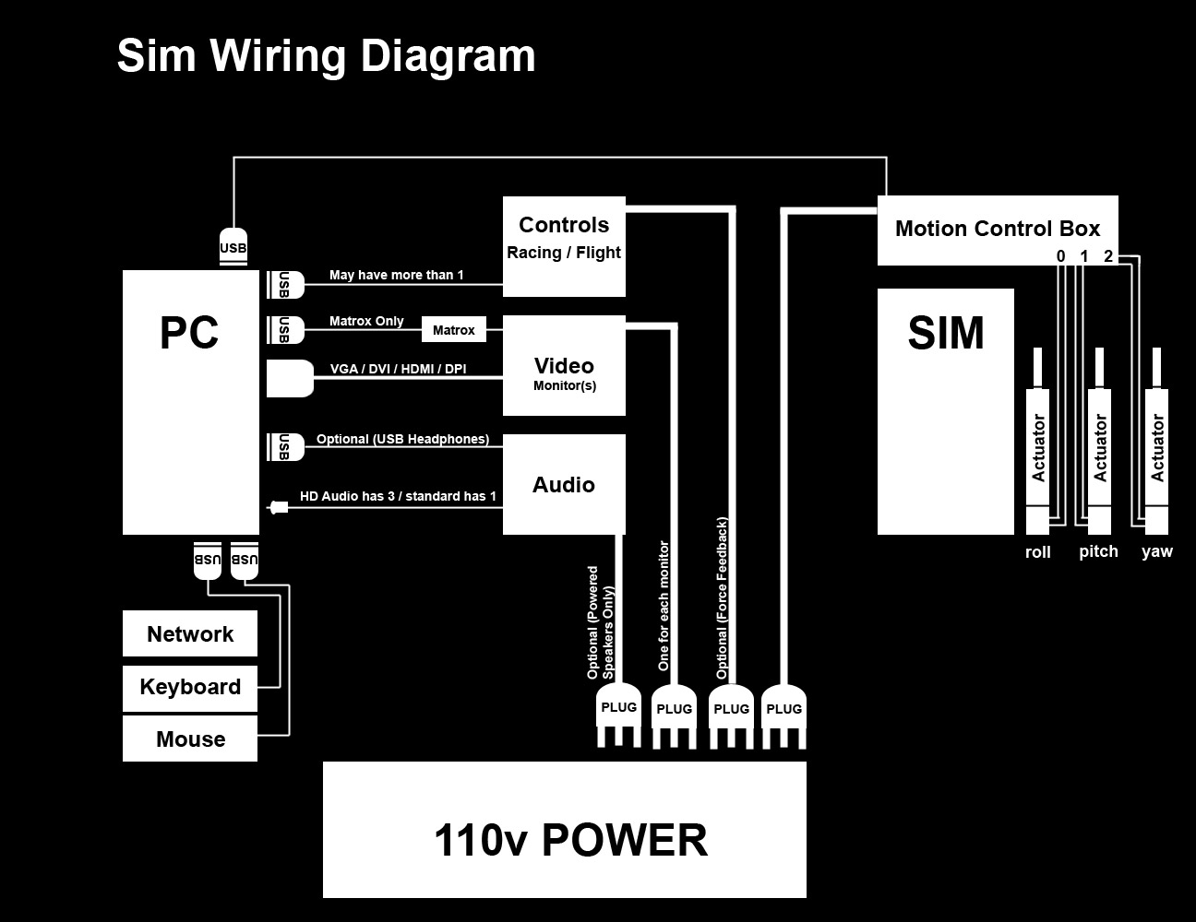

# Appendix C

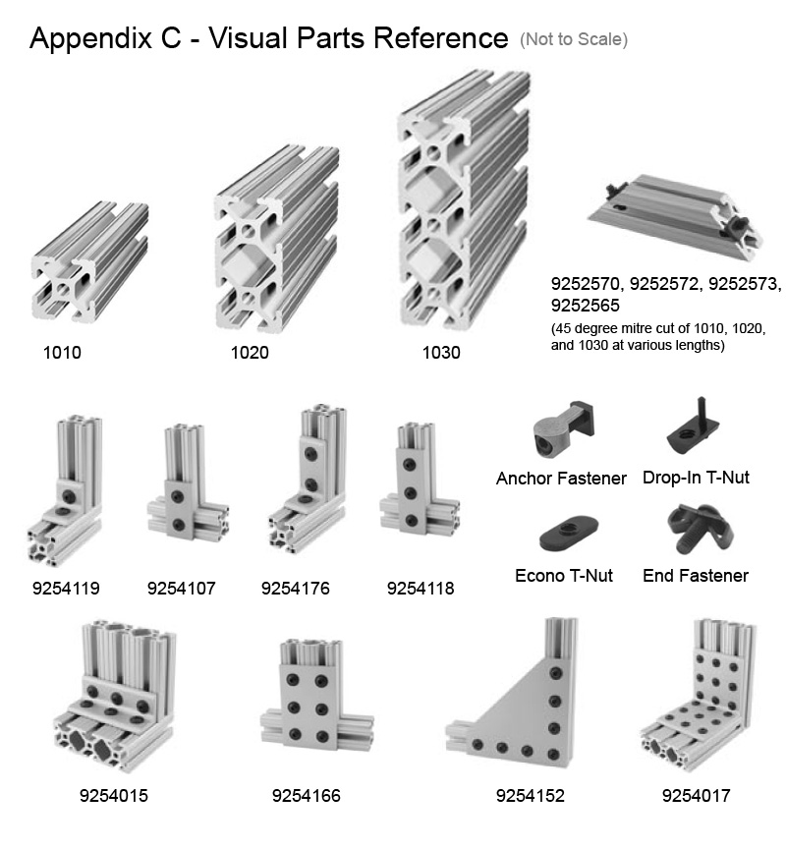

# Appendix D

